Your First Book That Sells
  - How to Publish and Make Good Money on Kindle: Real Royalties, Honest Reviews, and a Catalog That Pays
Lothar J. Musiol
Updated 1 October 2026
Copyright © 2026 Lothar J. Musiol. All rights reserved.
No part of this publication may be reproduced, distributed, or transmitted in any form or by any means, including photocopying, recording, or other electronic or mechanical methods, without the prior written permission of the copyright holder, except in the case of brief quotations embodied in critical reviews and certain other noncommercial uses permitted by copyright law.
This book is a general educational guide. Amazon’s KDP terms, royalty rates, tax rules, and advertising tools change over time and by marketplace. Every platform rule in this book was checked against KDP’s own help pages on 1 October 2026; treat every number as “how the arithmetic works,” verify the current figures before you rely on them, and get professional advice for your own tax and legal situation.
“Amazon,” “Kindle,” “KDP,” “Kindle Direct Publishing,” and “Kindle Unlimited” are trademarks of Amazon.com, Inc. or its affiliates. This book is an independent guide and is not produced, endorsed, or reviewed by Amazon.

Contents
How to Read This Book
Part I — The Short Road: One Month with One Book
Chapter 1: Write one kind of book
Chapter 2: Name the reader
Chapter 3: The number you keep
Chapter 4: A page a stranger can trust
Chapter 5: Cover, keywords, and categories
Chapter 6: Ask for an honest review
Chapter 7: Find readers and send the copy
Chapter 8: Thirty-two ways a book can pay you
Chapter 9: A small ad test
Chapter 10: The next book
Chapter 11: Six calm weeks
Chapter 12: When the book is already live
Chapter 13: Words you can copy
Chapter 14: A filled money sheet
Chapter 15: The Kindle file
Part II — The Landscape
Chapter 16: Why Self-Publish
Chapter 17: How Amazon Actually Pays You
Part III — Writing and Producing the Book
Chapter 18: Choosing What to Write
Chapter 19: From Draft to Manuscript
Chapter 20: Formatting That Doesn’t Break Kindle
Chapter 21: Covers That Sell in a Thumbnail
Part IV — Getting Discovered
Chapter 22: Categories, Keywords, and Your Product Page
Chapter 23: Pricing for Profit
Chapter 24: Launching Without an Audience
Chapter 25: Amazon Ads Without Wasting Money
Part V — The Business Side
Chapter 26: Getting Paid: Taxes, Payments, and Reporting
Chapter 27: KDP Select vs. Going Wide
Chapter 28: Avoiding the Traps
Part VI — Playing the Long Game
Chapter 29: From One Book to a Catalog
Chapter 30: A Realistic First-Year Plan
Part VII — One Topic, in Depth
Chapter 31: The First-Review Problem
Part VIII — Using AI Well
Chapter 32: Using AI Without Losing the Business
A Closing Word
Appendix A — The One-Page Launch Checklist
Appendix B — Royalty Quick Reference
Appendix C — ISBNs, Wide Distribution, and Further Reading
Glossary
Official sources
Also by Lothar J. Musiol

How to Read This Book
This book has two halves, and you can stop after the first one.
Part I is the short road. You follow one first-time author and her cozy mystery through one month of real decisions: what to write, who it is for, what one sale leaves her, how to fix the page, how to ask for honest reviews, and which of thirty-two money ideas to try first. Each chapter ends with one action. If you read only Part I, you can publish a book that pays you honestly.
Parts II to VIII are the full guide. They take the same steps apart with the complete arithmetic: both royalty plans line by line, the keyword and category fields, launch week, ads and break-even ACOS, taxes and payments, KDP Select against going wide, the traps that cost new authors money, building a catalog, the first-review problem in depth, and using AI without losing the business. A short closing word ties the two halves together, and the appendices after it hold a one-page launch checklist, a royalty quick reference, a glossary, and the official sources.
Every dollar figure is marked either as a teaching example, a made-up sum for practicing the arithmetic, or as a platform rule that Amazon published, with the official page listed at the back. Nothing in this book promises you a stated income.

Part I — The Short Road: One Month with One Book

Start here
Picture a first-time author with a finished cozy mystery and a price of $0.99 in her head. She has not asked what one sale would leave her. Part I is the month she finds out. She is a teaching example, not a real person, and every number in her month is a practice sum. Parts II to VIII are the full guide, with every number worked out.
Read it in this order. Write the book. Name the reader. Learn the number you keep. Then fix the page, the reviews, and the money. If the book is already on sale, still read in this order. The chapter about a quiet book will be there when you reach it.
There is one method, the keep test. Three lines. What one sale leaves you. Who the reader is, and who the reader is not. The one change you will make, and the day you will look. The four steps in the money chapter are only how you fill those three lines for a single idea. The calendars are dates on a wall. They are not a second method.
Every dollar figure is marked. A teaching example is a made-up sum so you can practice the arithmetic. A platform rule is something Amazon published, checked here on 1 October 2026. Recheck the linked page before you rely on it. Nothing in this book is a promise that you will earn a stated amount.

The keep test
Write the three lines before you spend money or a week.
The keep. What one sale leaves you, from the estimate in your KDP account. If you have no file yet, use a practice number from chapter 3 and write the word “practice” beside it.
The reader. The two sentences from chapter 2. Who it is for. Who it is not for.
The date. The one change, and the day you will look.
If a line is blank, do not pay for an ad, a promotion, or a stack of free copies. At each later decision the book fills the three lines with the example author’s numbers, so you can see the test instead of only the instruction.
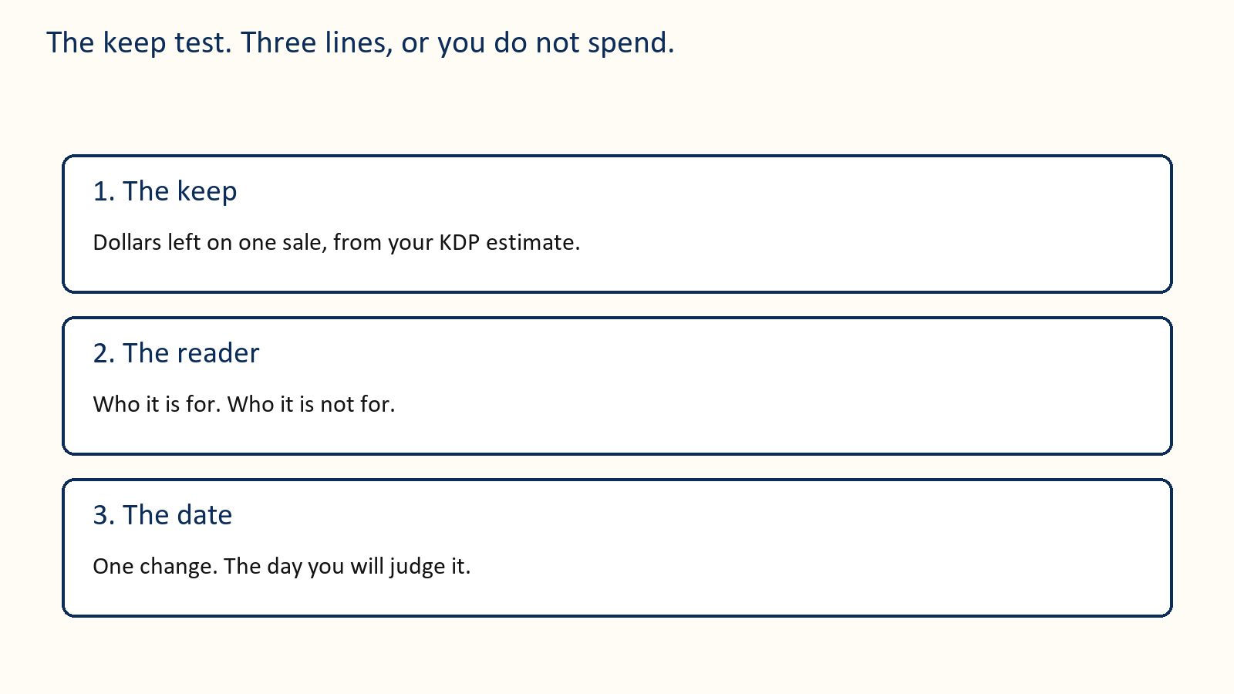

Chapter 1: Write one kind of book
The example book is a cozy mystery. One ferry office, one missing guest, one week, and the woman who keeps the office has to solve it. That is a form. If your book is also one kind of thing, write the sentence you could print under the title and go to chapter 2.
The author’s sentence is: a gentle mystery, a small town, no gore.
Then write one page for the path. What the reader knows at the start. What they know at the end. Fill the chapters inside that page. If you can retell the book by listing someone else’s chapters, you copied a table of contents. If you remember a clue from a book you admire, invent another. The chess piece the guest leaves behind in the example has to be the author’s own idea.
If you are not writing fiction, the same rule is stricter, and it is a note, not the door of this book. A technical handbook needs one meaning per word, a result the reader can use, and practice. A cookbook needs recipes that work in an ordinary kitchen. A memoir or a popular explanation needs a voice and a path a person can leave. Do not mix them in one file. Keep a familiar teaching order unless a different order teaches better. Then come back. The rest of this book is how the book, whichever kind it is, gets paid for.

Your action
One sentence for the form. One page for the path. Then chapter 2. Do not buy a cover while the manuscript is still two kinds of book.

Chapter 2: Name the reader
The mystery author is the example that runs through Part I. She begins the month at $0.99. She has two sentences to write before she is allowed to talk about price.
Do not write for “people who like books.” That group is everyone. A cover, a price, and an ad need one person.
Name the reader in clothes you can picture. A reader of cozy mysteries who wants a small town, a kind heroine, and no gore. Or a first-time author who wants a price that is not a guess and a plan that fits a kitchen table.
Write two sentences.
This book helps or entertains [this reader] by giving them [this experience].
This book is a poor fit for people who want [something else].
Here is a filled pair for a novel.
This book entertains readers who like a gentle small-town mystery and a heroine who solves it without a gun. It is a poor fit for people who want a thriller, a romance with no puzzle, or a joke on every page.
She looks at five books on the shelf her reader already browses. These are invented titles, a teaching example of a shelf, with ordinary prices, not a sale price. They are not a list to paste onto your own page.
The Lakeside Inn Mystery, $4.99
A Sleuth on the Night Desk, $3.99
No Gore in the Village, $4.99
The Locked Pantry, $2.99
Small Town, Quiet Case, $3.99
These stand for other people’s books, and her own title is not on this shelf. Another book’s title never goes in your keyword boxes. What she takes from the shelf is the words these books share and their readers use: small town cozy mystery, amateur sleuth inn mystery, clean mystery no gore, village puzzle mystery, quiet village detective. Those five phrases come back in chapter 5 and in the ad test.
Here is a filled pair for a guide.
This book helps a first-time Kindle author set a price, ask for an honest review, and decide what not to spend. It is a poor fit for people who want a guarantee of sales or a tour of every KDP button.
The second sentence is as useful as the first. It stops you from begging the wrong people to buy. A wrong buyer does not become a fan. They become a return, or a review that says the book was not what the page promised.

What you have when you finish
Two sentences. Five books a reader like yours already buys. One sentence about what your book must contain so the promise is true.

Your action
Write the two sentences before Friday. If they are blank, do not buy traffic.

Chapter 3: The number you keep
The sticker price is not your money. The number you keep is what is left after Amazon’s percentage and, in the 70 percent band, a delivery charge.
Call that number the keep. Every later chapter uses it. A sale that looks busy and keeps thirty-five cents is a different business from a sale that keeps two dollars.
On Amazon.com, as checked on 1 October 2026, the usual 70 percent ebook band is $2.99 to $12.99. Until 7 July 2026 the top of that band was $9.99, so older advice that tells you to stop at $9.99 is out of date. Price is only one rule. Territory and other requirements matter. Sales to readers in Brazil, Japan, Mexico, and India earn 70 percent only if the ebook is enrolled in KDP Select. Read the current price page, and read the estimate in your own KDP account, before you publish. [3] [4]
For a qualifying 70 percent sale, the basic sum is:
0.70 × (list price − any VAT − delivery cost)
In the 35 percent option, delivery is not subtracted. [4]
Amazon.com lists delivery at $0.15 per megabyte, using Amazon’s file size, not the size of the Word file on your desk. A 2 MB file is $0.30 of delivery. A picture-heavy book can be much larger. Use KDP’s estimate for the converted file.
Teaching example. No tax. 2 MB file. Rounded to the nearest cent.
$0.99 at 35 percent keeps about $0.35. Delivery is not taken off.
$2.99 at 70 percent: 0.70 × ($2.99 − $0.30) = $1.88.
$3.99 at 70 percent: 0.70 × ($3.99 − $0.30) = $2.58.
$4.99 at 70 percent: 0.70 × ($4.99 − $0.30) = $3.28.
$7.99 at 70 percent: 0.70 × ($7.99 − $0.30) = $5.38.
Whenever this book says “about $2.58,” it means that $3.99 line. It does not mean a mystery fee.
These examples have no VAT. A price that already includes VAT is a smaller base, so the keep is smaller than the line above. A return takes the keep back.
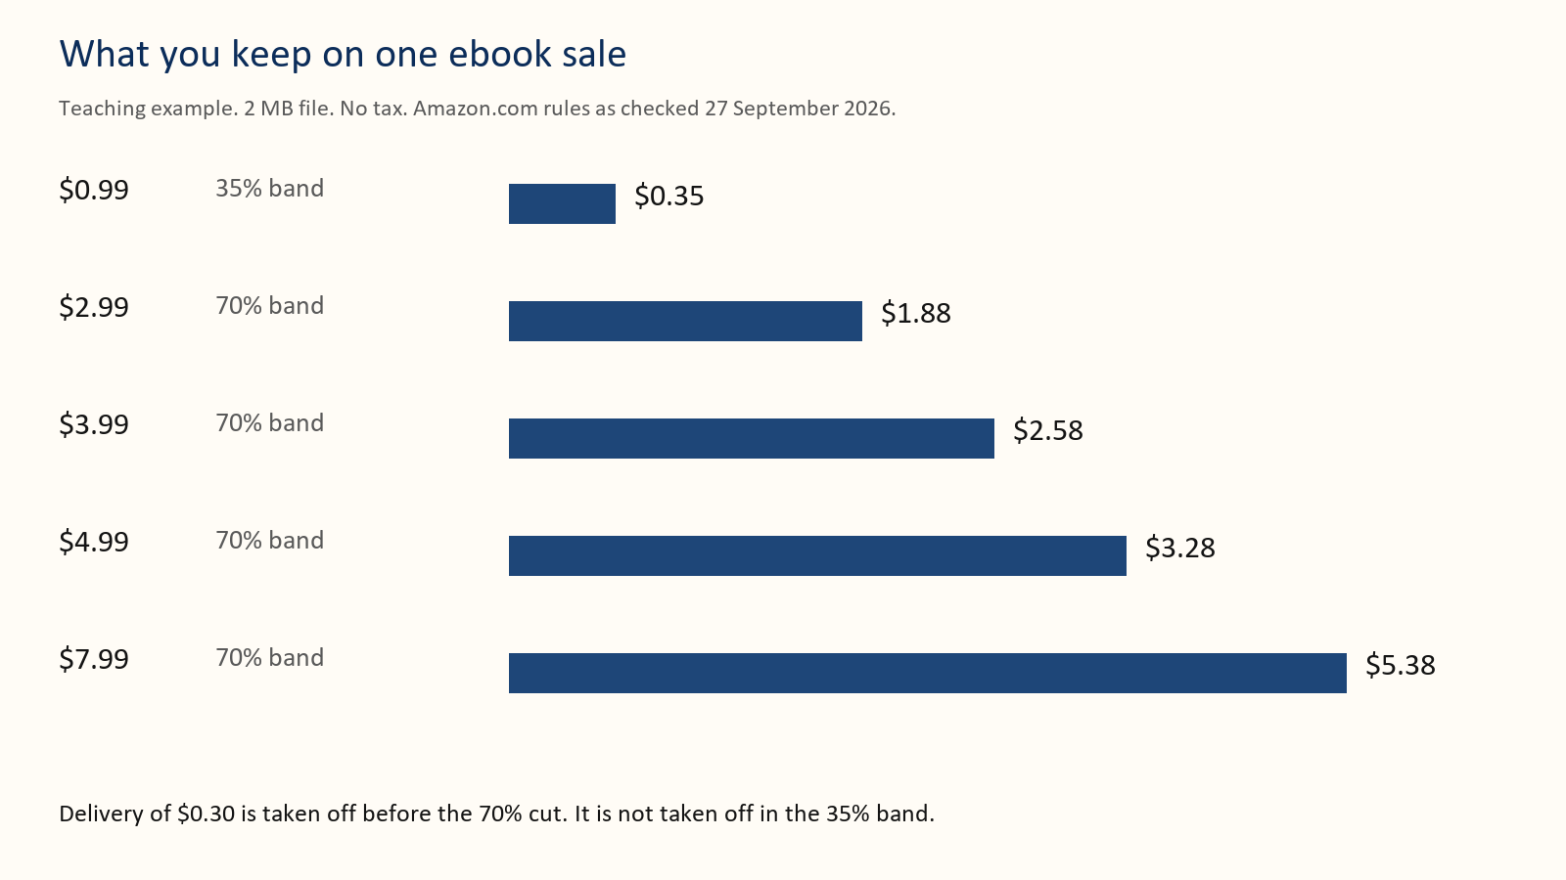
Thirty sales at the $2.99 keep of $1.88 are about $56. Twenty-five sales at the $3.99 keep of $2.58 are about $65. Fewer sales can pay you more. You still need a fair test. Change one thing at a time. If you change the price, the cover, and the ad on Monday, you will not know which one moved the money.
A paperback is a different sum. For a standard KDP paperback, you take the royalty rate times the list price, then subtract the printing cost. The print cost is not multiplied by the rate. On Amazon.com the rate is 60 percent at a list price of $9.99 or more, and 50 percent at $9.98 or less. Other marketplaces have their own dividing line. [7]
Teaching example only, not a quote for your book. A $14.99 paperback at a 60 percent rate, with a $4 print cost, keeps (0.60 × $14.99) − $4, about $5.00. The same book at $8.99 drops to the 50 percent rate and keeps (0.50 × $8.99) − $4, about $0.50. Your trim size, page count, and marketplace change the print cost. Use the calculator. Do not publish a paperback price you have not run through it.

What you have when you finish
Your price, the band it sits in, and the keep written in dollars and cents.

Your action
Open KDP’s estimate for your real file. Do not use $0.99 as the price of a book you spent months on.
Before you spend, here are the example author’s three lines. Write your own beside them.
Keep: about $0.35 at $0.99 today. The test is $3.99, about $2.58, if the file matches the chapter 3 example.
Reader: the two sentences from chapter 2.
Date: raise the ebook from $0.99 to $3.99, change nothing else, and look in four weeks.
If one line is still blank, do not pay yet.

Chapter 4: A page a stranger can trust
The cover, the description, the sample, and the book must promise the same thing. A kind review cannot repair a sample that is dull or a description that lies.
The first two sentences of the description do almost all of the work. Shoppers do not read paragraph four on a phone.
Here is a weak opening.
“This incredible novel will change your life. Readers have called it unputdownable. A must-read for everyone who loves a good story.”
It names no reader and no promise. “Everyone” is the sentence chapter 2 told you not to write.
Here is the opening of the example mystery.
“The woman who keeps the ferry office knows every guest who comes and goes. When one vanishes and leaves a chess piece on the blotter, she has until Sunday to find him, without scaring off the wedding party in the dining room. A gentle mystery for readers who want a small town, a puzzle, and no gore.”
The second version can be priced. The first version cannot.
Read your first two sentences out loud. If a stranger cannot say who the book is for, rewrite them before you touch the cover.
Then open the sample on your phone. Count how many screens appear before something the reader came for. Front matter is fine. A tunnel of copyright, praise, and a preface is a reason to close the sample.

Your action
Show your own two lines to one stranger. If they cannot say who the book is for, fix the lines before you buy an ad.

Chapter 5: Cover, keywords, and categories
People meet the cover as a thumbnail. If the title cannot be read at that size, the rest of the design does not matter.
Hold the cover at arm’s length, or shrink it on your screen until it is about the size of a postage stamp. You should still read the title. You should still know the kind of book. A thriller should not look like a cookbook. A quiet mystery should not look like a textbook.
The author’s name should not be the largest words unless strangers already seek that name. The subtitle, if you use one, should say the promise in words a reader would actually use.
Do not put a sentence on the cover that you cannot see at thumbnail size. Do not depend on a color alone to carry the meaning. The cover will be seen in gray on some devices.
Keywords are the phrases a reader types. On the KDP details page you get a set of keyword boxes. Fill them with phrases, not single vague words like “book” or “fiction.” Use words a reader would type, the way the mystery author’s phrases are the words her shelf shares in chapter 2. Never type another author’s name or another book’s title; chapter 22 explains why. Do not repeat the title in every box. Do not type claims you cannot stand behind, such as “bestseller” or “guaranteed income.” If the form on the page has changed since 1 October 2026, follow the form, not this paragraph.
Categories are shelves. The biggest shelf hides a new book. Look at five books your reader already buys and note where they sit. Choose the closest true shelves KDP offers, not the most famous shelf in the store. You can ask KDP to add categories later. Ask for shelves that are true. A book in the wrong shelf gets the wrong readers, and the wrong readers do not pay twice.
Here is a filled keyword set for the gentle mystery. It is an example of the kind of phrase, not a list to paste onto a different book.
small town cozy mystery
amateur sleuth inn mystery
clean mystery no gore
village puzzle mystery
quiet village detective
gentle puzzle novel
weekend mystery book
None of those is her title or anyone else’s. Each is a way a reader might search. If a phrase does not fit the book, it does not go in the box, even if it is popular.
Here is a cover brief you can hand to a designer, or use yourself.
One reader: people who want a quiet puzzle.
Must be readable as a thumbnail: the title, and that it is a mystery.
Must not look like: a romance cover, a thriller with a gun, a textbook.
Three words on the image at most, besides the title and your name.
I will reject it if I cannot read the title on my phone’s lock screen.

Your action
If the title fails on a phone, fix the cover before launch week.

Chapter 6: Ask for an honest review
A new book has little proof. An honest review is one piece of proof. It is not a bill.
You may send a free advance copy. Say that a review is welcome and optional. Do not ask for stars. Do not offer a gift card, a refund, or a favor in exchange for a kind review. Amazon has said a free or discounted copy is allowed only when you do not require a review and do not try to steer it. Extra incentives can wipe out that exception. Read the current Customer Reviews page before you send the invitation. [1] [2] Not every willing reader can post. Amazon.com sets a spending threshold for reviewers, so a missing review is often the platform, not a failed invitation. Chapter 31 has the full eligibility rules. You do not review your own book. A friend, relative, or business partner is a conflict, not a useful first review. [2]
Do not buy a pack of reviews. Do not trade reviews with other authors as a deal. Do not ask a reader to change a star. Do not make a second account to post what the first account could not.
Some people will not finish. Some will finish and say nothing. Both are allowed.
Here is a bad line.
“I gave you this book, so please post five stars by Friday or I cannot send you the next one.”
That is a debt. Delete it.
Here is a clean line.
“An honest review after publication is welcome and optional. No rating is requested. You can stop reading or say nothing.”
If a review never appears, check the store, the edition, and whether reviews are open yet. A preorder page is not always a place a reader can post. Do not tell anyone to make a new account to get around a block.

Your action
Delete any invitation line that sounds like a trade. Do not pay a service that promises stars.

Chapter 7: Find readers and send the copy
The best reader already likes this kind of book and has time this month. A person who likes “helping authors” but dislikes your subject will not buy book two.
Start with people who asked to hear from you. Then look at communities whose rules allow a polite invitation. Follow the rules. Do not scrape addresses. Do not add anyone to a list because they once said hello.
Tell them the subject, the length, the format, and the dates. Give them a way to decline before they apply. Collect a name, an email, the format, and one question about fit. Put any newsletter opt-in in a separate checkbox. Keep the list private.
Teaching example, not a rate you are owed. You invite 40 suitable people. 24 accept. 6 post a review. That is one imaginary campaign. For planning, also try 10 percent, 20 percent, and 30 percent of 30 copies: 3, 6, or 9 posts. Plan the cost so the low end is fine. Readers do not owe you a post.
Make the file easy to open. Test the link yourself, including any expiry. Name the file with the title and the date. Send it to one willing person before you send it to the group.
The mystery author sent her advance copy to a man who had asked for a thriller. He wrote back that the chess piece wasted his evening. She had skipped the sentence about who the book is not for. The file cost her an hour and taught her nothing about her book.
Send four notes at most. A confirmation. The file. After publication, when reviews can be posted, the store link. One gentle follow-up a week or two later. Then stop. If your file was broken, fix it and extend the time. Do not send the follow-up to someone who could not open the book.
If you are in KDP Select, or about to join, read the exclusivity rules before you email the ebook. A public full-book giveaway can break those terms. Ask KDP if you are unsure. [5]
Before you spend, here are the example author’s three lines. Write your own beside them.
Keep: $0. A free copy leaves nothing. The paid ebook is a separate line on the sheet.
Reader: the two sentences from chapter 2.
Date: send no more than the free copies you can support, and look when that limit is reached.
If one line is still blank, do not pay yet. Stop when you hit that number.

Chapter 8: Thirty-two ways a book can pay you
Pick three for this month. One should be a price. One should be the next book, even if the next book is only a sentence. One should be a format or a short extra.
Run every idea you pick through the same four steps. This is the whole depth of the list. You do not need a different system for each door.
Step 1. Write the keep for that product, from chapter 3 or from KDP’s estimate.
Step 2. Do the smallest version that can teach you something. A sentence of book two counts. A finished trilogy is not required to start.
Step 3. Pick the day you will look. Two weeks, or four. Write it down before you start.
Step 4. On that day, keep the idea or stop it, in one sentence on the money sheet. “Held the $3.99 price.” “Stopped the free days. No second book.” Do not start the next idea until that sentence exists.
Each idea below is three lines. What it is. The smallest version. The number that means stop. The keeps, when a line needs one, are the chapter 3 examples. After the example author raises her price, her ebook keep is about $2.58. Your file’s estimate wins over that round.

1 Charge a real ebook price
A normal book belongs in the 70 percent band when you qualify. The example test is $3.99, about $2.58 kept, against $0.99, about $0.35.
Smallest version: change only the price, for four weeks.
Stop if the keep on the sheet is lower than it was at the old price.

2 Make book one the handshake
Book one can be the book a stranger tries. Book two is where the catalog pays. After the price change, book one already keeps about $2.58. Do not cut it to make book two look expensive.
Smallest version: write both prices on one line.
Stop if book two still has no date you can say out loud.

3 Write the next book while this one is still warm
A second sale is the ordinary way one reader pays you twice.
Smallest version: one sentence at the end of book one, saying who book two is for.
Stop if that sentence could describe book one again.

4 Use a series page
A series page lets a shopper who liked one book see the next. The keep per sale does not change. The chance of a second keep does.
Smallest version: two finished books, each page linking to the other.
Stop if a reader of book one would not recognize book two as the next thing they wanted.

5 Sell a box set after three books
Three sales at about $2.58 keep about $7.74. A set at $7.99, same 2 MB example, no tax, keeps 0.70 × ($7.99 − $0.30), about $5.38. Take the set only if you want that $5.38.
Smallest version: three finished files, and that sum written down.
Stop if the set keep is a number you would not accept, or if two of the three books are still promises.

6 Add a paperback
You keep the rate times the list price, minus print cost. Not the sticker.
Smallest version: one price in the calculator, then a proof if the keep is worth printing.
Stop if that keep is smaller than the ebook’s about $2.58 and nobody has asked for paper.

7 Add large print
Same words, larger type, another listing, a higher print cost.
Smallest version: copy the paperback setup, enlarge the type, run the calculator again.
Stop if the keep falls below the ebook keep.

8 Try Kindle Unlimited on purpose
Select is 90 days. Page reads may pay you. The ebook stays out of other stores. For July 2026 the shared fund was $67.6 million, a little over four tenths of a cent per page, so a full read of a book that counts as 300 pages paid roughly $1.27. That is history, not a promise. Chapter 17 shows how the fund works and chapter 27 weighs it against selling everywhere. [5] [10]
Smallest version: read the terms and the renewal box, and write the end date.
Stop at day 90 if the page-read money is not worth the sales you gave up.

9 Run a short countdown, then restore the price
A countdown is a visit. The everyday price is the business. A countdown runs only on Amazon.com and Amazon.co.uk, only after the book has been in Select for 30 days, and for seven days at most. If the book is on the 70 percent option, it keeps 70 percent during the deal even below $2.99, with delivery still taken off. The list price must stay unchanged for 30 days before and 14 days after. [6]
Smallest version: a few days, one deal in the 90-day term, and the morning the full price returns written on the sheet.
Stop if you cannot name that morning, or if book two is not linked.

10 Make book one free only when book two is ready
A free download keeps $0. It pays only if some of those readers buy something else.
Smallest version: book two live and linked, then the free days.
Stop if book two is not live.

11 Sell a workbook beside the main book
A short book of prompts can be its own listing, at a keep of about $1.88 or about $3.28 in the chapter 3 example. The main book must still be complete.
Smallest version: a list of ten prompts that are not already chapters.
Stop if you cannot list ten.

12 Sell a one-sitting extra
A field guide or a troubleshooting list, finished, and priced so the keep is not a few cents.
Smallest version: one sentence and a price in the 70 percent band.
Stop if you cannot say it in one line, or if the main book’s first two lines are still unclear.

13 Teach the chapter once
An hour in a room can be a fee plus book sales. Ten seats can be worth more than ten keeps of about $2.58.
Smallest version: one chapter, a one-hour outline, and a fee.
Stop if you cannot name ten people who would care.

14 Sell a template pack from your own site
A spreadsheet or a set of prompts, sold beside the book. The book has to stand alone.
Smallest version: the file names and the price, written down.
Stop if a buyer who never buys the pack did not get what the book promised.

15 Translate one book that already sells
A second language is a second listing of a book strangers already want. A bad translation comes back as a return, and a return takes the keep back.
Smallest version: one chapter, read by someone who knows that language, before you pay for the rest.
Stop if the book has no readers yet.

16 Record audio after the ebook has readers
Audio is a second product. It is a poor first bet.
Smallest version: ask people who finished whether they would listen.
Stop if they would not.

17 Open a preorder you can finish
A reader can pay before the day. You must deliver the file on time.
Smallest version: a date, and a file that is already done.
Stop if the file is not done.

18 Choose a shelf where you can be seen
Two true categories beat one giant shelf where you are invisible.
Smallest version: two categories, and the five books that sit on them.
Stop if those five are not books your reader already buys.

19 Put the promise in the first two lines
The sentences from chapter 2, in the description. They do not change the keep. They change how many people reach the button.
Smallest version: show the two lines to one stranger.
Stop rewriting when that person can say who the book is for.

20 Leave the old books up
The backlist can pay you in a quiet month, if the samples still work.
Smallest version: open each old sample on your phone.
Stop leaving a book up when the sample is broken. Fix it this week or unpublish it.

21 Write one seasonal short
A holiday story or a summer guide, linked to the main book, live while the season is alive.
Smallest version: the season, and the date it must be on sale.
Stop if that date has passed.

22 Price a paperback a library can buy
Expanded distribution, the path many libraries use, pays a lower rate than Amazon’s own store. In the chapter 3 illustration, $14.99 at 60 percent keeps about $5 after $4 to print. At 40 percent it keeps (0.40 × $14.99) − $4, about $2. The calculator wins.
Smallest version: one expanded-distribution price, and the keep written down.
Stop if that keep is about $2 or less and print cost eats the rest.

23 Offer the book to a group you already know
A club or a class may buy several copies without an ad.
Smallest version: one letter to one group you actually know.
Stop if the offer has to promise reviews, grades, or income.

24 Spend on ads only after the keep is written down
A click is a donation until you know the keep. Chapter 9 is the test.
Smallest version: the keep line, filled, before you open the ads site.
Stop if that line is blank.

25 Sell the ebook in more than one store
If you are not in Select, the same file can be sold elsewhere. That store’s keep is on that store’s page, not in the Amazon table. [5]
Smallest version: one other store, and its royalty page, read.
Stop while you are inside a Select term.

26 Write to readers who asked
A list is a way to offer book two to people who already trusted you. It is a choice, not a toll.
Smallest version: one sentence in the back of the book, and one place to join.
Stop if you never write to them.

27 Add a hardcover only when the calculator leaves a keep
Hardcover is a higher sticker and a higher print cost. Rate times price, minus print.
Smallest version: one price in the calculator.
Stop if that keep is smaller than the ebook’s about $2.58, or if you have not held a paperback proof yet.

28 Publish a second edition for a real reason
A real correction gives you a reason to write to past readers. Shuffling sentences does not.
Smallest version: a list of three fixes a past reader would be glad to hear about.
Stop if you cannot name three.

29 Give away a short extra, not the whole book
A story or a checklist, made to point at the paid book. Not the only book you have. That was idea 10.
Smallest version: the extra, outlined on one page.
Stop if the paid book’s first two lines are not done.

30 Open one more Amazon marketplace
Another country has its own price and its own estimate. Do not copy the US price across.
Smallest version: one country where your reader lives, and that estimate on the sheet.
Stop if you are about to open five countries on the same day.

31 Share a bundle with one other author
Two finished books, the same reader, a link, and no review trade.
Smallest version: one book you would hand your own reader, and one question to that author.
Stop if you have not read their book, or if they want a review swap.

32 Revisit the backlist price once a year
Once a year, write the keep for each live book. Move one price, or move none. Story A is the shape.
Smallest version: the current keep of the oldest book, on the sheet.
Stop if you are changing prices every month.
Leave these for later. Mugs. A paid fan club. A big course with no audience. They add work. They rarely add a keep until strangers already want the book.

Three ideas, done all the way through
These are teaching stories. Copy the shape, not the dollars.
Story A, the price. This is the mystery author, later in the same month. Her only book is $0.99. The KDP estimate says she keeps about $0.35. In four quiet weeks she sells 20 copies. Keep, about $7. She changes only the price, to $3.99. The estimate now says about $2.58. She does not touch the cover or the ad, because there is no ad. Over the next four weeks she sells 12 copies. Keep, about $31. Fewer sales, more money. She writes that on the sheet and holds the price for another four weeks before she believes it. If the second month collapses, she can go back. One change. One window.
Story B, the paperback. The same author’s ebook keeps about $2.58 at $3.99. She wants paper. The calculator says a 240-page paperback costs about $4 to print in her marketplace. She tries $14.99 at 60 percent: (0.60 × $14.99) − $4 is about $5. She does not list it at $9.99. At 60 percent, 0.60 × $9.99 is $5.99, minus $4 to print, about $2. The ebook keeps about $2.58. Paper at that price pays less, and it is a heavier object. She orders a proof, reads ten pages, and only then clicks publish. The print cost in this story is an illustration. Her calculator, not this paragraph, sets the real number.
Story C, the capped ad. The author writes “keep about $2.58” at the top of a page. She sets a $40 cap and a stop date. She uses the five reader phrases from chapter 2: small town cozy mystery, amateur sleuth inn mystery, clean mystery no gore, village puzzle mystery, quiet village detective. After the cap, the screen shows clicks and two sales. Two times $2.58 is about $5, against $40 spent. She does not raise the budget. She rewrites the first two description lines, waits, and only then decides whether another $40 is a test or a habit.
Before you spend, here are the example author’s three lines. Write your own beside them.
Keep: about $2.58 on the example mystery, now at $3.99.
Reader: a gentle mystery, a small town, no gore. Not a thriller.
Date: run one idea, and look on the day you wrote down before you started.
If one line is still blank, do not pay yet. Do not start a second idea until this one has paid you or taught you to stop.

Chapter 9: A small ad test
An ad introduces the book. It also shows you a weak page, because you pay for the look.
You do not need a large review pile to run a tiny test. You do need a cover that passes the thumbnail test, two true description lines, and a keep written down. Large spending with none of those is how a quiet book becomes an expensive quiet book.
Teaching example, after the mystery author’s price change. She keeps about $2.58 on a $3.99 sale. A click costs $0.30. If one sale comes from every ten clicks, the ad costs $3.00 to earn that $2.58. The click would have to cost about $0.26 or less to break even, because $2.58 × 0.10 = $0.26. At 5 percent, the ceiling is about $0.13. These are ceilings, not recommended bids. Refunds, delayed reports, and page-read money move the real result. Stay under the ceiling. Do not treat the sales number in an ad screen as the money you keep. Chapter 25 turns the same test into break-even ACOS, the figure the ad screen shows.
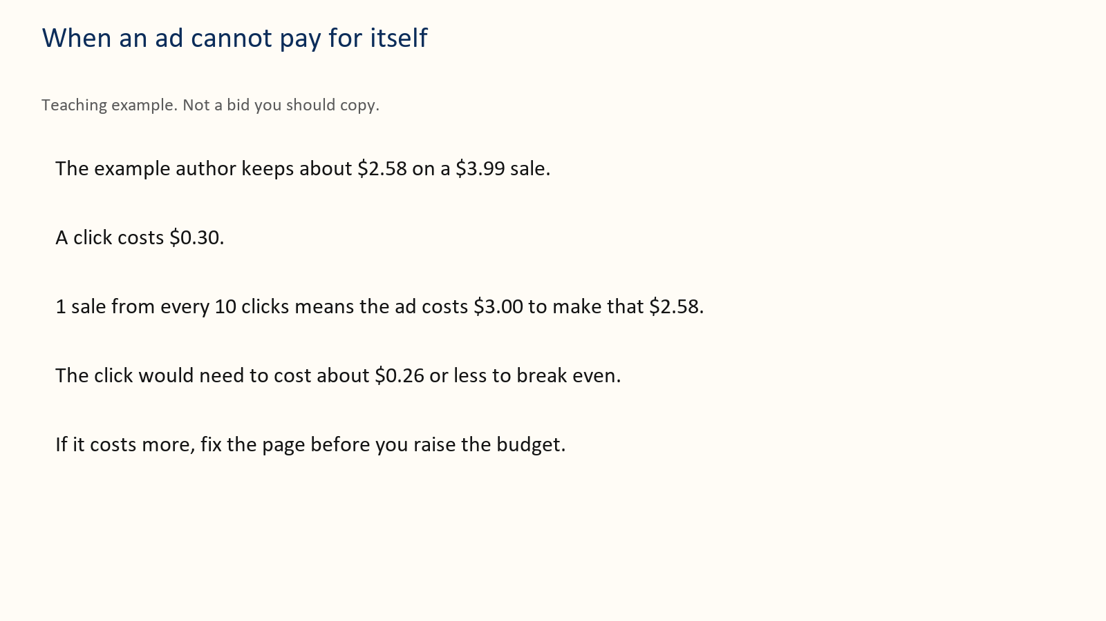
A practical test uses Sponsored Products, the kind of ad that shows a book to shoppers. Button names on the ad site change. The decisions do not. You still choose a budget, an end date, a few phrases a reader would type, or a few books that reader already buys. One campaign is enough. Cap the test at an amount you can lose, such as $20 or $60, and write the stop date before you turn it on. Do not paste a hundred keywords you have not read.
Here is a fourteen-day log you can copy. Teaching example. Keep about $2.58 on a $3.99 ebook. Cap $40.
Day 0. Write the keep, the cap, the stop date, and five phrases. Turn the test on.
Day 3. Look only. Do not change anything. Note money spent.
Day 7. If almost nobody clicked, the cover or the phrases are the suspect. Change one of those, not the cap.
Day 14. Stop at $40 even if you have not “learned enough.” Write sales, money spent, and money kept if each sale matched the $2.58 example. Then one sentence: continue, change the page, or stop.
When you look, use this order.
Impressions and almost no clicks: the cover or the targeting is wrong. Fix the thumbnail or the phrases. Do not raise the budget.
Clicks and no sales: the page does not match the ad, the sample is weak, or the price is a surprise. Fix one of those.
Sales that keep less than the ad cost: the keep is too small for this traffic, or the click price is too high. Lower the bid, or pause, or move the book’s price only as its own test.
Stop at the cap even if you are curious. Curiosity is not a budget.
Kindle Unlimited money, if you are enrolled, goes in its own column. Do not give the ad credit for every page read that week.
Before you spend, here are the example author’s three lines. Write your own beside them.
Keep: about $2.58 on the example mystery, now at $3.99.
Reader: a gentle mystery, a small town, no gore. Not a thriller.
Date: stop the ad at $40, or on day 14, whichever comes first.
If one line is still blank, do not pay yet. One test. Stop at the cap. Then one new decision.

Chapter 10: The next book
One book can pay you a little. A row of books can pay you again from a reader who already trusts you.
That second payment is not a reason to lose money on purpose today. If book one loses money, book two is a second product, not a refund of the first loss.
Teaching example, after the price change. 100 people buy book one at $3.99 and the author keeps about $2.58, so those first sales keep about $258. Thirty of them later buy book two at the same keep, about $77. Together that is about $335, or about $3.35 per first buyer. Paying $2 to find one of those buyers can fit. Paying $4 does not.
If half of those book-two buyers also buy a third book at the same $2.58 keep, that is 15 people, about $39 more, about $3.74 per original buyer. Still under $4. Do not count a whole series as if every reader buys every book.
Name the next book. Link it when the link works. If it is not written, say so. Do not print a month you cannot meet.
Before you spend, here are the example author’s three lines. Write your own beside them.
Keep: about $2.58 on the example mystery. Do not cut that price to advertise a book that does not exist.
Reader: a gentle mystery, a small town, no gore. Not a thriller.
Date: do not discount book one unless the sentence for book two is written, and look again in four weeks.
If one line is still blank, do not pay yet. If you cannot say why a reader wants book two, leave book one at its ordinary price.

Chapter 11: Six calm weeks
Move these dates if the book is not ready. A late, finished book beats an on-time file you are ashamed of.
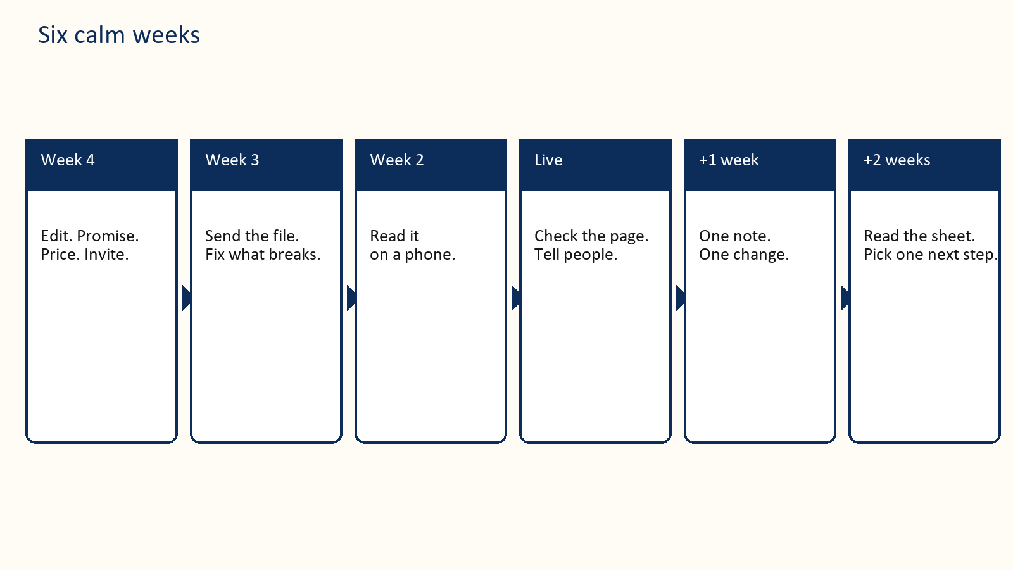
Four weeks before. Finish the edit that blocks a reader. Write the two reader sentences. Draft the first two description lines. Choose the price and write the keep. Set the total money you can lose. Invite advance readers only if the book is actually readable.
Three weeks before. Send the advance file. Fix anything the first readers cannot open. Prepare the cover only if it passes the thumbnail test.
Two weeks before. Read the ebook on your phone. Check headings, pictures, and the live price rules again. Create the KDP entries now if you have other books launching the same week, because KDP allows only two new titles per format each week. Do not send a review link before reviews can be posted.
Publication week. Open the live page yourself. Check the sample, the price, and the series link. Tell people who asked. Send the store link to advance readers when a review is possible. Write what you spent and what you kept.
One week after. Send the single gentle note if you promised one. Change at most one thing.
Two weeks after. Read the money sheet in chapter 14. Pick one next step: a clearer page, a capped test, a pause, or the first sentence of book two.
If you only have seven days and the book is already live, use them like this.
Day 1. Write the keep from KDP’s estimate.
Day 2. Rewrite the first two description lines.
Day 3. Thumbnail test. Fix the cover if the title fails.
Day 4. Pick two true categories and seven reader phrases.
Day 5. Read the sample on a phone and fix the first stuck point.
Day 6. Circle three money ideas from chapter 8. Date them.
Day 7. Fill the money sheet with this week’s real numbers, even if they are zero.
Put those seven days, or the six weeks, on a calendar today.

Chapter 12: When the book is already live
A slow book rarely explains itself. Find the first broken step. Fix that step. Leave the later steps alone for two weeks.
Nobody can tell what the book is. The title fails at thumbnail size, or the first two lines could describe any book. Fix the cover or the lines. Do not buy clicks to a page you would not understand yourself.
The right people never see it. Your categories are a giant shelf, or your phrases are words you like rather than words readers type. Change the shelf and the phrases. Give it two weeks.
People open the sample and leave. The front matter is a tunnel, or the promise on the page is not in the first chapter. Move the reader to the thing they came for. Fix the sample, not the ad budget.
People read and do not review. Some never will. Check that reviews are open. Send the one optional note from chapter 13 if you have not already. Then stop. A missing review is not proof you should discount the book to $0.99.
Several readers name the same flaw. Believe the pattern. Fix the book or the description. Do not argue in public. Do not ask for a new star rating. Old reviews can stay after you improve the file.
Sales happen and you still lose money. Separate the keep from the sticker. Subtract ad spend. A hundred sales at $0.35, minus a $60 ad, can be a loss. Pause the spend. Consider the $2.99 or $3.99 keep if the book is worth that price. Test the price by itself.
You are about to add a second ad, a second discount, and a new cover on the same day. Do not. You will learn nothing.

How you know the fix worked
Pick the number before you start the two weeks. Examples of a fair test, not targets you are owed:
The thumbnail. Two people who have not seen the cover can read the title on a phone.
The description. Two people can say who the book is for after the first two lines.
The price. You changed only the price, and the keep on the sheet is higher or lower for a reason you can say.
The ad. You stopped at the cap. Money kept is written next to money spent. You are allowed to stop.
If you cannot say the number in advance, you will talk yourself into another spend.
Before you spend, here are the example author’s three lines. Write your own beside them.
Keep: about $2.58 on the example mystery, unless the broken step is the price itself.
Reader: a gentle mystery, a small town, no gore. Not a thriller.
Date: change only the earliest broken step, and look in two weeks.
If one line is still blank, do not pay yet. Write the result on the sheet. Keep the change, or revert it.

Chapter 13: Words you can copy
Replace the brackets. These are your words to readers. Do not write their review for them.

Public invitation
I am inviting readers who enjoy [subject] to receive a free advance copy of [Title]. It is [one true sentence and about how long], planned for [date].
If it fits and you have time during [dates], you can ask for a copy here: [link]. An honest review later is welcome and optional. No star rating is requested. You can stop or say nothing.

Confirmation
Thank you for asking about [Title]. I plan to send the [format] file on [date]. Publication is planned for [date]. You can opt out at [how]. The free copy does not require a review.

Delivery
Your copy of [Title] is here: [link]. To open it, [steps you have tested]. If it fails, reply with what you see and I will help. I will send the store page when the book is live and reviews can be posted. A review is optional. Please do not pass the file on.

The live page
[Title] is available here: [link]. If you have read it and want to leave an honest review, use the review option on that page. Reviewing is optional. If you review, please mention that you received a free advance copy. Thank you for your time.

One follow-up
A last note about [Title]. If you finished and want to leave an honest review, the page is [link]. If you already did, thank you. If you would rather not, that is fine. I will not ask again about this book.

Inside the book
Thank you for reading. If you want to help another reader decide whether this book suits them, you can leave an honest review where you found it. It is optional. What you actually thought is the useful part.

First two lines you can adapt
For a novel: “[Name] wants [ordinary goal]. When [event] happens, they have until [deadline] to [action], without [cost they refuse to pay]. A [genre] for readers who want [three concrete tastes].”
For a guide: “This book helps [specific reader] do [specific job] without [the pain they already have]. You will leave with [the concrete thing: a price, a sheet, a plan]. It is a poor fit if you want [the opposite].”

Chapter 14: A filled money sheet
Copy this shape. The lines under each label are yours to fill. The numbers above them are the example author’s month, a teaching example, not a report.
Book: the example cozy mystery
____________________
Price: $3.99 in the example
____________________
Keep per sale: about $2.58 in the example
____________________
Copies you hoped for: 40. Hoped-for keep about $103.
____________________
Ad cap and stop date: $40, the 28th
____________________
Sales you would have had with no ad: 10
____________________
Actual paid copies: 22
____________________
Money kept, if each copy matched $2.58: about $57
____________________
Money spent: $40
____________________
Left after the spend: about $17
____________________
Editor and cover still unpaid: $600. Month one did not repay them.
____________________
Page reads: none. She is not in Select.
____________________
The one change: the ad, and nothing else
____________________
The day you look: two weeks. Do not raise the cap.
____________________
A useful sentence: “$3.99, keep about $2.58, ad stopped at $40, the cover is still unpaid. The description is the next test.”
A useless sentence: “Ads don’t work.” You know this month. You do not know ads.

Chapter 15: The Kindle file
The Word file is not what the reader sees. Open the preview. Read it on a phone with the type larger than you prefer.
The file has to meet the Kindle Publishing Guidelines. [9] Use real headings so the contents links work. Do not hide the only copy of a warning inside a picture. A picture needs words a screen reader can use. Do not rely on color alone. If a table becomes a smear on a phone, replace it with short lines.
Check the author name, title, subtitle, description, cover, categories, keyword boxes, countries, and price. Look at the converted file size and the royalty estimate. That estimate is the keep you should write on the sheet, in place of this book’s rounded examples, as soon as you have it.
KDP asks about AI each time you publish a new book or republish an edited one. Answer for what you actually did. Text, a cover, an interior picture, or a translation that an AI tool produced must be declared, even after heavy editing. Spelling checks, tightening, and brainstorming on your own writing need not be. Either way you are responsible for the content. Chapter 32 states the rule in full. [8]
Two more 2026 rules belong on the same checklist. Since 21 September 2026, KDP lets you create only two new titles per format each week: two ebooks, two paperbacks, and two hardcovers, reset every Sunday at midnight UTC. A book in three formats uses one slot in each. Editing a live book does not count. Plan the launch week around it. [11] And the DRM box now matters more. Since 20 January 2026, if you publish without DRM, a verified buyer can download the book as EPUB and PDF. Choose that on purpose. [12]
Have one other person open the ebook, jump to a chapter, follow one example, and come back to the contents. Do not announce the book until that person can move through it without you in the room. A return takes the keep back.

Where to go next
That is the whole short road. Parts II to VIII take each step apart with the full arithmetic: the royalty plans line by line, the keyword and category fields, launch week, ads, taxes, KDP Select against going wide, the traps, the catalog, the review problem in depth, and using AI without losing the business. Read them in order, or jump to the chapter that matches the line on your keep sheet that is still blank.

Part II — The Landscape

Before the Full Guide
Part I walked one book through one month with rounded numbers and one action per chapter. The full guide covers the same ground again, slower and in production order: the landscape and the money (Part II), making the book (Part III), getting it found (Part IV), the business plumbing (Part V), the long game (Part VI), and two topics in depth, reviews and AI (Parts VII and VIII). Where Part I already gave a rule in full, the chapters here point back to it rather than repeat it.
The full guide makes you one promise: every number in it comes with the arithmetic attached. When it says a 70% royalty, it shows you what’s subtracted before that 70% ever reaches your account. When it says a category trick works, it tells you which part is a documented KDP mechanism and which part is a reasonable-but-unverifiable inference about how the algorithm behaves. When a chart is illustrating a shape rather than a disclosed statistic — a pricing curve, a launch-week effect, a backlist compounding over years — its caption says so, in words, on the chart itself. Nobody selling you a course about “the Amazon algorithm” actually has its source code, and a book that pretends otherwise is the first warning sign covered in Chapter 28.
Say the goal plainly, since the title already does: the point of everything that follows is making real, durable money from what you publish, not admiring the craft of publishing for its own sake. Most of what actually stands between a finished manuscript and real income isn’t talent — it’s a specific, learnable set of hurdles: an empty review section that makes cold traffic distrust an otherwise good page, a price picked by guesswork instead of arithmetic, a category chosen for ego instead of visibility, a scam that extracts money before the book has sold a single copy, a first year of income too thin to notice before the compounding in Chapter 29 has a chance to start. Every chapter ahead exists to get you past one specific hurdle on that list, in order, not to make you a more refined hobbyist.
That distinction matters because self-publishing has two very different reputations. To one crowd, it’s the most honest deal in publishing: no gatekeeper, a royalty rate three to seven times what traditional trade publishing pays, and a payment that lands every month for as long as the book sells. To another crowd, it’s a swamp of “publish a book in a weekend with AI” grifters, hybrid presses that charge new authors thousands of dollars for what a KDP account gives away free, and get-rich-quick threads that quietly stop posting income updates once the truth sets in. Both reputations are earned. The mechanics in this book are the same mechanics the grifters misrepresent — the difference is entirely in whether you use them to publish something worth reading, priced and positioned honestly, or to flood a category with noise until Amazon’s own enforcement catches up with you.
Who this book is for: someone who either has a manuscript already, or is willing to write one, and wants the business of getting it in front of buyers explained without a sales pitch at the end of every chapter. It is not a writing-craft book — Chapter 19 touches revision because revision is where most self-published books actually lose readers, but it will not teach you plot structure or sentence rhythm. It is not a get-rich-quick book either. Chapter 30 is blunt about what a realistic first year looks like, and it is not a yacht.
One more thing before Chapter 16: everything downstream of “click Publish” — categories, keywords, price, ads, reviews — only works on a book someone actually wants to finish. No amount of keyword research rescues a book that doesn’t deliver on its own cover promise. Keep that in the back of your mind through every chapter that follows; it is the one piece of advice in this book that was true before Amazon existed and will still be true after whatever replaces it.

Chapter 16: Why Self-Publish
Publishing a book used to mean convincing a gatekeeper. You wrote a query letter, an agent said yes or (nineteen times out of twenty) no, the agent pitched editors, an imprint offered a contract, and eighteen months to two years later a book appeared in stores — assuming nothing fell through along the way, which it often did. That path still exists, it still confers real prestige and real distribution, and for some books it’s still the right choice. It is also not the subject of this book.
Self-publishing through Amazon’s Kindle Direct Publishing (KDP) collapses that entire chain into: you upload a file, you set a price, and roughly 24–72 hours later the book is for sale, worldwide, with no one’s permission required but your own. That is either the best thing to happen to writers in a century or a flood of unedited noise, depending on which corner of the internet you ask, and the honest answer is that it’s both — the barrier to publishing dropped to zero, and the barrier to publishing well did not move an inch. This book is about the second barrier.

The three doors, and what each one actually costs
Traditional publishing. An advance (increasingly modest for all but lead titles), a royalty typically in the 7–25% range depending on format and figured off list or net price depending on the contract, professional editing and distribution you don’t have to arrange yourself, and a timeline measured in years. You give up pricing control, cover approval is often just consultation, and rights can be tied up for the life of copyright unless the contract reverts them. For a debut author with no platform, traditional deals have also gotten harder to land, not easier — imprints increasingly want an existing audience before they’ll bet on a book.
Hybrid and vanity publishers. A company offers to “publish” your book for a fee — sometimes a few hundred dollars, sometimes tens of thousands — providing some mix of editing, cover design, formatting, and distribution. Some hybrid presses are legitimate and transparent about exactly what they charge for and why. A great many are not: they charge premium prices for services (an ISBN, an ebook conversion, a KDP upload) that cost nothing or almost nothing to do yourself, and they lean on a new author’s uncertainty about the process to make “free” look like “expensive.” Chapter 28 covers how to tell the two apart before you sign anything.
Self-publishing. You are the publisher. That sentence is doing a lot of work, and it cuts both ways: no one is stopping you, and no one is helping you either, unless you hire the help yourself. In exchange, KDP pays a 70% royalty on ebooks in the standard price band (Chapter 17 shows the exact arithmetic) against traditional publishing’s single-digit-to-teens net royalty, keeps your rights entirely in your own hands, lets you change a price or fix a typo the same afternoon you notice it, and puts the book for sale before a traditional deal would have finished its first round of submissions. The cost is that editing, cover design, formatting, categories, keywords, pricing, launch, and advertising are now your job — either your own labor or money you spend hiring someone else’s. Every chapter after this one is one piece of that job, done properly instead of guessed at.

Why “self-published” stopped meaning “unedited”
A decade ago “self-published” was near-synonymous with “unedited, badly formatted, amateur cover.” That reputation is dying slowly, for a specific reason: the authors making real money at this treat it like the small business it is. They hire editors. They commission or carefully design covers that meet genre and category conventions. They track royalty reports the way any business owner tracks a P&L. Amazon’s own bestseller lists are now thick with self-published authors who outsell most traditionally published midlist titles, precisely because they run the operation professionally rather than treating “self-published” as a license to skip the parts of publishing that were never actually optional.
Key takeaway: Self-publishing removes the gatekeeper, not the job. It trades a publisher’s cut and a publisher’s timeline for a publisher’s workload. Whether that trade pays off depends entirely on how well you do the job in the chapters ahead — not on the platform, which is free and identical for every author who uses it.
Every chapter from here on is one stage of a single pipeline. It’s worth seeing the whole shape before diving into the first piece of it:
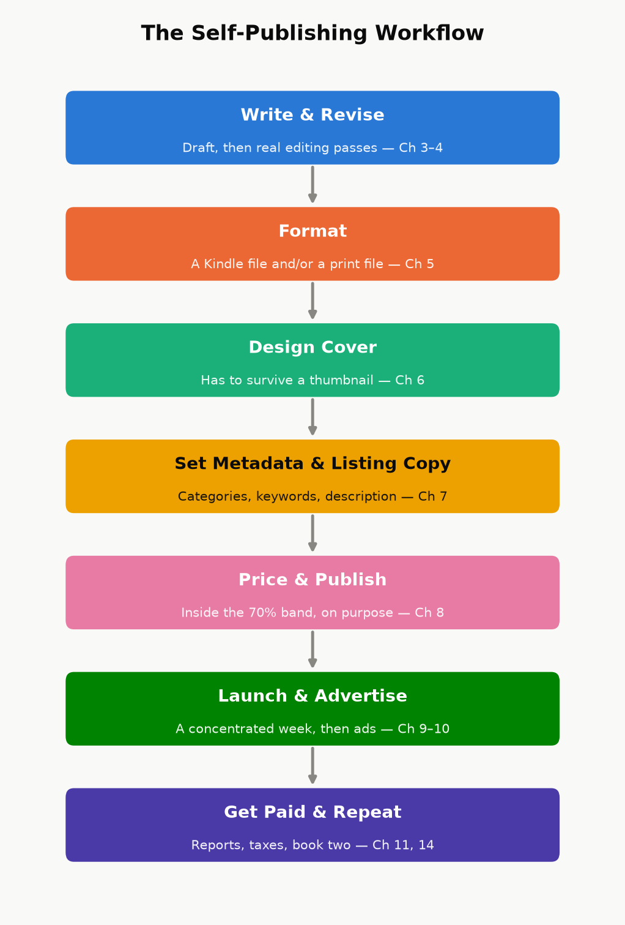
Figure 16.1 — The self-publishing workflow this book walks through, one chapter at a time. Nothing here is optional; skipping a stage just means finding out about it later, from a review or a royalty report instead of from this book.

A note on doing both
These paths aren’t mutually exclusive across a career, or even across a single book — some authors self-publish a series to prove it sells, then use that sales data to land a traditional deal for future volumes; others go the other direction, getting rights reverted on an out-of-print traditionally published backlist title and re-publishing it themselves. Nothing in this book requires you to pick a side forever. It requires only that, for the books you do self-publish, you treat the business side with the same care you’d want from a publisher you were paying to do it for you.

Chapter 17: How Amazon Actually Pays You
Before categories, before keywords, before a single dollar of advertising — you need to know what a sale is actually worth to you, in real currency, after Amazon’s cut and its fees. Almost every downstream decision in this book (what to price the book, whether an ad is profitable, whether Kindle Unlimited is worth joining) is a variation on the arithmetic in this chapter. Get this part wrong and every later chapter inherits the error.

The ebook royalty: two plans, one cliff
KDP offers two ebook royalty plans, and — this trips up a lot of new authors — which one you get is determined automatically by your list price, not chosen as a marketing strategy:
70% royalty, available when your list price falls within the plan’s price band for that marketplace (as of this writing, $2.99–$12.99 in the US store — expanded from a $9.99 ceiling that had stood since 2007, effective July 2026 — with corresponding bands in other currencies), after a delivery fee based on the file’s size — about $0.15 per megabyte in the US store — is taken off the list price. The 70% applies to what is left: 0.70 × (list price − any VAT − delivery), the same formula Chapter 3 uses. This plan also carries a “don’t undercut yourself” rule: KDP can decline the 70% rate if you’re offering the same book for less somewhere else. The expansion is opt-in for existing titles: a book already priced between $10 and $12.99 stays on the 35% plan until you go into Rights & Pricing and switch it by hand — the wider band doesn’t apply itself.
This number will move again. The ceiling sat at $9.99 for nineteen years before this book was written, then changed. Every dollar figure in this book is a snapshot, not a law of nature — KDP changes royalty splits, price bands, and delivery-fee rates on its own schedule, with no obligation to announce it loudly. Check the current numbers on KDP’s own Pricing Page before you act on anything in this chapter; if it disagrees with a number printed here, KDP is right and this book is out of date.
35% royalty, available at any price from $0.99 up to $200, with no delivery fee subtracted. This is the only plan available outside the 70% price band — price a book at $1.99 or $13.99 and you’re on 35% automatically, whether you meant to be or not.
That’s the cliff: price one cent outside the 70% band and your royalty rate doesn’t taper, it drops by half. A worked example makes the stakes concrete.
Worked example. A 350-page ebook, about 2 MB as Amazon converts it, priced at $4.99, no VAT:
At 70%: delivery is 2 MB × $0.15 = $0.30, taken off first, so 0.70 × ($4.99 − $0.30) ≈ $3.28 per copy, the same keep as the $4.99 line in Chapter 3.
At 35% (say the author instead priced it at $2.49, just under the band): $2.49 × 0.35 = $0.87 per copy — with no delivery fee to subtract, but also less than a third of the higher price’s payout.
Pricing $2.50 lower cost this author roughly $2.41 per sale, not $0.87. That gap is the whole reason Chapter 23 spends as much time on pricing psychology as it does — the 70% band isn’t a suggestion, it’s where almost every nonfiction ebook in this genre should live unless there’s a specific reason not to.
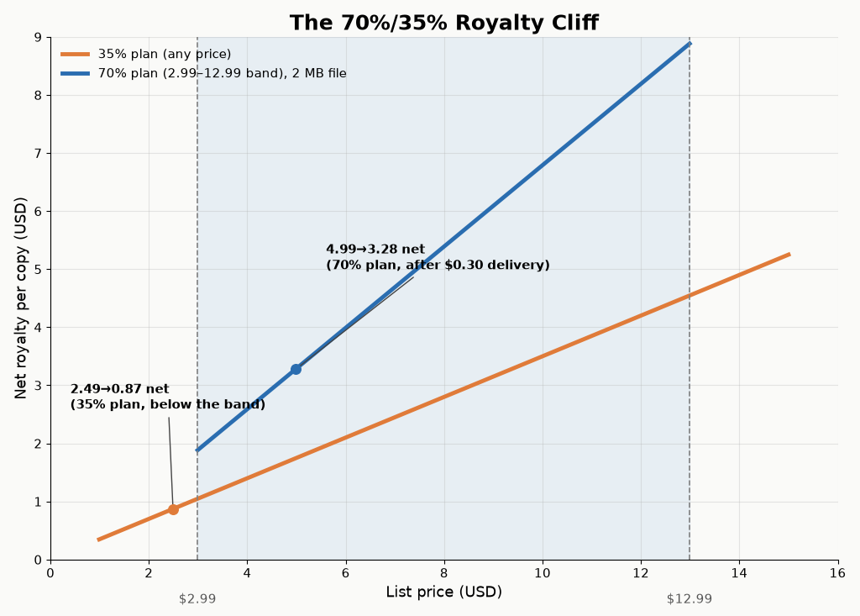
Figure 17.1 — Net author royalty per copy at each price point. The step at $2.99 and the ceiling at $12.99 are the 70%-plan boundaries; everything outside that band falls back to the flat 35% line.

Kindle Unlimited and the page-read fund
If you enroll a book in KDP Select (Chapter 27 covers the exclusivity trade-off that comes with it), it becomes available to Kindle Unlimited and Kindle Owners’ Lending Library subscribers, and you’re paid not a royalty per “sale” but a per-page rate out of a shared monthly fund — Amazon sets aside a pool of money each month and divides it by the total normalized pages read across all Select books. The per-page rate therefore moves slightly every month; it has historically sat in the range of roughly $0.004–$0.005 per page (KDP announces the exact figure after each month closes, in your Reports dashboard). Pages are counted using Amazon’s own KENPC (Kindle Edition Normalized Page Count) standard, not your Word document’s page count, so formatting choices — font embedding, image sizing, front-matter bloat — can shift your page count even though the words didn’t change.
Worked example. A 300-KENPC-page book fully read by one subscriber, in a month where the fund pays $0.0045/page: 300 × $0.0045 = $1.35 for that one full read — comparable to, sometimes less than, a single 70%-royalty sale, but earned from a reader who might never have paid $4.99 up front. Whether that trade is good for your book is exactly the question Chapter 27 answers.
For a sense of scale with a real book instead of a round number: this book runs about 33,700 words. Amazon doesn’t publish its exact KENPC formula, but the figure self-publishers have reverse-engineered by comparing known word counts against observed KENPC values clusters around 250 words per normalized page — which would put this book at roughly 135 KENPC pages, and one full Kindle Unlimited read of it at around $0.60 at the rate used above. Treat that as an estimate, not a receipt; the point is that a word count and a KU payout are the same number wearing different clothes.

Print: paperback and hardcover
Print royalties don’t use a percentage-of-price plan the way ebooks do; they use a formula:
Royalty = (List Price × Royalty Rate) − Printing Cost
Paperback, sold through Amazon’s own store: 60% royalty rate at a list price of $9.99 or more on Amazon.com, 50% below that (Chapter 3 works both cases; other marketplaces set their own dividing line).
Paperback through expanded distribution (third-party retailers, bookstores, and libraries KDP can place the book with beyond Amazon itself): 40% royalty rate — the same list price, a smaller share, and worth checking on a book-by-book basis whether it’s worth opting into.
Hardcover: also a 60% royalty rate minus printing cost, sold through Amazon’s own store.
Printing cost is not a number you pick — KDP calculates it from page count, trim size, ink type (black-and-white vs. color interior), and paper choice (standard white vs. cream), and it recalculates automatically if you change any of those. Use KDP’s own price calculator when you’re setting a print list price; don’t estimate the printing cost by hand, and don’t set a list price without checking that royalty ends up positive — it’s possible to price a heavily illustrated color paperback so low that KDP’s own calculator shows a negative or near-zero royalty at that price.
Key takeaway: A royalty rate is not a profit margin. It’s the number Amazon subtracts its own costs from — delivery fees for ebooks, printing costs for paperback and hardcover. Your actual per-copy profit is always smaller than the headline percentage, and every pricing decision later in this book starts from the real number, not the advertised one.

Reading your own numbers
Everything above is policy, which changes; your KDP Reports dashboard is fact, which doesn’t. Chapter 26 explains which of its reports to trust for what. Get in the habit of reading them weekly during a launch and monthly afterward — they are the only source in this entire book that’s about your book specifically rather than the platform in general, and every other chapter’s advice should eventually show up as a change in these numbers.

Part III — Writing and Producing the Book

Chapter 18: Choosing What to Write
“Write the book only you can write” is lovely advice and a poor business plan on its own. The books that make good money on Amazon sit at the intersection of two circles: something you can actually write well, and something a large enough group of people are already actively trying to buy. This chapter is about finding that intersection using Amazon’s own storefront as a research tool, instead of guessing.

Amazon is a market-research tool you already have access to
You do not need paid keyword-research software to start. Amazon shows you demand directly, if you know where to look:
Browse the category you’re considering (not just the top-level genre — drill into the specific subcategory) and look at the current Best Sellers and Hot New Releases lists, not just the all-time top 100. All-time lists are survivorship-biased: they show you what won years ago, not what’s selling now. Hot New Releases shows recent books that are already gaining traction — a much better signal of live demand.
Check review count relative to publication date. A book with 4,000 reviews published eight years ago tells you the category has (or had) demand; a book with 300 reviews published four months ago tells you demand exists right now and a new entrant can still compete for it.
Look at who’s publishing in the category. A subcategory dominated by three or four publishers with decades of backlist is a hard room to enter. A subcategory full of single-book authors and recent, thin catalogs is fragmented — easier to be noticed in, though sometimes fragmented because the actual demand is smaller than it looks.
Read the one- and two-star reviews on the current bestsellers in your topic, not the five-star ones. Five-star reviews tell you the book worked; one- and two-star reviews tell you exactly what it left out, explained by someone who wanted it to be there. That gap is your outline.
Worked example. Applying all four checks to one hypothetical category — a beginner’s guide to a specific hobby:
Best Sellers vs. Hot New Releases: the all-time top 20 are dominated by three books published 6–10 years ago, each with 8,000+ reviews. Hot New Releases for the same category shows two books published in the last 90 days already at 40–60 reviews — live demand, not fossilized demand.
Review count vs. publication date: one of those new entrants has 55 reviews after 10 weeks, roughly 5–6 a week — livelier than the older incumbents, who now average under 20 a week each.
Who’s publishing: four different single-book authors published in the last 18 months sit alongside the three long-established incumbents in that top 20 — fragmented, not a closed shop.
One- and two-star reviews on the incumbents: a specific complaint — no troubleshooting section for humid climates — recurs across dozens of reviews on all three bestsellers, and none of them has fixed it.
None of that guarantees a sale. It tells you the category has live buyers, room for a new entrant, and one specific, checkable gap a new book could lead with in its own subtitle and description (Chapter 22) — the difference between “I think people want this” and “here’s what twenty minutes of browsing this exact category actually showed me.”

Write to a shelf, not into a void
Publishers call this “writing to a shelf” — knowing, before you write a word, which existing shelf your book would sit on, and what a reader browsing that shelf already expects. It sounds like it constrains creativity; in practice it’s the opposite of chasing a trend. Trend-chasing means noticing something is popular this month and racing to publish before the wave passes — by the time a trend is visible on Amazon’s charts, a meaningful number of other authors have already seen it too, and the category fills up fast. Writing to a shelf means picking a category with durable, structural demand (a persistent problem, a persistent hobby, a persistent stage of life) and writing the best specific answer to a specific reader’s specific question, rather than the broadest possible book that vaguely covers a popular topic.
Key takeaway: “Broad audience” and “big audience” are not the same thing. A book explicitly written for one clearly defined reader — a specific skill level, a specific goal, a specific constraint — usually outsells a book written to appeal to everyone, because the specific book’s cover, title, and sample pages all signal “this is for you” to the reader who actually needs it, instead of asking a general browser to self-select from vague language.

Standalone economics vs. series economics
A standalone book earns once per reader. A series earns on read-through — a reader who finishes book one and buys book two, three, four without any new marketing spend from you at all, because Amazon’s own “customers who bought this also bought” and “next in series” placements do the selling. This is the single biggest lever available to a self-published author with a limited budget: a five-book series with modest per-book sales and strong read-through routinely outearns a single book that sold as many total copies, because the series compounds — every new reader of book one is a prospective buyer of the other four, indefinitely, with no additional ad spend required. This applies to nonfiction too: a “beginner,” “intermediate,” and “advanced” set on the same topic, or a set of books that each solve one piece of a larger problem, gets the same compounding effect fiction series get from cliffhangers.
None of this is a substitute for writing something good. It’s the difference between writing something good into a category with active buyers and writing something equally good into a category nobody is currently searching. Both take the same effort to write; only one reliably gets found.

Chapter 19: From Draft to Manuscript
A finished draft and a finished manuscript are not the same object, and the gap between them is where most self-published books lose readers — not at the idea stage, and not usually at the sentence-craft stage, but in the unglamorous work of catching the errors, gaps, and inconsistencies that a single read-through by the person who wrote it will never catch, because that person already knows what they meant to say.

The passes, in order
Developmental — is the structure right? Does the argument (nonfiction) or the plot (fiction) actually hold together, in the right order, with nothing important missing and nothing redundant?
Line edit — does each paragraph read well? Is the voice consistent? Are explanations at the right level for the stated audience?
Copyedit — grammar, consistency (character names, spelled-out numbers vs. numerals, capitalization rules, a style choice applied the same way everywhere), and fact-checking any claim a reader could look up and check.
Proofread — the final pass, done on the manuscript in its near-final formatted state, catching typos, double spaces, and formatting accidents introduced by the editing process itself.
These are genuinely different skills, and treating them as one pass — “I’ll just read it again” — is the most common reason a self-edited book feels “almost professional” instead of professional. If you can only afford to hire one of these out, hire the copyedit; it catches the errors a reader notices consciously (“that’s a typo”) rather than the ones they only feel (“something about this felt amateur”).
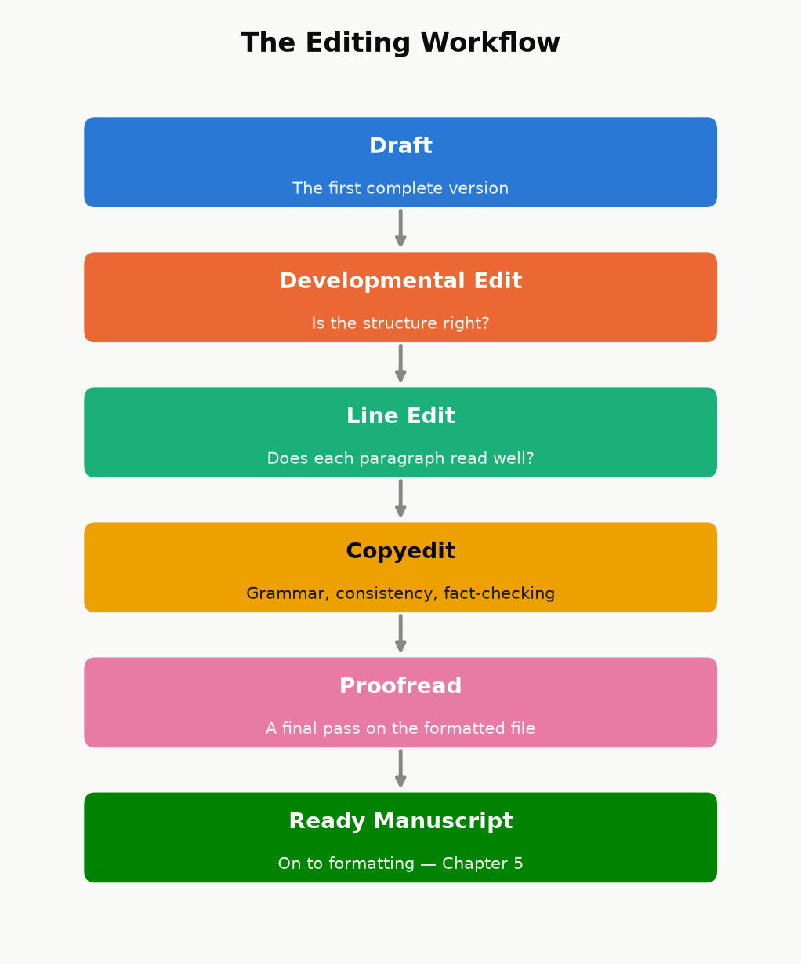
Figure 19.1 — Four genuinely different passes, run in order, ending in a manuscript that’s actually ready for Chapter 20 — not four names for the same read-through.
Illustration: what “professional-grade” editing looks like in practice. Picture a long technical handbook put through three separate review passes after its first “complete” draft — each one briefed to hunt for what the previous pass missed rather than re-check settled items, and each one re-deriving every worked numerical example from scratch rather than trusting the displayed answer. A process like that keeps finding a fresh batch of real problems on every pass: arithmetic errors, a claim that quietly contradicts the book’s own formula two paragraphs earlier, cross-references pointing at the wrong chapter after a renumbering, and sometimes a fix from an earlier pass that introduced a new, smaller inconsistency of its own. A mechanical sweep is a different tool again: a simple search for overused qualifier words — “roughly,” “essentially,” “itself” — appearing twice on the same page can turn up dozens of repeats in a cookbook or a memoir that a normal read-through sails past every time, because a reader’s eye and a targeted script are looking for different things. The lesson isn’t “hire three editors” if your budget doesn’t allow it — it’s that the errors still in your manuscript after one careful read are, almost by definition, the ones a normal read doesn’t catch. Budget at least one pass that is specifically not just reading the book again: a fact-check pass, a consistency script, a reader who has never seen the manuscript before.

Where AI genuinely helps, and where the line is
Used well, AI tools can speed up the unglamorous parts of this process: a first-pass consistency check across hundreds of pages, generating several alternative phrasings of an awkward paragraph for you to choose between and rewrite, condensing research notes, or catching a subset of the kind of mechanical errors described above. Used badly, it becomes the entire book — a prompt, minimal human review, and a KDP upload — and readers have gotten noticeably better at spotting the tell-tale flatness of that approach, which shows up in review sections as a specific and damaging complaint.
Two things are not optional, regardless of how much AI assistance you use in your process:
Amazon requires disclosure. KDP’s publishing questionnaire asks you to declare whether a title contains AI-generated text, images, or translation, and misrepresenting that is a content-policy violation, not a gray area. Answer it honestly.
A human has to be the last editorial judgment. Whatever tools condense, draft, or suggest, the decision that a sentence is accurate, that an example is correct, and that a chapter says what you actually mean has to be made by a person who is accountable for it — which in practice means the fact-check and consistency passes above are not optional just because a tool helped write the first draft.
Chapter 32 covers AI’s use elsewhere in the business (covers, ad copy, keyword research), states the disclosure rule in full, and names a specific process — condensing existing books and auditing the result until it no longer resembles them — that is not the same thing as what this section describes.

A minimum revision checklist
If you do nothing else before publishing, do these:
Read it aloud, or have text-to-speech read it to you. Your ear catches rhythm problems and repeated words your eye slides past.
Check every number and every cross-reference. “As shown in Chapter 19” needs to actually be Chapter 19, still, after every reorganization.
Run one adversarial pass. Read it once specifically looking for ways to be wrong — a claim you can’t actually back up, a promise the book doesn’t deliver on, a contradiction between an early chapter and a later one.
Get at least one outside reader who has never seen the manuscript before, and ask them specifically where they got confused or bored, not just whether they “liked it.”

Chapter 20: Formatting That Doesn’t Break Kindle
Ebook formatting and print formatting are not the same job wearing two hats — they solve different problems, and treating one file as automatically correct for both formats is where a lot of self-published books develop avoidable, embarrassing bugs (a page-number reference in a book with no fixed pages, a table of contents with no working links, a paperback with no page numbers at all).

Ebooks: let Kindle do the navigation
A Kindle reader can change font size, font, and line spacing, which means your ebook has no fixed pages — “page 47” means something different on every device and at every font size a reader might choose. Two consequences follow directly:
Don’t build a page-numbered table of contents. It cannot be accurate, because there are no fixed pages to number. Kindle instead builds its own “Go To” navigation menu automatically, directly from your document’s Heading 1 / Heading 2 paragraph styles — which is why using real heading styles (not just bold, oversized text that merely looks like a heading) is the single most important formatting choice in the whole manuscript. A plain-text contents listing (titles only, no page numbers, the way this book’s own front matter does it) is a nice reader convenience on top of that, not a replacement for it.
Skip the index. A print index maps terms to page numbers; without fixed pages, that mapping is meaningless. If a reference title needs a true, searchable index, that’s a signal to route it through print rather than positioning it as a Kindle-only reference work.
Beyond headings, keep ebook formatting deliberately plain: standard paragraph styles, images sized to look correct at typical device widths rather than at one specific screen size, and no fixed-width text boxes or multi-column layouts, which most reflowable Kindle formats handle poorly. Kindle Create (Amazon’s free formatting tool) or a clean Word document with correctly applied heading styles both get you there; what matters is the underlying structure, not which tool produced it. Before you publish, use KDP’s own online previewer and check the book on more than one simulated device size — a layout that looks fine on a tablet-width preview can crowd an image awkwardly on a phone-width one.

Print: everything the ebook didn’t need
A paperback or hardcover interior needs the things the ebook explicitly skipped, plus a few of its own:
A real, page-numbered table of contents — because print pages are fixed, this one actually works, and readers expect it.
Page numbers and (usually) running headers, placed and styled consistently throughout.
Front matter in the conventional order: title page, copyright page, optional dedication, table of contents, then the body — readers of print nonfiction expect this shape, and deviating from it reads as amateur even when nothing is technically wrong.
A trim size choice. 6”×9” is the most common choice for nonfiction — large enough to keep line lengths comfortable, small enough to print economically — with 5.5”×8.5” a common alternative for shorter, more portable guides.
Margins that account for the gutter — the inner margin needs extra room so text isn’t swallowed by the binding, especially as page count grows.
Bleed, only if something touches the page edge. A book with no full-bleed images or background color doesn’t need a bleed margin at all; add one only for pages that actually require it.
Spine width and cover dimensions calculated by KDP’s own cover template tool, not by hand. Spine width depends on exact page count, trim size, paper color (white vs. cream), and interior ink (black-and-white vs. color) — four variables that make hand-calculating it a good way to order a cover that doesn’t fit.
A physical proof, ordered and actually read, before you hit publish. Screen previews miss things — color that renders differently in print, a margin that looked fine on screen but crowds the gutter, a font substitution — that only show up in your hands.
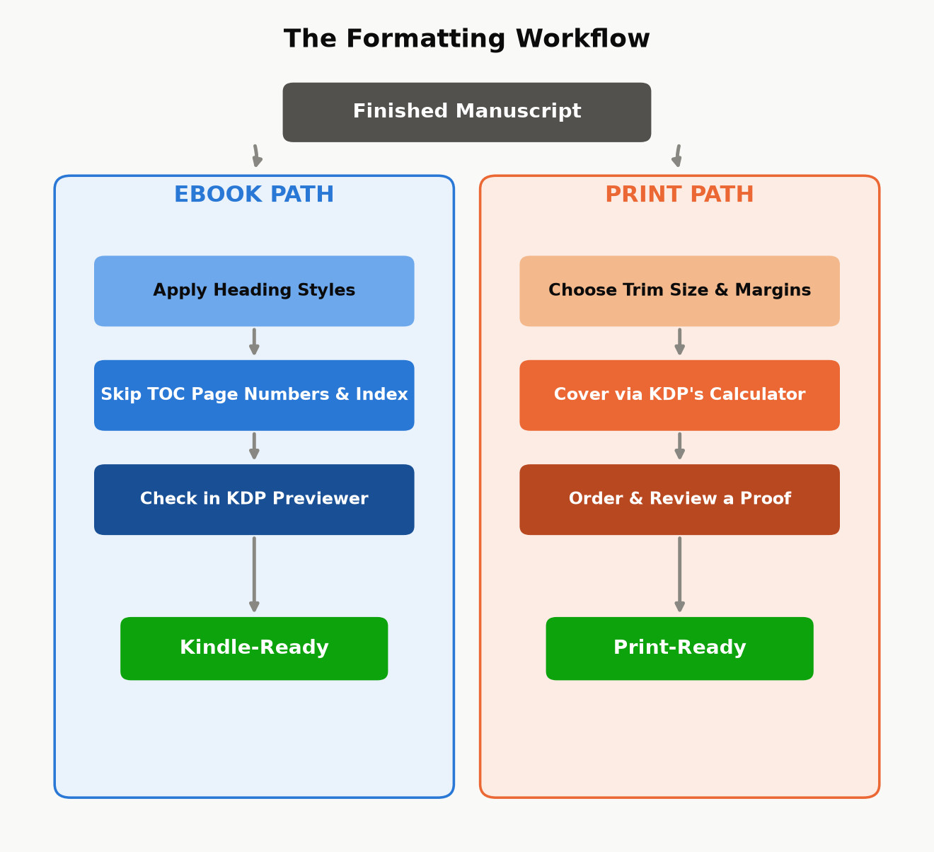
Figure 20.1 — The same finished manuscript, two different finishing workflows. They diverge immediately, and “did the ebook steps by habit on the print file” (or vice versa) is exactly the kind of avoidable bug this split is meant to prevent.
Key takeaway: Format for the reader’s actual device, not for how the manuscript looks in your word processor. An ebook formatted like a Word printout (fixed page-number references, a dead table of contents) looks broken to a Kindle reader; a paperback formatted like a webpage (no page numbers, no running headers) looks unfinished to a print reader. Same words, two different finished products.

Chapter 21: Covers That Sell in a Thumbnail
A cover has one job before it has any other job: survive being shown at roughly the size of a postage stamp. Almost every place a shopper actually encounters your book for the first time — search results, a “customers also bought” carousel, a category browse grid — shows it small, often under 150 pixels wide, often on a phone screen, often for under a second before the shopper’s eye moves on. A cover that looks stunning full-screen and unreadable as a thumbnail has failed at its actual job, no matter how good the artwork is.

The thumbnail test
Before you finalize any cover — yours or a hired designer’s — shrink it down to actual thumbnail size and look at it from a normal viewing distance, not zoomed in on your monitor. Ask three questions:
Can you read the title at that size, at a glance, without leaning in?
Does the genre or category read correctly at a glance — does a business book look like a business book, a thriller like a thriller — even with no ability to read the small print?
Is there one clear focal point, or does the eye not know where to land?
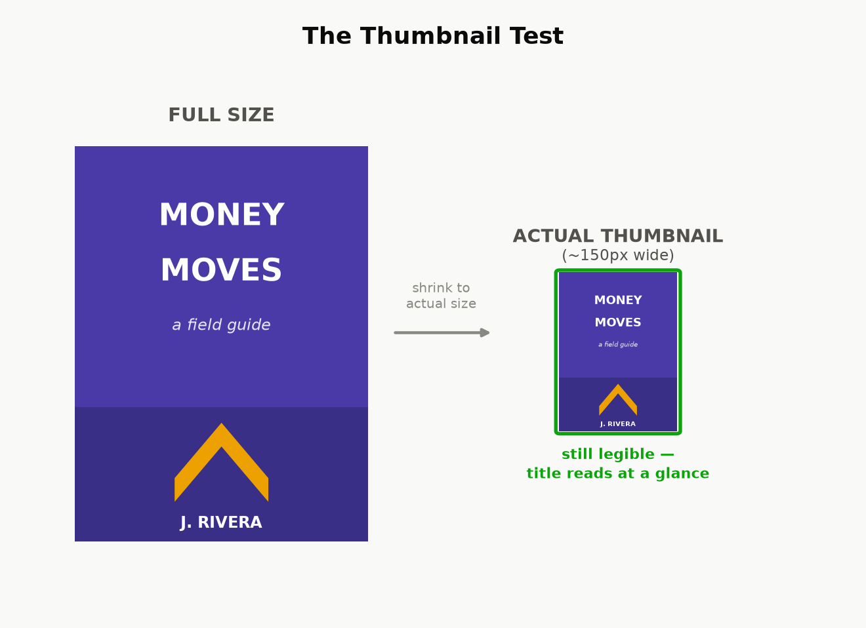
Figure 21.1 — The same cover concept at full size and at the size a shopper actually sees it first. Details that read fine large enough often disappear entirely at thumbnail size — check at the smaller size, not the larger one.

Genre conventions exist because readers use them
A reader scanning a category page is pattern-matching, not reading — they’ve learned, from years of browsing, what a thriller cover looks like versus a cozy mystery, what a business book looks like versus a memoir. This isn’t a creative constraint to fight; it’s a communication channel to use. A cover that deliberately breaks convention can work, but only as a calculated choice made after you understand what you’re breaking from — breaking convention by accident, because you didn’t research what similar, successful books in your exact category actually look like, just reads as confusing rather than distinctive. Before commissioning or designing a cover, pull up the current bestsellers in your specific subcategory and note what they share: color palette conventions, typography weight, how much of the cover is imagery versus type, where the author name sits relative to the title.

Hierarchy: title, subtitle, author — in that order, usually
For most nonfiction, the reading order a cover should guide the eye through is: title first (the hook), subtitle second (the specific promise — for nonfiction, the subtitle is doing real advertising copy work, not just decoration; it’s where “learn to play piano” becomes “learn to play piano in 30 days with no prior experience”), author name last, unless you’re already a known quantity in the category, in which case your name can carry as much weight as the title. Don’t split attention evenly across all three — a cover where the title, subtitle, and author name are all the same visual weight gives the eye nowhere obvious to start.

DIY, template, or hire — and what each actually costs
KDP’s built-in Cover Creator produces a serviceable, template-based cover for free. It is recognizable as a template to anyone who’s seen a few of them, which is a real cost even though the dollar cost is zero — fine for testing an idea, rarely the right choice for a book you’re investing real marketing effort behind.
Template marketplaces and freelance platforms (pre-made cover templates customized with your title, or a freelancer working from a brief) typically run from double digits to a few hundred dollars and can look genuinely professional if you choose a template built for your actual genre and category, not just one that looks nice in isolation.
A dedicated cover designer, especially one who already works in your specific category, costs more — often several hundred dollars and up — but understands the genre conventions above without being told, and is usually the best return on investment for a book you expect to actively market, because the cover is one of the few assets that keeps working for you on every single impression, for free, for as long as the book is listed.
Whichever route you take, run the finished cover through the thumbnail test above before you commit to it — it’s the cheapest quality check in this entire chapter, and the one most often skipped.

Part IV — Getting Discovered

Chapter 22: Categories, Keywords, and Your Product Page
A shopper finds your book two ways: searching for it directly, or browsing a category and encountering it. Keywords control the first path, categories control the second, and both are set from the same KDP upload screen in about five minutes — which is exactly why they’re worth doing carefully instead of on autopilot. This is the cheapest, highest-leverage discoverability work in the entire book, because it costs nothing and takes effect immediately.

The seven keyword slots
KDP gives you seven keyword fields, each accepting a phrase of up to fifty characters. Three rules make the difference between slots that work and slots that are quietly wasted:
Use full phrases, not single words. A slot can hold “budgeting for freelancers with irregular income,” not just “budgeting” — and a specific phrase matches how people actually type search queries far better than any single generic word does. A single word also wastes the other forty-plus characters of space you were given.
Don’t repeat words already in your title, subtitle, or series name. Amazon already indexes those for search; a keyword slot spent repeating “budgeting” when your title already contains “budgeting” is a slot doing no new work at all. Spend every slot on a phrase your title doesn’t already cover.
Never use another author’s name, a competing book’s title, or a trademarked term you don’t own, even though it’s technically possible to type one into the field. This is a KDP content-policy violation, not a gray-area growth hack, and it risks the listing itself, not just the keyword.
Where do the actual phrases come from? The single best free source is Amazon’s own search bar: start typing a query a real customer might type — “how to self-publish,” “self-publishing for” — and read the autocomplete suggestions. Those are real, aggregated queries other shoppers have actually typed, which makes them a far better source than guessing. Reading the “Look Inside” blurb language and the customer-review wording on the current bestsellers in your category is a second free source — readers often describe a book using different words than the author chose for the title, and those reader words are exactly what future readers will search.
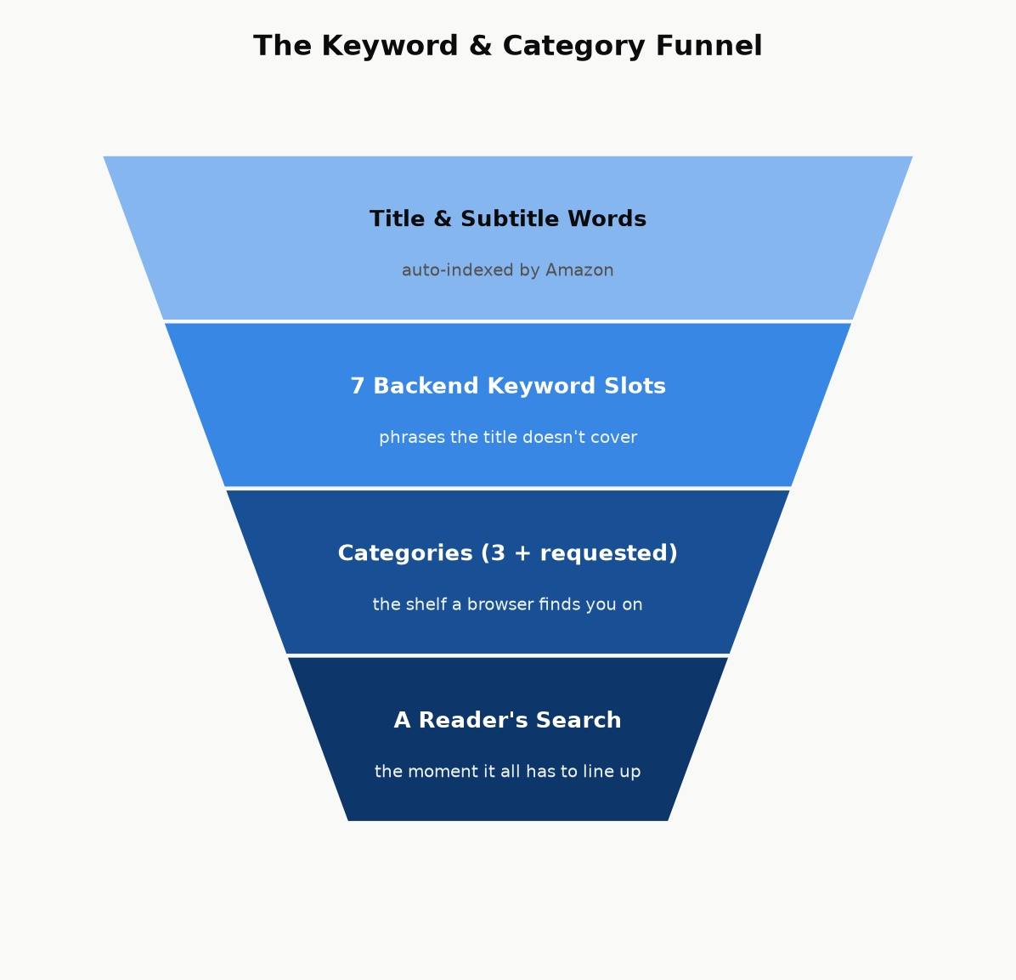
Figure 22.1 — Discovery is a funnel: your title and subtitle are indexed automatically, seven backend keyword slots extend that coverage to phrases the title doesn’t use, categories place you on the right shelf, and all of it only pays off if it matches what a real shopper actually types or browses for.

Categories: pick the smallest room you actually belong in
At upload, KDP lets you choose up to three browse categories from Amazon’s BISAC-based category tree. The instinct to pick the biggest, most prominent category (“Business & Money”) is usually a mistake — it’s an enormous room where you’re competing against every business book on Amazon for attention. The more specific leaf category you can honestly claim (“Business & Money → Small Business & Entrepreneurship → Home-Based Businesses,” for instance) is a much smaller room, which means a given level of sales velocity moves you much further up its charts — including, for a genuinely small category, potentially far enough to earn an “#1 Best Seller” orange tag, which is itself a credibility signal that helps convert future browsers.
Amazon’s full category list is considerably longer than the three slots exposed in KDP’s own self-service picker, so choose your three with real care at upload rather than treating the choice as a draft you’ll casually widen later. More generally, whatever question or problem comes up anywhere along the way — categories included, but by no means limited to them — KDP support is there to help, and a direct answer from them beats guessing from any outside source, including this book.
Key takeaway: Keywords are free, instant, and editable — you can revisit them the day after launch based on how the book is actually performing. Categories are chosen once at upload from a shorter list than Amazon’s full category tree contains, so choose your three with real care.

Your product page: the description does the selling the cover can’t
The cover (Chapter 21) earns the click. The book description — the block of text on the product page, up to 4,000 characters, with light HTML formatting available (bold, italics, line breaks, bullet lists) through KDP’s description editor — is what turns that click into a sale. It is advertising copy, not a table of contents, and the single most common mistake is writing it like the second thing instead of the first.
The shape that works, in order:
A hook, in one or two sentences. Open on the reader’s actual problem or the transformation they want, not on your book’s topic. “Most new authors lose money on their first book” earns another sentence of attention; “This book is about self-publishing on Amazon” does not.
The promise. One short paragraph on what the book delivers and, for nonfiction specifically, why this author — credentials, results, or a specific angle that differentiates it from the ten other books on the same shelf.
A scannable bulleted list of concrete takeaways. Most shoppers skim rather than read a product description top to bottom; five to eight specific, concrete bullets (“The exact royalty math behind the 70%/35% split,” not “Learn about royalties”) do more conversion work than another paragraph of prose.
Proof, if you have it. A review pull-quote, a credential, a relevant result — this section is optional and short; don’t manufacture proof you don’t have.
A short call to action. One line, telling the reader what happens next (“Scroll up and grab your copy” reads as a cliché for a reason — it works because it removes the last moment of friction before the buy button).
Worked example — before and after.
Before: “This book covers how to publish on Amazon KDP. It talks about royalties, pricing, categories, keywords, and marketing. It is useful for anyone who wants to become a self-published author.”
After: “Most new authors lose money on their first book — not because the book is bad, but because nobody told them how the royalty math, the categories, or the ads actually work. Your First Book That Sells fixes that, with the arithmetic shown every time. Inside, you’ll learn: the exact price where your royalty rate cuts in half (and why most authors hit it by accident) · the seven keyword slots almost everyone wastes · a break-even ad formula you can run in your head · which KDP Select and going-wide decision actually fits your book. No guru pitch, no upsell — just the mechanics, shown, so you can run the numbers yourself.”
Same facts, same length limit — the difference is entirely in what got promoted to the first sentence and what got turned into something scannable instead of buried in a paragraph.
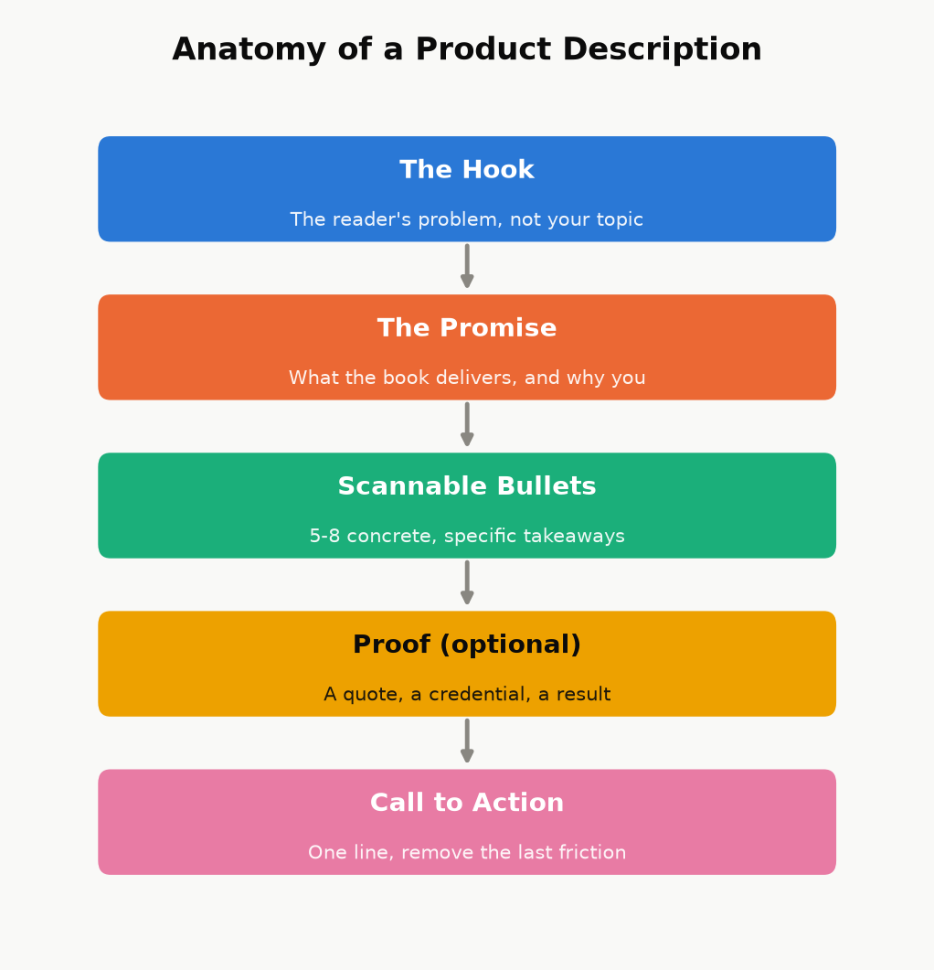
Figure 22.2 — The description’s job, in order. Skip the hook and open on your topic instead, and most shoppers never reach the part where you actually make your case.
Two more product-page pieces, both free and easy to skip:
Amazon Author Central. A free profile — bio, photo, and every book you publish under that name, automatically linked — that turns a single-book sale into a chance to be discovered as an author with a catalog (Chapter 29). There’s no reason not to set this up on day one.
A+ Content (Enhanced Brand Content). Image-and-text modules that can appear further down the product page. Eligibility and setup have changed more than once and vary by account, so treat this as “worth checking your current KDP dashboard for,” not as a guaranteed day-one option the way Author Central is.
Like price and keywords, the description isn’t a one-time decision — it’s editable the same afternoon you notice it isn’t converting, at zero cost. If a book has decent traffic (from ads or category placement) but a weak conversion rate, the description is one of the first three places to look, right alongside the cover and the price.

Chapter 23: Pricing for Profit
Chapter 17 showed you the mechanical cliff between the 35% and 70% royalty plans. This chapter is about where inside — or deliberately outside — that band your specific book should sit, and why “as high as the market will bear” and “as low as possible to win on price” are both usually wrong answers for a new nonfiction title.

The default range, and why
For most standalone nonfiction in the $2.99–$12.99 band, $3.99–$6.99 is a sensible starting range: high enough to signal real value (a $0.99 how-to guide reads, fairly or not, as slight and disposable to a lot of shoppers), low enough to be an easy impulse decision against a specific, felt problem. A narrow, high-authority professional or technical niche can often support pricing at or near the $12.99 ceiling of the 70% band — readers solving an expensive problem (a business decision, a certification, a skill tied directly to income) are reliably less price-sensitive than readers buying general-interest nonfiction, and testing a higher price within the band costs you nothing but a little time to observe the effect on conversion.
Pricing under $2.99 does double damage at once: it drops you to the 35% royalty plan (Chapter 17’s cliff) and it can read, to a browsing shopper, as a signal that the book itself is thin or low-effort — the opposite of the “impulse-buy bargain” effect a low price is often chosen to create. There are legitimate reasons to price low deliberately (a short lead-in title meant to build an email list or a series, discussed below) — but those are choices made for a specific strategic reason, not a default.
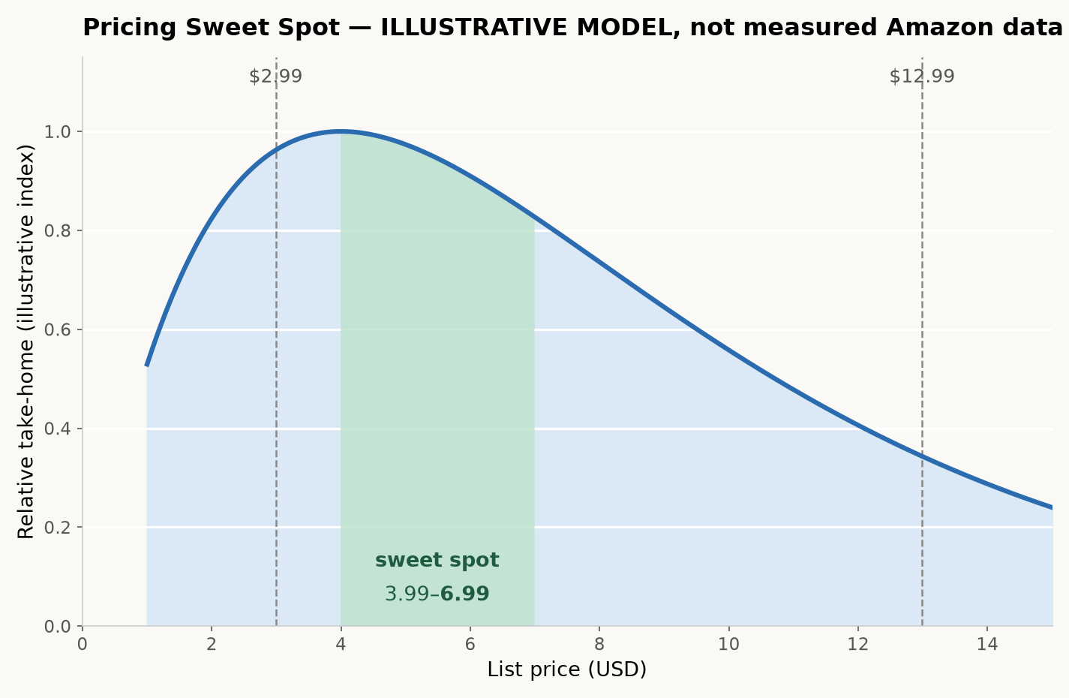
Figure 23.1 — Illustrative model, not a disclosed Amazon statistic: take-home per book is price times conversion, and conversion falls as price rises. The curve’s shape — a broad middle that beats both extremes — is the real lesson; the exact peak location varies by book, category, and audience.

Print has its own floor
A paperback or hardcover list price must clear the printing cost before any royalty exists at all (Chapter 17’s formula). KDP’s price calculator will show you the minimum list price at which a royalty becomes positive for your exact page count, trim size, and ink choice — treat that number as an absolute floor, not a target, since a print book priced at the bare minimum often leaves you earning a few cents a copy after printing cost, which covers approximately none of the time this book has described so far.

Pricing a series on purpose
For a series or a closely related set of nonfiction guides, price is a strategic lever across the whole set, not just one book: many authors price the first entry a little lower than the rest, specifically to lower the barrier to the read-through effect described in Chapter 18 — a reader who tries book one cheaply and likes it converts into a full-price buyer for every subsequent book, with no further marketing spend from you. True “$0.00 forever” pricing isn’t directly settable on KDP outside specific short promotional windows; the common way authors achieve a genuinely permanent free first-in-series title is by setting the ebook free on a retailer that allows it directly (Apple Books, or a distributor like Draft2Digital that reaches several at once — see Chapter 27), then submitting that lower price to Amazon as a price-match request, since Amazon’s own systems will match a lower verified price found elsewhere.

Discount tools, honestly described
KDP Select enrollment (Chapter 27) unlocks Free Book Promotions — a limited number of days where an enrolled book can be offered free directly on Amazon, useful for a launch push or to re-energize a backlist title’s visibility. The alternative in each 90-day term is a Kindle Countdown Deal, a short scheduled discount that keeps your selected royalty rate even below $2.99; idea 9 in Chapter 8 lists its eligibility and list-price rules. You get one or the other per term, never both. These tools have changed before, so check the KDP Select pages for what is offered today rather than relying on an older blog post.
This chapter covers pricing at the level every book needs. Chapter 31 goes much further into one specific piece of it — the mechanics of when to move the price and why, tied to the review-seeding timeline — for anyone who wants the deeper tactical version once the basics here are settled.

Chapter 24: Launching Without an Audience
The single biggest myth about a book launch is that it requires an existing audience. It doesn’t — it requires concentration: the same number of sales and reviews landing in a short, coordinated window does far more for a new book’s visibility than the identical numbers trickling in over a month, because Amazon’s own ranking and recommendation systems respond to velocity — how fast a book is moving right now — not just cumulative totals.

Pre-orders: a deadline you set for yourself
KDP lets you list a book for pre-order up to a year ahead of its release date, which gives you weeks or months to gather momentum before day one instead of starting cold. The trade-off is a real deadline: your final manuscript file has to be locked in and approved before the release date, and Amazon has tightened its enforcement around pre-orders that miss their promised release — a pattern of late files can cost an account its pre-order privileges entirely. If you use a pre-order, treat the file-upload deadline as immovable and finish your revision passes (Chapter 19) with real margin before it, not right up against it.

Building an ARC team, correctly
An ARC (Advance Reader Copy) team is a small group of readers who receive the book free, ahead of or right at launch, in exchange for an honest review. Recruiting one is straightforward — a call-out to your existing network, relevant online communities for your genre or topic, or a simple sign-up page — but the ethical and policy line here is sharp and worth stating plainly:
Key takeaway: You may give a book away free in exchange for a reader’s honest opinion. You may never give anything — a free copy, cash, a discount, or any other incentive — in exchange for a positive review, or review-swap with other authors. The first is normal, encouraged industry practice and is what an ARC team actually is. The second is a violation of both Amazon’s content policies and FTC disclosure rules, and it’s the exact mechanism behind several real account suspensions. Ask for honesty, not praise, and say so explicitly when you hand out review copies.

Launch week is a coordination problem, not a luck problem
The goal of launch week is to concentrate every review, every purchase from your own network, and any promotional push you’re running into the same narrow window — rather than let them land in a scattered trickle — because a short burst of real velocity is what triggers “Hot New Release” placement and meaningful category rank movement. Category rank is relative and constantly recalculated: it reflects your sales velocity compared to everything else currently active in that category, not a lifetime total, which is exactly why the specific, smaller category you chose in Chapter 22 matters so much at launch — the same burst of sales that barely dents a giant category’s chart can be enough to hit #1 New Release or #1 Best Seller in a well-chosen, narrower one, and that badge then becomes its own discoverability and credibility signal to every subsequent browser.
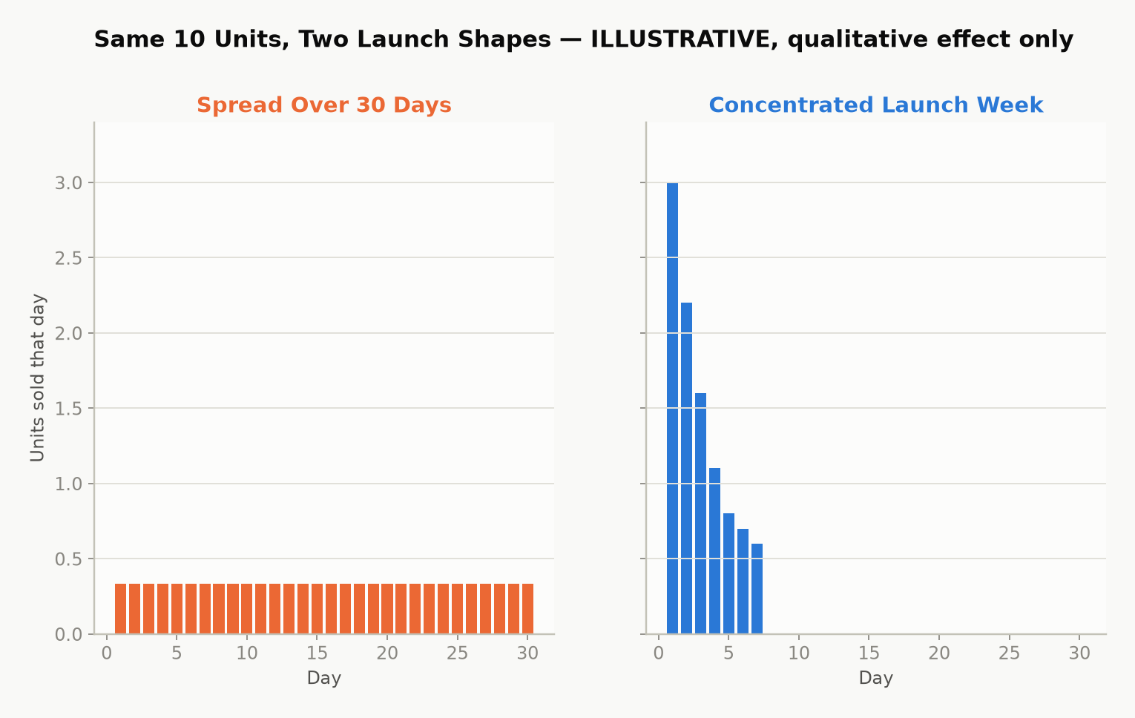
Figure 24.1 — Illustrative model: the same total sales, spread thin across a month versus concentrated into a launch week. Amazon’s own ranking mechanics aren’t public, but the qualitative effect — concentrated velocity moves rank further than the same total spread thin — is well established indie-publishing practice, not a guarantee for any specific book.
A practical launch-week checklist: line up your ARC reviews to post at or immediately after launch rather than whenever each reader happens to finish; tell your own network the specific date rather than “it’s out now” whenever convenient; and hold back any planned ad spend or promotion (Chapter 25) to start the same day rather than staggering it in afterward.
Everything above is the shape of a launch. Chapter 31 is the deep version of just the ARC and review-eligibility piece — who can actually post where, how to run the roster without tripping Amazon’s rules, and what to do with the first review that isn’t a good one — for anyone whose launch lives or dies on review count specifically.

Chapter 25: Amazon Ads Without Wasting Money
Amazon Advertising (Sponsored Products, for most authors) lets you pay to place your book directly in search results and on other books’ product pages. It’s the closest thing self-publishing has to a dial you can turn up or down on demand — and also the fastest way to lose money if you turn it on without understanding the one number that actually matters: whether an ad is profitable at all.

Auto campaigns first, manual campaigns second
Start with an automatic targeting campaign, where Amazon chooses which searches and product pages to show your ad against based on your book’s own metadata. Its job isn’t to be profitable on day one — it’s to generate data: after a couple of weeks, its Search Term Report shows you exactly which real customer searches actually led to clicks and sales. Take the phrases that converted well and move them into a manual campaign, where you control the bid on each keyword directly, and let the underperforming broad automatic spend taper down. This sequence — auto for discovery, manual for control — avoids the common new-advertiser mistake of guessing at keywords from scratch and bidding blind.
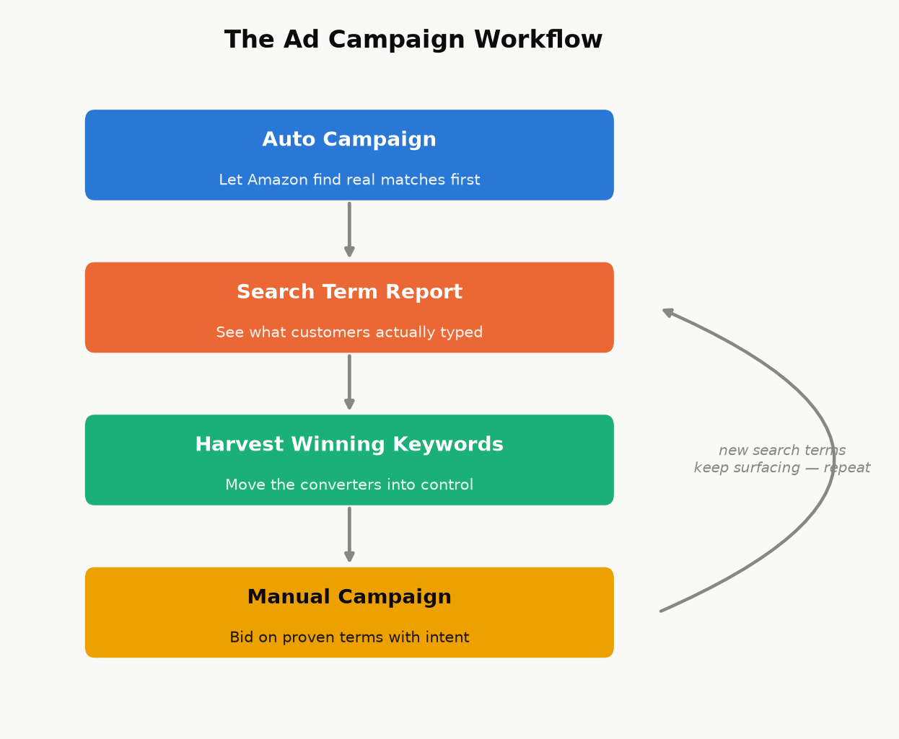
Figure 25.1 — This isn’t a one-time setup. New search terms keep surfacing after the first harvest, so the loop back to the Search Term Report keeps running for as long as the campaign does.

The only formula that matters: break-even ACOS
ACOS (Advertising Cost of Sales) is simply:
ACOS = Ad Spend ÷ Ad-Attributed Sales × 100%
An ad is profitable exactly when its ACOS is below your break-even ACOS — the percentage of a sale’s revenue that equals your actual royalty margin:
Break-even ACOS ≈ Royalty per Copy ÷ Sale Price × 100%
Worked example. A $4.99 ebook earning a $3.28 royalty (Chapter 17’s worked example, the same keep as Chapter 3) has a break-even ACOS of 3.28 ÷ 4.99 ≈ 66%. Spend $10 in ads and sell two copies attributed to that spend ($9.98 in sales, $6.56 in royalty) and your ACOS is 10 ÷ 9.98 ≈ 100% — about $3.44 lost on the ad, even though it “worked” in the sense of generating sales. The same $10 spend producing five sales ($24.95 in sales, $16.40 in royalty) gives an ACOS of 10 ÷ 24.95 ≈ 40% — under the 66% break-even line, and about $6.40 ahead.
Chapter 9 runs the same test from the other end, as the most a single click can cost before it eats the keep. Use whichever form your ad screen makes easier to read; they give the same answer.
Break-even is a floor, not a target. Community-reported benchmarks among self-published authors commonly put a healthy target ACOS for a single nonfiction title with no backend series well below that floor — often cited in the 20–35% range — with more room to run a break-even or slightly negative campaign on a series book that has real read-through behind it. Expect the first thirty to sixty days of any new campaign to run hotter than your real target while it gathers the data described below; a high ACOS in that window is normal, not a verdict on the book.
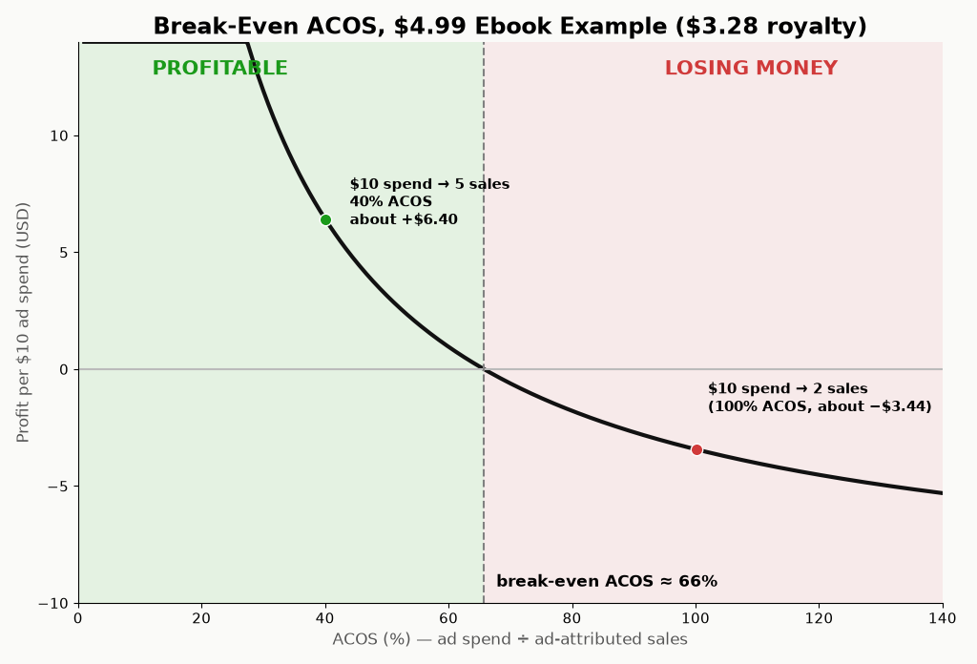
Figure 25.2 — The break-even line for the $4.99 example above. Below the line, an ad is paying for itself before any read-through, page-read income, or brand-visibility effect is even counted; above it, the ad is a net cost you’re choosing to pay for exposure, which can still be a reasonable choice during a launch, as long as you’re making that trade on purpose.
Two caveats worth holding onto: direct ACOS profitability isn’t the whole picture. A break-even-or-slightly-negative ad during launch week can still be worth running for the visibility and momentum effects described in Chapter 24, as a deliberate, bounded spend — the danger is treating every ad that way indefinitely, rather than as a specific, time-limited choice. And a single sale can undercount a book’s real return if it’s part of a series — factor a reasonable estimate of read-through into subsequent volumes before writing off a campaign that looks marginal on book one alone.

Budget discipline for a new advertiser
Start with a small daily budget and let a campaign run long enough to gather a meaningful number of clicks before judging it — a campaign killed after two days rarely has enough data to mean anything.
Read the Search Term Report, not just the campaign-level ACOS — it’s common for one converting phrase to be subsidizing several non-converting ones sitting in the same auto campaign.
Add non-converting search terms as negative keywords once they’ve had enough clicks with zero sales to be a real signal, not a fluke — this stops you paying repeatedly for traffic that’s already shown you it doesn’t convert.
Revisit bids and budgets weekly, not daily — day-to-day noise in a small campaign’s numbers is mostly randomness, not signal.

Part V — The Business Side

Chapter 26: Getting Paid: Taxes, Payments, and Reporting
The most common reason a new author’s first royalty payment is delayed or smaller than expected has nothing to do with sales — it’s an incomplete tax interview. This chapter is the unglamorous plumbing that makes sure the money your earlier chapters worked to earn actually reaches you, at the rate it’s supposed to.

The tax interview isn’t optional paperwork — it sets your withholding rate
Before KDP releases any royalty, it requires a tax interview, completed in your account settings:
US persons complete a Form W-9.
Non-US individuals complete a Form W-8BEN.
Non-US entities (a company rather than an individual) complete a Form W-8BEN-E.
Here is the part that catches people off guard: royalties are US-source income for tax purposes, and the default US withholding rate on that income for a non-US person is 30%, taken straight off the top before you ever see it. Many countries have a tax treaty with the United States that reduces or eliminates this withholding on royalty income specifically — but that reduced rate is not automatic. To claim it, your W-8BEN needs a foreign taxpayer identification number and an explicit treaty claim referencing the relevant treaty article. Skip that step, even by accident, and you default to the full 30% withholding regardless of what your country’s treaty actually allows.
Key takeaway: Treaty rates and eligibility genuinely vary by country and change over time — this book won’t guess a number for your specific situation. Look up your country’s current entry in the US Tax Treaty tables (or ask an accountant who handles cross-border royalty income) before your first sale, get whatever foreign tax ID the treaty claim requires, and complete the W-8BEN correctly the first time. Fixing an incorrect tax interview after the fact is entirely possible but slower than doing it right before you need it.
If a required taxpayer ID takes time to obtain in your country, start that process as early as possible — ideally before you expect your first payment — rather than discovering the delay when a payment is already held up.

How and when you’re actually paid
KDP pays royalties by direct deposit (or check, where direct deposit isn’t available for your country/currency), roughly 60 days after the month in which the royalty was earned closes — a February sale is typically paid around the end of April, not immediately. Payment also requires your accumulated royalty balance to clear a minimum threshold, which varies by currency and payment method; check your own Payment settings inside KDP for the current number rather than relying on a fixed figure here, since these thresholds are exactly the kind of detail that changes without much announcement.

Reading your reports without confusing yourself
KDP gives you three different views of your own money, and new authors frequently compare the wrong two against each other:
Sales Dashboard — near-real-time, estimated units and royalties. Useful for watching a launch unfold; not the final number.
Prior Months’ Royalties report — the finalized figures for a closed month, after returns and any KENP fund rate is set. This is the number that will actually match what gets paid.
Payments report — the actual disbursements made to your bank account, which lag the royalty-earned month by the ~60-day delay above.
Expect the Sales Dashboard’s running estimate and the eventual finalized monthly report to differ slightly — that’s normal, not an error, and it’s exactly why the finalized report, not the live dashboard, is the number to use for any real accounting.

Treat it like the business it is
Once money is actually moving, a little bookkeeping discipline pays for itself: keep records of every business expense (editing, cover design, ads, any software or service subscriptions) against your royalty income, and consider a dedicated bank account once revenue is more than trivial, purely to keep the paper trail clean. Whether self-published royalty income counts as self-employment income or passive royalty income for tax purposes is a real, fact-specific question in a number of jurisdictions — it typically depends on how regularly and actively you’re engaged in the business of writing and publishing, not just on the fact that “royalty” is in the name — and it materially affects which expenses are deductible and whether self-employment-type tax applies. This is exactly the kind of question worth a genuine conversation with an accountant familiar with creative or royalty income once you’re earning enough for the distinction to matter, rather than a guess from a general-purpose guide like this one.

Chapter 27: KDP Select vs. Going Wide
Once a book is written, formatted, priced, and ready to launch, you face one more structural decision: does the ebook live on Amazon exclusively, or everywhere at once? Neither answer is universally correct, and the honest version of this chapter is that it depends heavily on your genre and your specific readers.

What Select actually asks for, and what it gives back
Enrolling an ebook in KDP Select commits it to a rolling 90-day exclusivity period: for that ebook edition specifically, it can only be sold as an ebook through Amazon — not Apple Books, Kobo, or anywhere else. This restriction applies to the digital edition only; a paperback or hardcover edition of the same book is entirely unaffected and can be sold anywhere regardless of your Select enrollment. In exchange, Select unlocks:
Kindle Unlimited / Kindle Owners’ Lending Library page-read income (Chapter 17’s KENP mechanics) — for some genres, this is not a minor bonus but the majority of total revenue.
Free Book Promotions — a limited number of days where the book can be offered free directly on Amazon, useful for a launch push, a series first-volume strategy (Chapter 23), or reviving a quiet backlist title.
At the end of each 90-day term, Select auto-renews unless you opt out — worth calendaring, so a decision to go wide doesn’t get delayed by simply forgetting the renewal date exists.

What “going wide” gets you instead
Going wide means distributing the ebook to multiple retailers and library platforms — Apple Books, Kobo, Barnes & Noble, Google Play Books, and library-lending systems — either by uploading to each directly or, far more commonly, through an aggregator like Draft2Digital or PublishDrive, which handles the individual retailer relationships for a cut of sales made through it. The upside is real: your income isn’t dependent on one platform’s rules, algorithm changes, or payment terms, and some readerships (certain nonfiction niches especially) skew more heavily toward Apple or library reading than Amazon’s fiction-heavy Kindle Unlimited subscriber base does.
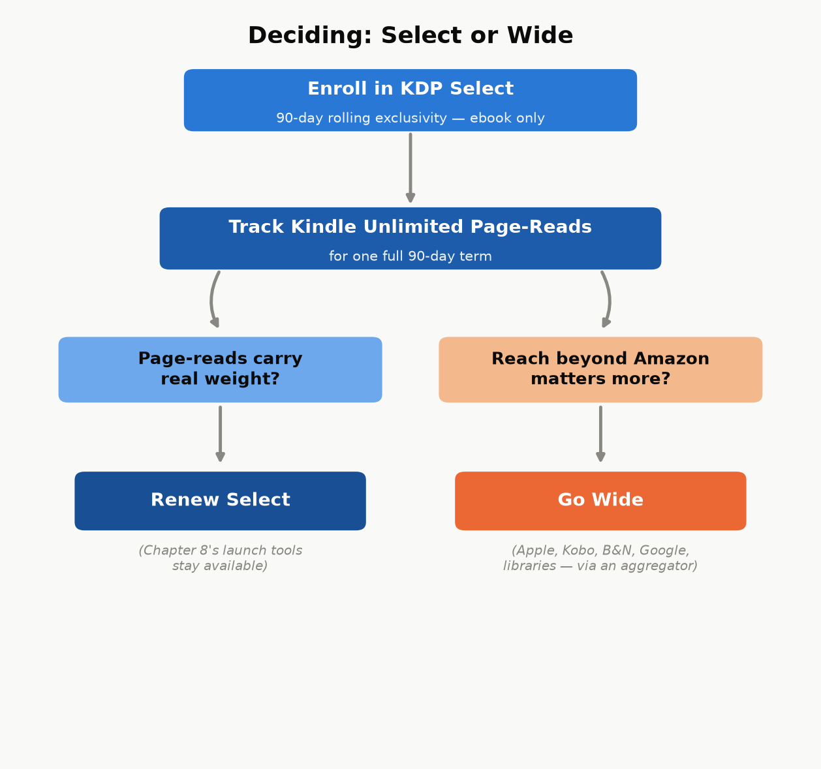
Figure 27.1 — Not a one-time choice: run one real 90-day term, then let what actually happened to your page-reads make the next decision instead of a genre-wide generalization.

Choosing without guessing
A reasonable default for a new author with no existing data: enroll the first book (or series) in Select for one 90-day term, watch the actual page-read numbers against what wide distribution would plausibly have earned, and make the next term’s decision from real data instead of a genre-wide generalization.
Worked example. A 300-KENPC-page nonfiction ebook at $4.99 (70% royalty ≈ $3.28/copy after the delivery fee, per Chapter 17), against 300 reader engagements over one 90-day term:
All 300 as direct purchases, wide distribution, comparable net across stores: 300 × $3.28 ≈ $984 for the term.
The same 300 readers under Select, but 120 of them read the book in full through Kindle Unlimited instead of buying it (at Chapter 17’s illustrative $0.0045/page rate): 180 direct sales (180 × $3.28 ≈ $590.40) plus 120 full KU reads (120 × 300 pages × $0.0045 ≈ $162) ≈ $752.40.
In this illustration, wide comes out ahead per reader, because a full KU read at $1.35 is worth less than a $3.28 sale. Select only wins the comparison when it brings in readers who would not have bought at $4.99 at all — a number this book cannot supply for your specific book, your genre, or your audience. That missing number is exactly why the advice above is to run one real term and read your own dashboard, not to trust this arithmetic, or anyone else’s, for a decision this dependent on who your actual readers are.
Certainty, labeled. Kindle Unlimited tends to matter most for genres with heavy series readers who consume books quickly (romance, fantasy, thriller fiction, in particular) and matters less for many nonfiction categories, where a reader may buy once rather than subscribe-and-binge. That is a widely observed pattern among authors, not a KDP-published rule — “tends to” is not a guarantee for your specific book, which is exactly why testing one real term beats assuming either way.

Chapter 28: Avoiding the Traps
Every mechanism described in this book so far is free, documented, and available to any KDP account. Everything in this chapter exists because that fact — self-publishing costs nothing but effort — is exactly what a whole ecosystem of scams, shortcuts, and account-ending mistakes is built to obscure. Knowing what this chapter covers is often the difference between a first-time author who keeps their account and their earnings, and one who doesn’t.

Vanity and predatory hybrid publishers
The scam is almost always the same shape: a company charges a new author a fee — anywhere from a few hundred to many thousands of dollars — for services that either cost nothing (an ISBN assignment, a KDP upload, basic ebook formatting) or cost a small fraction of what’s being charged (professional cover design, a real developmental edit). Watch for:
Unsolicited contact — “we read your manuscript and think it has real potential” from a company you never submitted to. Legitimate publishers don’t cold-call unpublished manuscripts they found on their own.
Upfront fees framed as necessary for basic access to distribution that KDP already provides for free.
Vague, inflated promises — “bestseller,” “bookstore placement,” “Hollywood option potential” — offered with no specifics about how, paired with pressure to sign quickly.
None of this means every paid publishing-adjacent service is a scam — freelance editors, cover designers, and formatters described in earlier chapters are legitimate paid services doing real, specific work. The distinguishing question is always the same: can you name, specifically, what this fee is paying for, and could you get that same specific thing done elsewhere for less? A legitimate freelancer answers that question instantly. A predatory hybrid publisher’s answer is deliberately vague.

Fake reviews and rank manipulation
Buying reviews, joining a review-swap ring, or paying for a “guaranteed ranking boost” service are all violations of Amazon’s content policies, and the consequence isn’t limited to the one book involved — Amazon can suspend an entire account over manipulated reviews or rank manipulation, which means every book you’ve ever published under that account stops earning at once, not just the one that triggered it. There is no version of this trade-off that’s worth it: the honest ARC-team approach from Chapter 24 achieves the same “reviews at launch” goal legitimately, with none of the downside risk.

AI-content flooding
A different, newer version of the same underlying trap: mass-producing large numbers of thin, minimally reviewed, AI-generated books to flood categories, hoping volume compensates for quality. Amazon has been actively tightening enforcement against exactly this pattern — content-quality policies, required AI-content disclosure (Chapter 19), and publishing limits: since 21 September 2026 every account can create only two new titles per format (ebook, paperback, hardcover) each week, down from ten. Beyond the policy risk, it’s a reputation trap for your author name and your existing titles: a flood of low-effort books under one name damages trust in your better books too, in a marketplace where a reader’s next click is often “see all books by this author.”
A more polished-looking relative of this trap gets its own treatment in Chapter 32: books that don’t look thin or AI-flooded at all, because the process used to make them included a step specifically designed to erase the resemblance to the handful of existing books they were actually built from.

Copyright and licensing traps
Two mistakes show up often enough to name directly: assuming something is public domain when it isn’t (public-domain status depends on specific publication dates and jurisdictions, and a translation, annotation, or edited edition of a public-domain work can itself carry separate copyright even when the underlying original doesn’t), and using images — cover art, interior illustrations — without a license that actually covers commercial use. A stock image licensed for personal or editorial use is not automatically licensed for a book you’re selling; check the specific license terms every time, for every image, not just the ones that look obviously professional.
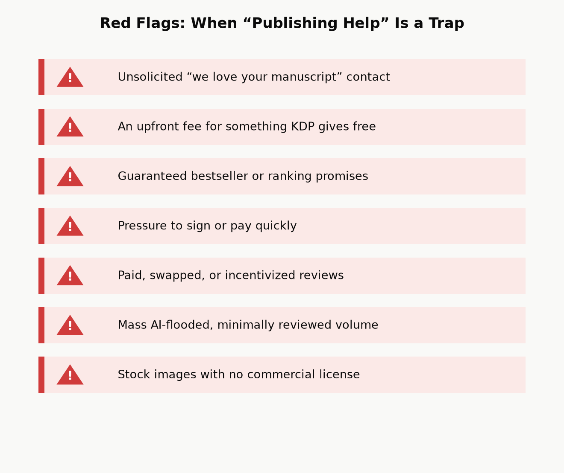
Figure 28.1 — The common thread across every trap above: a shortcut that trades a small, certain cost now (an editor’s fee, a slower honest launch) against a large, uncertain cost later (a suspended account, a damaged reputation, a copyright claim) — and the trade almost never pays off in your favor.

Two more triggers worth naming directly
Two more patterns come up often enough in independently reported KDP account actions to name on their own, and neither one requires the bad intent behind the traps described above — an author can trigger either while doing something that felt entirely reasonable at the time.
Duplicate or near-duplicate content: publishing the same book, or a lightly reworded version of it, under a new title, a new cover, or a new account. This is the specific risk a poorly done public-domain modernization (Chapter 32) can run into even with no intent to deceive anyone, and it’s also what a “relaunch” of a book that didn’t sell can look like to Amazon’s systems if the fix was cosmetic rather than substantive.
KDP Select exclusivity violations: while a book is enrolled in Select (Chapter 27), its ebook can’t be sold, given away, or distributed anywhere else Amazon doesn’t control — not another retailer, not your own website, not a bulk-emailed review PDF. The common way authors trip this isn’t defiance, it’s forgetting: a book enrolled in Select months ago, then quietly included in a later website giveaway or bundle without checking whether it’s still exclusive.
Add banned or misleading backend keywords (Chapter 22) and a skipped AI-content disclosure (Chapters 19 and 32) to the list, and that covers most of what independent trackers of KDP account actions report repeatedly, alongside the review-manipulation and copyright traps already named above. None of the five requires malice — which is exactly the argument for treating this chapter as a checklist to run against your own upcoming launch, not just a warning about other people’s bad behavior.

The best filter: check KDP’s own help pages first
A large share of “secret” paid courses promising to reveal how self-publishing really works are, on close inspection, reselling information KDP already publishes for free in its own Help pages and this book’s chapters. Before paying for any course or service that claims special insider knowledge of “the algorithm” or “what really works,” spend twenty minutes checking whether the claim is actually just documented KDP policy with a markup attached. Often, it is.

Part VI — Playing the Long Game

Chapter 29: From One Book to a Catalog
Every chapter so far has been about one book. This chapter is about the point at which the math changes: a catalog of several related books doesn’t just add up its individual books’ income — it compounds, because each additional title increases the discoverability surface of every title already in the catalog, not just its own.

Why a catalog outearns the sum of its books
A reader who finishes your first book is shown your other books directly, on your Amazon author page, on each book’s “more by this author” section, and through “customers also bought” placements — at zero additional marketing cost, because you already paid the one-time cost (writing it, formatting it, launching it) to acquire that reader’s attention in the first place. A five-book catalog isn’t five separate customer-acquisition problems; it’s one customer-acquisition problem (get a reader to try book one) followed by four essentially free upsells. This is the same read-through economics from Chapter 18, extended from a single series to an entire body of work.
There’s a second, quieter compounding effect: the fixed costs of learning this whole system are paid once. The time spent learning to navigate KDP’s upload flow, understanding your own ad account well enough to run a profitable campaign, developing a cover style that reads correctly for your category, building an ARC team and an email list — none of that resets to zero for book two. Book two of a well-run catalog typically takes meaningfully less total effort to launch than book one did, for the simple reason that most of that effort was fixed-cost learning, not per-book labor.
Illustration: planning for compounding from day one. Picture a beginner’s guide to a hobby planned from the start as a set of separate, topic-sized books — getting started, the common mistakes, the first big project — rather than as a single giant volume, so that each finished book immediately extends the discoverability and “more by this author” surface of every book already published, instead of asking one enormous, slow-to-finish book to carry the entire catalog’s earning potential alone. Another author might run two unrelated lines at once, say a cozy mystery series and a set of regional cookbooks, which spreads risk the same way a diversified small-business portfolio does: a slow month or an algorithm change affecting one category doesn’t take down income from the other at the same time. Neither choice — many small books in one series, or several unrelated catalogs at once — is the “correct” one in isolation; both are the same underlying principle (a catalog compounds; a single book doesn’t) applied to two different situations.
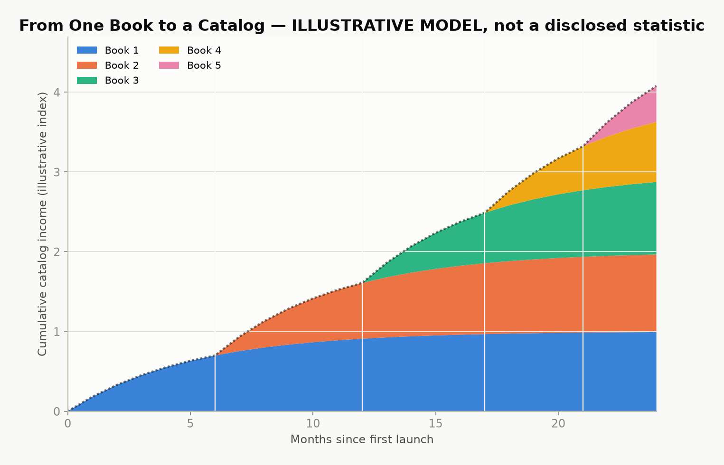
Figure 29.1 — Illustrative model, not a disclosed statistic: cumulative catalog income over time as each new book adds both its own sales and a cross-sell boost to every earlier title. The compounding shape is the real lesson — a real catalog’s actual curve depends entirely on genre, quality, and consistency of output.

Bundles and an owned audience
Two more tools extend a catalog’s earning power beyond individual book sales:
Box sets and bundles. Combining several existing books into one discounted bundle product creates a new, sellable item with close to zero additional creation cost — the content already exists — while giving price-sensitive readers and new-to-you browsers a lower-friction way to try several books at once.
An email list, built from a simple sign-up offer (a short bonus chapter, a checklist, a free related short work) placed inside your existing books’ back matter. A list of genuinely interested readers is a source of concentrated launch-day velocity (Chapter 24) that you control directly, rather than one that depends entirely on Amazon’s algorithms, ad auctions, or luck — the single most durable hedge against any one platform changing its rules on you.

A second format, mostly for free: audiobooks
There’s a third format beyond ebook and print, and it extends a catalog the same way bundles and an email list do: almost all of its cost is paid once, against content that already exists. ACX (Audiobook Creation Exchange) is Amazon’s audiobook platform, producing for Audible, Amazon, and iTunes from one submission — the audio equivalent of KDP itself.
Three ways to get a finished audiobook, at three very different price points:
Narrate it yourself. Zero cost beyond your own time and reasonably decent recording equipment. A real option for nonfiction in particular, if the author has a clear, listenable voice — readers of a how-to guide are often buying the author’s judgment as much as the words, and hearing it in their own voice is not a downgrade.
Royalty share with a narrator. No upfront cash — the narrator is paid out of future royalties instead of a fee, typically splitting close to evenly with the rights holder. This is the standard route for an author with no production budget but a book (or catalog) with a real chance of actually selling, since a narrator taking a royalty-share deal is, in effect, betting on the book too.
Pay-per-finished-hour (PFH). A professional narrator, paid a flat fee for each finished hour of audio — commonly several hundred dollars per hour, which puts a full-length audiobook’s upfront cost in the low-to-mid thousands. You keep the full royalty going forward; you also carry the entire financial risk if the audiobook doesn’t earn it back.
A newer, fourth option: Amazon has been rolling out AI-narrated (“Virtual Voice”) audiobooks directly through KDP for eligible titles, at little to no cost — a real, current alternative to the three routes above for an author testing whether their book’s audience wants audio at all before committing real money to it. Eligibility, available voices, and quality have been moving targets since this feature launched; check your own KDP dashboard for what’s actually offered before assuming it works the way an older article describes.
Worked example. A pay-per-finished-hour audiobook running 6 finished hours at $300/hour costs $1,800 upfront, fully owned by the author afterward. The same book via royalty share costs $0 upfront, but every future audiobook royalty is split with the narrator, indefinitely. Neither choice is simply “better” — PFH is the better bet for a book with proven sales already (Chapters 17 and 30 show you how to tell); royalty share is the better bet for a first audiobook on an unproven title, since it caps the downside at zero.
Exclusivity works the same trade-off shape as KDP Select (Chapter 27): ACX offers a meaningfully higher royalty rate for audiobooks distributed exclusively through Audible, Amazon, and iTunes, against a lower rate for non-exclusive distribution that also reaches other audiobook retailers and library platforms. Check ACX’s current royalty table before committing — like every rate in this book, it’s a real number that changes over time, not a fixed constant.
Not every book belongs in audio. A book that leans on charts, worked numerical examples, or anything the reader needs to see translates poorly to a listen-only format — this book’s own royalty-cliff chart and break-even ACOS math, read aloud with no image to look at, would be a worse experience than the page version, not an equal one. A narrative nonfiction book, a memoir, or a novel has no such problem. Know which kind of book you’ve written before assuming audio is the obvious next format.

Chapter 30: A Realistic First-Year Plan
This book opened with a promise to show its arithmetic, including the unflattering parts. Here is the unflattering part: self-publishing income is a power law, not a bell curve. A small share of books and authors earn very well; a large share earn modestly or barely cover their production costs; very few outcomes land neatly in between. Nothing in this book changes that distribution — what it changes is your odds of landing in the better half of it, by doing the specific, checkable things (real editing, honest launch coordination, correct categories and keywords, disciplined ad spending, a catalog instead of a single bet) that separate a professionally run small business from a hopeful one-off.
Key takeaway: Treat your first book as tuition, not a lottery ticket. Its most valuable output may not be its own royalty check — it may be everything you learn about your category, your readers, and your own process, which book two then gets to apply at a fraction of the effort. That’s not a consolation prize; it’s exactly how the compounding in Chapter 29 gets started.

A month-by-month shape for a first book
Every catalog’s real timeline will vary, but a reasonable default shape, tying every earlier chapter together:
Months 1–2 — Write and research (Chapters 16, 18). Confirm the category and audience against real Amazon signals before finishing the draft, not after.
Month 3 — Revise, design, recruit (Chapters 19, 21, 24). Run your editing passes, commission or finalize the cover, and open ARC-team recruitment early enough for readers to actually finish the book before launch.
Month 4 — Format, list, launch (Chapters 20, 22, 23, 24). Format for the correct output(s), set categories and keywords deliberately, price with intent, and concentrate your launch-week activity rather than spreading it thin.
Months 5–6 — Read the data, adjust, decide on ads (Chapters 25, 26, 27). Start (or continue) advertising with real break-even math, read your first finalized royalty report rather than the running estimate, and make your first informed KDP Select renewal decision from actual page-read numbers.
Months 7–12 — Start the next book, with everything you now know (Chapters 18, 29). Apply the category and audience research to book two (or book one of your next series) with the fixed-cost learning from this round already paid off, and begin building the email list and bundle options that only make sense once more than one book exists.
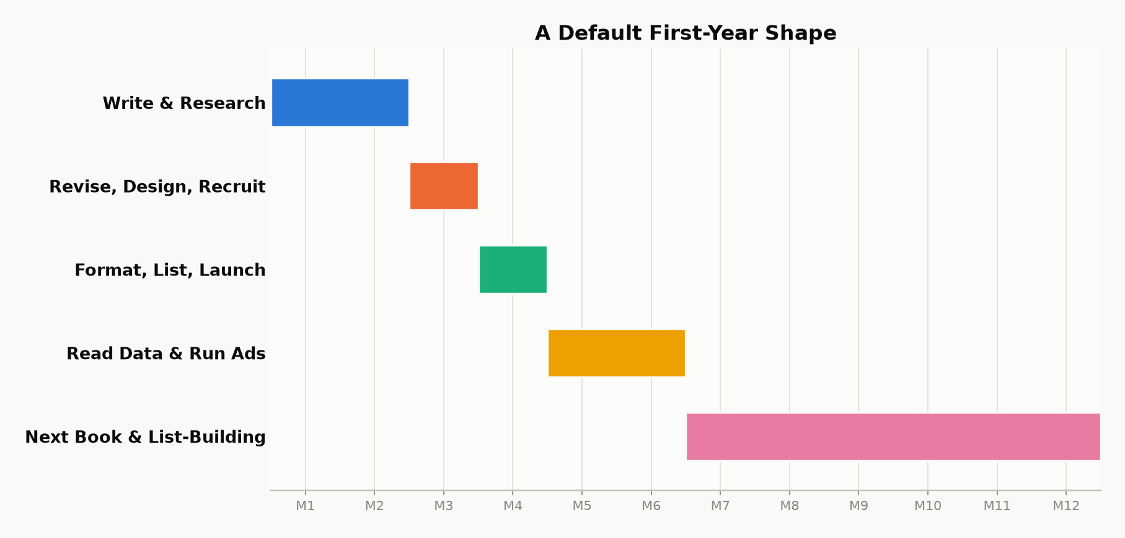
Figure 30.1 — A default first-year shape. The exact pace will stretch or compress around real life — the sequence (research before writing, editing before launch, data before the next big decision) matters more than hitting these specific months.
Whatever your book earns in its first year, the honest measure of whether this was worth doing isn’t that first royalty number in isolation — it’s whether you finished the year with a repeatable process and a second book underway. That’s the entire difference between having self-published a book, and having become a self-publisher.

Part VII — One Topic, in Depth

Chapter 31: The First-Review Problem
The target for this chapter isn’t a few sales that make the page look alive — it’s unit economics that still hold up once your friends have already bought their copies. Reviews and price are the two levers you can actually control before you’ve built a list large enough to matter on its own, and everything below treats them as mechanics to run correctly, not as marketing flourishes on top of a finished book.
As in every other chapter, Amazon’s written rules are treated here as real constraints, and any claim about how ranking actually behaves is labeled explicitly as inference rather than fact. The pricing bands referenced below reflect KDP’s 70 percent ebook option as expanded in July 2026 ($2.99–$12.99 on Amazon.com) — confirm the live help page before you lock in a price, the same caution this book asks for everywhere else.
Terms used in this chapter. ARC: advance reader copy, sent before the book is live. KU / Select: Kindle Unlimited and KDP Select, Amazon’s borrow-and-subscription program. ASIN: the product ID a book receives on publication — no review can post before it exists. EPUB: the reflowable file format every e-reader except Kindle actually wants.
A note on the examples ahead: the public field reports this chapter can actually check — published accounts, real numbers, a real launch date — mostly come from fiction, because fiction authors publish that kind of detail far more often than nonfiction authors do. The mechanics don’t care: a review-eligibility rule, a royalty band, and a launch-week concentration effect work identically on a novel and a how-to guide. Read “book one” and “series” below as your nonfiction title and your line of related titles (Chapter 29) — the arithmetic transfers directly, even where the example doesn’t.

Selling a few copies is not a business
Most debut Kindle books do sell — to the author, to a handful of acquaintances, and to whoever happens to stumble in during the week the title is genuinely new. Then that week ends: Best Sellers Rank slides back down, and any ads that were running start costing more than they return. The author typically concludes that “self-publishing doesn’t pay,” having sampled a market that never actually saw a trustworthy product page in the first place.
A book that makes real money does three things a hobby listing doesn’t. It converts strangers who have no prior loyalty to you. It stays findable after the launch spike fades. And it leads somewhere else — another title, an email list, a borrow that pays out by the page. None of those three things begins with hoping; they begin with a product page a cold reader will actually finish and say yes to, priced so that enough royalty survives to fund the next unit of attention you buy or earn.
Reviews, in that light, are not decoration — they’re how a stranger agrees to pay. And price is not a reflection of the book’s worth or your own confidence in it; it’s simply how much of that stranger’s “yes” you get to keep, and whether the store will even show your book in the band where serious shoppers actually look.
The rest of this chapter turns those two sentences into something you can actually do: seed honest reviews before you spend on traffic, price for the royalty band and for the life of the whole catalog rather than for one launch, and only treat book one as an acquisition cost once book two actually exists to collect the debt it created.
Key takeaway: Reviews and price are not marketing decoration on top of a finished book — they are the two levers that decide whether a finished book becomes a business. Get the sequence right (proof before spend, price for the band and for the catalog) and everything else in this chapter is mechanics.

Where the money actually comes from

Not from the first ten cousins
Friends and family can put a number on your sales dashboard, but that’s essentially all they can do. They can’t put your book into “Customers who bought this also bought.” They can’t teach Amazon’s systems who the book is actually for. And they often can’t leave a review at all without violating Community Guidelines — the $50 spend-history rule described later in this chapter is exactly the trap that catches them. Treat their purchases as a rounding error in your real numbers. If your business plan depends on them, you don’t yet have a business plan.

From conversion on paid and organic traffic
Amazon gets paid when someone buys a copy, or, under Kindle Unlimited, when someone borrows one. Rank, as authors actually observe it in practice, tracks recent commercial events like these rather than a lifetime total. Reviews don’t appear anywhere in a published Amazon formula as a direct weight on rank — but they change whether a given click actually turns into one of those commercial events in the first place. A listing that converts at twice the rate of its neighbor can effectively buy the same ads for half the real cost per sale, which is exactly why a zero-review page makes advertising feel like a scam while a reviewed page makes the identical bid look perfectly rational.
The promotional newsletters that actually move the needle — the ones worth paying for once you have proof a book sells — routinely refuse to feature books with an empty or near-empty review module. That isn’t the newsletter being precious; it’s the newsletter protecting its own conversion rate for its subscribers. Without one of those newsletters, and with no list of your own, a free day or a $0.99 blast has nowhere to get real traction from.

From read-through, not from a single SKU
A standalone debut only gets one chance to collect money from a given reader: that one purchase, or those pages read. A series gets to collect again. If half the readers who finish book one go on to buy book two at full royalty, then book one can reasonably be priced as bait to get them there. If there is no book two, that same low price is just a cheap book with nothing behind it. The authors who report genuinely real income are disproportionately the ones with several related titles, not the ones with one beloved book and a perfect product description.
Amazon doesn’t publish a read-through figure, so what counts as “healthy” is only ever self-reported — but series authors who track their own numbers commonly describe 50 to 60 percent from book one to book two as solid, with anything well under half treated as a sign to fix book one’s ending, blurb, or back matter rather than a reason to rush book three into print. A free or heavily discounted book one pulls that number down on its own, since it fills the funnel with readers who paid nothing and were never sorted for fit — weigh read-through from a launch discount against another discounted launch, not against a full-price one, or the comparison won’t mean much.
Kindle Unlimited complicates this picture in a useful way: a borrow counts as a commercial event the moment it happens, and the pages read after that pay out separately, from a shared pool (Chapter 17). A book that converts borrows well but loses most of its readers by chapter two has a real leak in it — and advance readers who either finish the book or stop partway through and tell you why are a much cheaper way to find that leak than discovering it after a month of paid ads.

The first-review problem, restated as cash flow
Launch week is the one genuinely cheap moment when your own list, incoming advance-copy reviews, and any small test of ad spend can all land in the same window at once — and Amazon’s own systems weight what happened recently more heavily than a lifetime total. Spend that window on a page with no testimony at all, and it converts poorly. Spend it on a page that already carries a few independent, honest paragraphs of review, and a larger share of the same visitors become actual sales — because sales, or “units” in Amazon’s own language, are the one thing the store’s systems know how to extend further.
That’s exactly why you recruit advance readers while the KDP file is still a draft: they can’t post a review until the book’s ASIN actually exists, and they can’t read even a short book overnight. The calendar you’re actually working against here is a reading calendar first and a marketing calendar second — reverse that order, and launch week arrives as an apology instead of an event.
A KDP Select free day is not a substitute for this. Free downloads don’t count as paid sales, and they reliably produce downloaded files rather than reviews. Nobody has published a clean study on organic post-free review rates; author forums describe them anecdotally, often in fractions of a percent — treat that as a reason to test on a small scale rather than as a citation you can rely on. An advance-reader group that specifically asked to read the book in its genre is a fundamentally different population: posting rates of roughly a quarter to two-fifths are commonly logged by authors who actually bother to count. Call that survivorship bias with better manners if you like, but it’s the specific bias you want working in your favor. Use the wider, anonymous crowd only after the page can already convert on its own; use the small, recruited group to make that conversion possible in the first place.
Certainty, labeled. If Amazon never uses review count internally, shoppers still see the empty module, newsletter editors still use it as a gate, and ads still die on untrusted pages. The cash-flow case does not require an occult coefficient.

Price: what KDP will pay you
Chapters 3 and 17 set out the two ebook options: 70 percent inside the $2.99–$12.99 band on Amazon.com, once you select it, with the delivery charge taken off the price first, and 35 percent outside the band with no delivery charge. This section applies that rule to launch and series pricing rather than restating it.
Worked example. A price-by-price picture, approximate, 2 MB file, no VAT, 70 percent selected — 0.70 × (price − $0.30 delivery) wherever 70 percent applies, the same keeps as Chapter 3:
List price | Typical royalty band | Rough net / sale | Job of this price
$0.99 | 35% | ~$0.35 | Launch spike or loss-leader. Never the forever price of a lone book.
$2.99 | 70% | ~$1.88 | Floor of serious money. Default if unsure.
$3.99–$4.99 | 70% | ~$2.58–$3.28 | Genre fiction’s long-term home for many series mid-books.
$5.99–$7.99 | 70% | ~$3.98–$5.38 | Longer work, established name, or dense nonfiction.
$9.99–$12.99 | 70% if option on | ~$6.78–$8.88 | Only if comps and proof support it. Debut novels rarely.
$1.99 | 35% | ~$0.70 | The 35% trap dressed up as a friendly compromise. Worse net than $2.99 despite looking cheaper to the reader.
$13+ | 35% (outside the band) | high in isolation | The royalty math is fine alone; a debut rarely has the comps or proof to hold that price, so volume collapses before the math gets to matter.

The important comparison here is that $2.99 at 70 percent usually earns more per copy than $1.99 at 35 percent does, and often earns more than a higher price that would have fallen outside the band before the July 2026 expansion. Don’t price at $1.99 in an attempt to “meet readers halfway” — doing so leaves most of that copy’s actual value on the table.
Here’s the same math worked through for a heavier file: a 20 MB illustrated nonfiction title priced at $9.99 with the 70 percent option selected. Delivery fee: $0.15/MB × 20 MB = $3.00, taken off first. Royalty: 0.70 × ($9.99 − $3.00) ≈ $4.89 — well below the $6.78–$8.88 the table above shows for a lean 2 MB file at a similar price. The royalty percentage never changed; the file size did all the damage. Compress your images before trusting any of these figures for your own book, and rerun the math on Kindlepreneur’s KDP royalty calculator using your file’s actual size rather than the 2 MB assumption this chapter has used throughout.
Print is an entirely separate ledger from the ebook math above: the print rate times the list price, minus the print cost (Chapters 3 and 17), with the rate on Amazon.com dropping from 60 to 50 percent below a $9.99 list price. Don’t let a paperback’s list price influence your ebook price out of vanity, and don’t set a paperback’s price so low that the print cost simply eats the royalty; the print cost doesn’t care how proud you are of the cover.

Initial price versus later price
Skip ahead to whichever of the following two subsections actually matches your situation — a debut with nothing behind it yet, or a series with at least one sequel already live. The math genuinely doesn’t agree with itself across these two cases, and that’s intentional: they’re different problems.
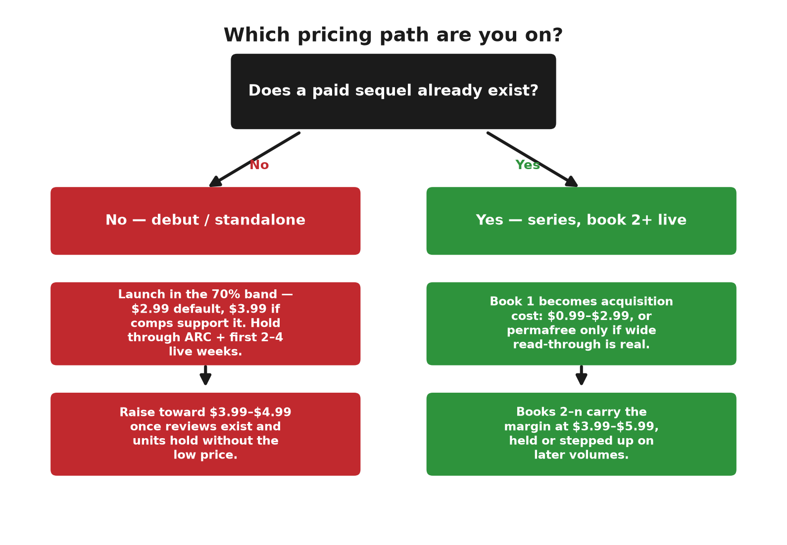

The principle
An early, low price buys you information and motion — real data about whether the book sells at all, and enough velocity to get noticed. A later, higher price harvests the trust you’ve since earned. A debut with no reviews yet simply can’t support the top of its genre’s price band, because shoppers have no real reason to pay a premium for a completely untested book. Once the page has genuine proof behind it, raising the price isn’t greed; it’s simply refusing to keep subsidizing strangers indefinitely.
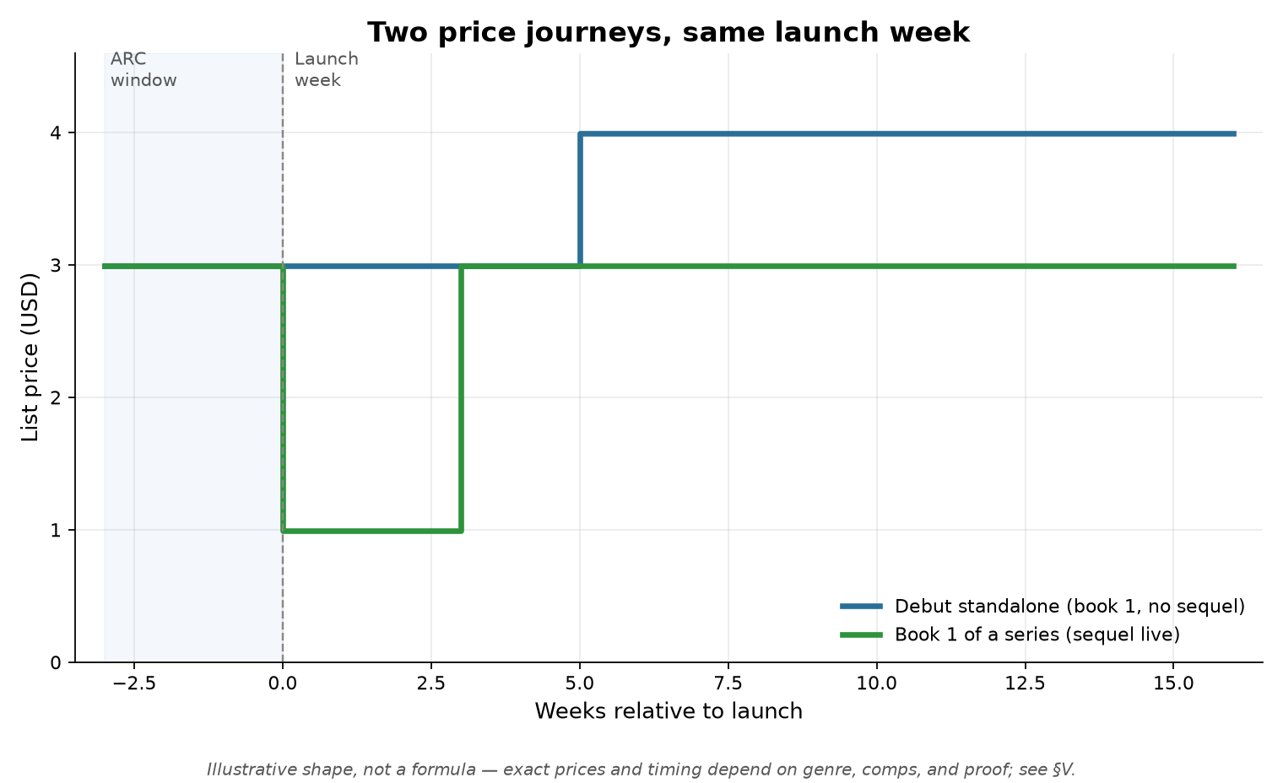

A debut standalone (or book one with nothing behind it)
- Don’t launch at $0.99 unless you already have a list or a paid promotional blast lined up to make use of it. At that price you’ll earn almost nothing per copy, you’ll train your first public readers to see the book as a bargain-bin item, and — with no sequel yet — you have no way to recover that subsidy later.
- Launch somewhere in the 70 percent band. $2.99 is the reasonable default; $3.99 makes sense if your category’s visible comparable titles cluster around that price and your book is long enough that $2.99 would look oddly cheap by comparison.
- Hold that launch price through the advance-copy window and the first two to four weeks the book is live. During this period you’re collecting reviews and building your first “customers also bought” neighborhood — not maximizing theoretical margin.
- Raise the price toward $3.99 or $4.99 once two things are both true: a handful of specific, substantive reviews exist, and your daily unit sales haven’t been depending entirely on the lower price. If sales collapse when you raise the price by a dollar, you’ve simply found the ceiling — lower it back down. That’s useful data, not a failure.
- Don’t open a first novel with no existing name at $7.99–$12.99. Literary exceptions to this exist, but they aren’t the norm — look at the actual first page of your category’s bestseller list, not at how you personally feel about the manuscript’s worth.

A series, once two or more books exist
Once a series has two or more books, book one effectively becomes an acquisition cost, and books two onward become the actual margin. Here’s the pattern that tends to survive contact with the royalty math:
Title | Early life | Settled life | Why
Book 1, only child | $2.99–$3.99 | Same until a sequel exists | No funnel. This book must earn.
Book 1, sequel live | $0.99 for a launch window, or stay $2.99 | $0.99, $2.99, or permafree | You can now afford to give the first yes away.
Books 2–n | $3.99–$5.99 | Hold or step up on later volumes | This is the catalog’s wage.
Box set | Inside 70% band | A little under the sum of parts | Catches binge readers; still pick 70%.

A permanently free book one — free everywhere, with Amazon price-matched to that free price — conflicts directly with KDP Select enrollment on that same title, since it’s fundamentally a wide-distribution tactic. It only pays off if read-through to the paid sequels is genuinely real; a permanently free book one backed by a single thin sequel is simply a gift to the internet.
Pricing book one at $0.99 during a new-release window is the Select-compatible version of the same underlying idea — you’ll earn 35 percent on those copies, plus page-read income from Kindle Unlimited if you’re enrolled. The actual point is driving traffic into book two, which stays priced in the 70 percent band.

When to raise, when to cut
- Raise the price once proof exists, once a sequel exists, once a promotional window ends, or when comparable titles on the same shelf have moved. Raise by a dollar at a time and watch a full week’s results before deciding anything further — don’t yo-yo the price daily.
- Cut the price for a scheduled, announceable promotion, not out of impatience on a quiet Tuesday. Permanent cuts train your own list to simply wait you out.
- Never pair a price cut with a required review of any kind — the free or discounted copy is the only concession you’re legally allowed to make.

Kindle Unlimited changes the launch discount
If the title is enrolled in Select, a $0.99 or free window still pays you when Kindle Unlimited readers actually read the pages — which makes a launch discount considerably less risky than it would be outside Select, provided readers actually finish the book. If they don’t finish, you’ve effectively paid for sampling that produced neither royalty nor a review. Advance copies exist partly so you can find that out privately, before launch, rather than publicly, after it.

The constraint that keeps the money
Chapter 6 gave the rule in one line: a free or discounted copy is allowed, but a required, steered, or rewarded review is not. Friends, employees, and author-for-author review swaps all sit outside what Amazon considers acceptable here. An unverified advance-copy review still displays publicly — it simply lacks the Verified Purchase badge. Chasing that badge by refunding readers after they buy is exactly the kind of pattern that gets listings cleaned out.
Enforcement here has only gotten more aggressive over time, not less: Amazon has spent the last several years actively pulling flagged reviews — incentivized, traded, or machine-written — and closing accounts on both sides of that trade. One genuine, unsolicited paragraph from an actual stranger now outlasts a hundred purchased five-star ratings that simply vanish in the next enforcement sweep. Confirm the current Community Guidelines before you build any kind of reviewer roster; this is the part of the rulebook that changes the most often.
A second, separate rule applies to the manuscript itself, not just its reviews: KDP requires disclosure of AI-generated content, on a distinction that is Amazon’s to draw, not an author’s judgment call. Chapter 32 states that rule in full, with the exact line KDP draws between disclosed and undisclosed use — read it before you check either box on the AI-content questionnaire.

Who is allowed to post on Amazon
A free copy alone is not enough to make someone eligible to review. On Amazon.com, Community Guidelines require a reviewer to clear a specific spend threshold before they’re allowed to leave a rating or written review at all:
- At least $50 spent on that marketplace with a credit or debit card in the past twelve months.
- Promotional discounts do not count toward that $50.
- Gift-card-only spend is widely treated as not counting either.
- Each Amazon marketplace sets its own bar in its own currency — spend on Amazon.co.uk or .ca does not qualify an account on .com, and the reverse is equally true.
That’s exactly why a brand-new Amazon login can read your EPUB in full and still hit a wall at the review button. Prefer advance readers who already have a history of Amazon reviews on other books. Never tell anyone to go spend fifty dollars specifically so they can review you — that starts to look like an implicit condition on the review. And meeting the spend threshold still doesn’t create a Verified Purchase badge on its own; that badge comes from a separate check confirming they actually bought this specific title on Amazon at a normal price.
This same fragmentation shows up in royalty bands as well, not just in review eligibility. Amazon.com’s 70 percent band is priced in US dollars; Amazon.co.uk, Amazon.de, and the rest each publish their own band in their own local currency, and a book can end up sitting inside the band on one storefront while falling outside it on another, even at what looks like “the same” converted price. A series priced consistently in USD is not automatically priced consistently in royalty terms once it’s live across five different storefronts. Check each marketplace’s own current help page — not a currency converter — before assuming your domestic pricing logic carries over.

Goodreads is a different door
Goodreads works under an entirely different rule: it has no spend minimum at all. A normal member account can rate a book as soon as its edition exists in Goodreads’ system, including well before publication — something Amazon never allows. Treat posting on the two platforms as two separate jobs: Goodreads while your advance readers are still reading, and Amazon on the morning the KDP page actually goes live. A Goodreads rating never counts as an Amazon review, and the two shouldn’t be confused.
For advance copies specifically, Goodreads now asks the reader to confirm they actually read the book (marking it Did Not Finish is an allowed answer) and to pick a source for how they got it — author or publisher, Giveaway, NetGalley, or other — and that source can display alongside the review. Marking a book “Want to Read” isn’t enough to leave a star rating; the book has to sit on Read, Currently Reading, or Did Not Finish. Never tell readers to hide the fact that they received a free copy on Goodreads — the source picker itself is how that gets disclosed.
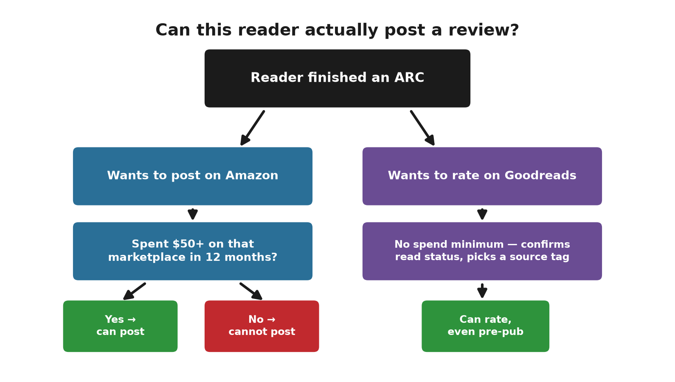

The first bad one
Not every review will be a good one, and that’s worth preparing for honestly. Amazon does not remove a review simply for being critical or for landing at one or two stars — it only removes reviews that actually violate Community Guidelines: obscenity, harassment, spam, off-topic content, someone else’s personal information, or a competitor posting in bad faith. A reader who genuinely disliked the book falls into none of those categories, and reporting that review through Amazon’s “Report abuse” link won’t get it removed, nor should it.
Don’t reply to it. An author’s public reply sits permanently underneath the review, and a defensive-sounding one will read worse to future shoppers than the original star rating ever did on its own. If the review does name a genuine production fault — a broken table, a missing chapter, a formatting error — fix the file and move on; that fix helps the next hundred readers far more than any argument with this one reader ever would.
A single candid three-star review that names a specific, genuine gripe is, by most working authors’ own account, worth more to a cold shopper than yet another five-star review that just repeats “loved it.” A page of nothing but superlatives actually reads like a page where nobody felt able to be honest. Recruit your advance readers for honest reactions, not for unanimous praise — the ARC form described below is already built to ask for exactly that.

Running the roster without breaking the rule
In practical, unromantic terms, this means: a sign-up form that states plainly that any review is optional. A roster that favors genre readers with a public history of actually writing reviews — and, on Amazon specifically, an account capable of posting one at all. Three emails cover the whole relationship: you’re confirmed for the list; here’s the file; here’s the live URL once the book is out. One later follow-up note to everyone who downloaded. And never a sentence like “book two only if you posted four stars” — that crosses directly into being a gift card, which Amazon’s rules explicitly forbid.

Delivering the file
Convert the Word file to EPUB before sending it to human readers. KDP itself can accept a .docx file directly, but your readers shouldn’t have to deal with one. Lock the manuscript’s text before anyone reviews it — a public review of a draft is, after all, only ever a review of that draft, not of the finished book.
If you email the EPUB, the attachment is the book — but a Kindle does not open a Gmail attachment by itself. The reader has two paths:
- Forward the saved file to their own address ending in @kindle.com (Amazon → Content and Devices → Preferences → Personal Document Settings), sent from an email address Amazon has already approved on that same page.
- Or open the `.epub` directly in the Kindle app, Apple Books, or Google Play Books.
Services like BookFunnel and StoryOrigin exist specifically so you don’t have to teach this process to readers one at a time.
Key takeaway: Every rule in this section exists to answer one question honestly — did a real reader choose to say this? A free copy, a spend threshold, a disclosure checkbox, and a delivery method are all just plumbing in service of that one fact. Optimize the plumbing all you want; never touch the fact itself.

The free pipeline, now as a profit tool
Open your sign-up form the same week the draft manuscript is ready. Aim to recruit thirty to fifty people if your goal is something near ten posted reviews. Send the files two to three weeks before the book goes live, and only ask for Amazon reviews once the form and roster actually exist. If you use a paid matching service, they generally prefer a runway of about forty days and a title that isn’t already stale by the time they receive it.
Published guidance on managed ARC campaigns — built around real deadlines, reminders, and an actual managed roster rather than a link dropped into a Facebook group — reports review rates landing between roughly 38% and 75% of the readers who received a file, nowhere near the fractional percentage a cold free-day grab typically produces. A roster of twenty to thirty readers commonly turns into ten or more day-one posts by that same logic.
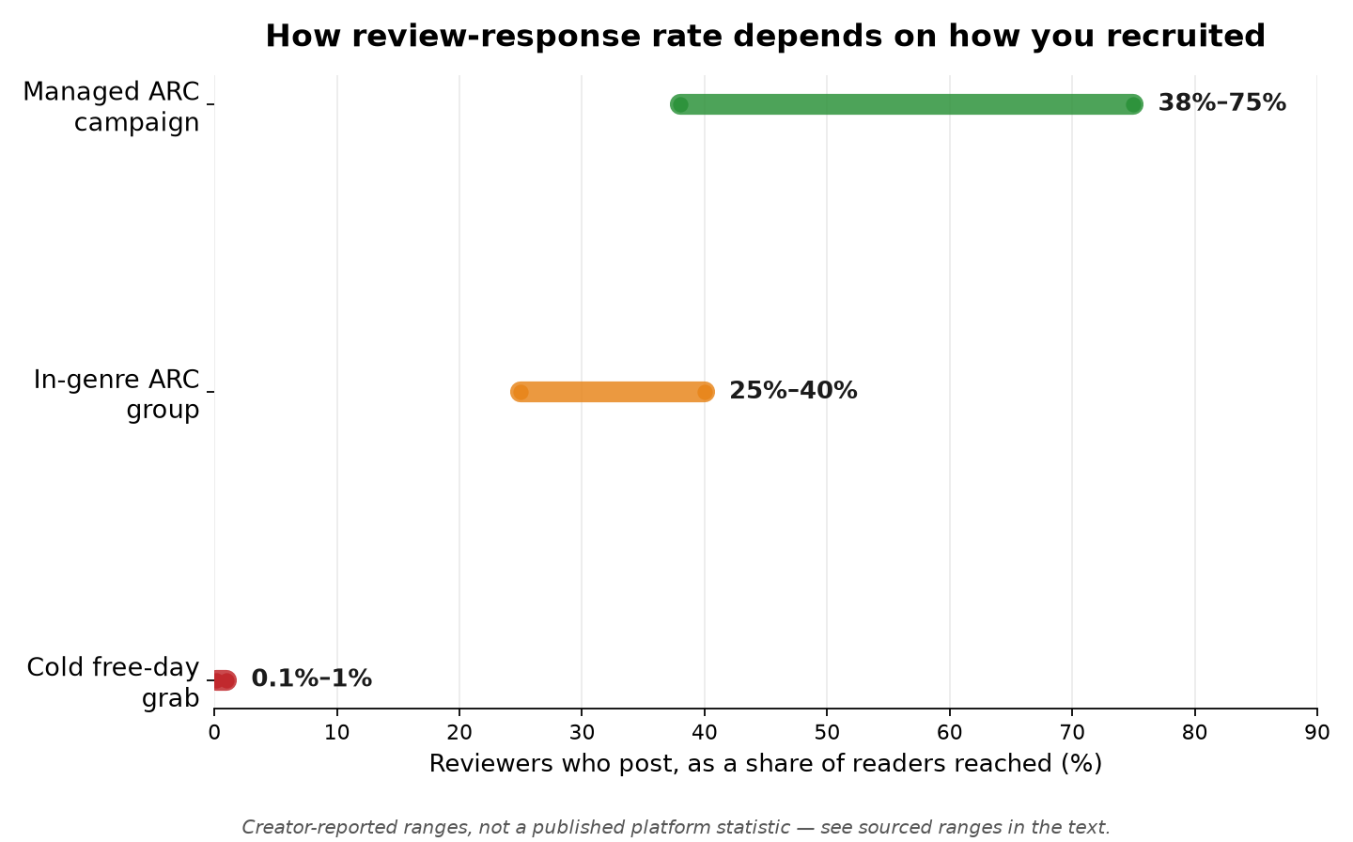

Who the form is for, and where it goes when you have no list
Think of the Google Form as an application, not an invitation. It should be filled out by strangers who already read in this genre — not by family. If you have no existing list and no followers yet, skip those sources entirely; you never actually had an audience to draw from there. Build the form itself at forms.google.com, asking for: name, email, three in-genre titles read in the last year, an Amazon or Goodreads profile link, device type, a finish-by date, optional trope preferences or hard limits, and a required checkbox confirming that any review is optional and must be honest. Share only the form’s link, never the EPUB itself — the spreadsheet collecting responses behind the form is your actual roster. You review and approve applicants first, then send the file.
As for where that form link actually goes: search Facebook for groups like Indie Fantasy Addicts ARC and Beta Readers, ARC Group for Readers & Authors, and ARC Readers and Authors, plus a genre-specific group such as a science-fiction ARC group if that fits your book. Join each group, read its pinned rules, and post the link once — no buy link, no request for a required review. On Reddit, stick to r/ARCReaders and r/AdvanceReaderCopy specifically, not general subreddits like r/scifi or r/selfpublish. One public post under your pen name and up to five direct messages to small reviewers who already post in-genre are both optional additions. If you get zero signups after a full week, that’s a reason to run a quiet test — repost the identical ask in exactly one low-traffic group by itself, and see whether that single quiet pond produces even one response before concluding the whole genre has no readers to find — or a reason to consider paying a service like BookSirens later. It is never a reason to fall back on recruiting relatives.
When | Action | Money reason
Upload week | EPUB, form, recruit | Reading time is the bottleneck on launch conversion.
2–3 weeks out | Deliver files | Posts need to exist the week units are cheap to get.
Live week | Review URL; hold sensible price | Convert the spike. Do not discount into 35% without a sequel.
Weeks 3–6 | Consider a $1 raise if proof exists | Stop subsidizing once trust is visible.
Book 2 in hand | Reprice book 1 as bait if you wish | Move margin to the titles that collect it.

Recruit in this order: your own list first, then your own channels, then groups that specifically exist for advance copies. Screen every applicant for genre fit and a real, checkable profile. After each campaign, tag every reader Core, Soft, or Out — a reader earns “Core” status for the next campaign because they actually posted, not because they awarded five stars. Track downloads against sends, posts against sends, and how many Core readers from last time remain Core this time. Holding onto readers who never even opened the file, purely for the vanity of a longer list, is exactly how a catalog stays a hobby instead of becoming a business.

What to pay for — only if it raises expected value
Only pay to fill a genuine hole in your funnel, not to soothe your own anxiety about launch. If you have no existing reader names to draw from, a capped matching service like BookSirens Promote or Booksprout can help. If Kindle delivery logistics are eating up your week, BookFunnel’s mail tool handles that. If you want to trade newsletter placements with other authors later, StoryOrigin is built for that. For librarians specifically, NetGalley is the standard route, though it won’t reliably produce ten Amazon reviews on a small budget. Using two separate finder networks on the same title is largely wasted spend — the same reader doesn’t convert any faster for having been found by both of them.
A bounded BookSirens experiment — a listing fee plus a few dollars per reader they find who actually downloads the book, capped at twenty-five readers — costs less than a month of ads run against an empty, unreviewed page. What you’re actually buying is downloads from people who asked to read the book, not guaranteed written reviews. The review stays entirely optional throughout, which is the whole point of the arrangement.

After the listing can bear traffic
Select’s terms are in Chapter 27: ninety days of ebook exclusivity, page-read income, and either free promotional days or a Kindle Countdown Deal in each term. Free days used after you have proof the book converts, and actually announced to someone, can genuinely acquire new readers. Free days used before you have that proof, announced to no one, are a tree falling in an empty forest. A Countdown Deal keeps your 70 percent royalty during the discount, even below $2.99 — it’s built for books that are already selling, not for books trying to find their first readers.
If you decline Select and go wide instead, Draft2Digital reaches other retail stores and library vendors — just uncheck Amazon in its distribution settings, since Amazon is handled directly through KDP. Library licenses are a slow secondary market that develops over time, not something to expect results from during launch week. A permanently free book one lives entirely in the wide-distribution world; it has no place inside Select.
Ads belong in this sequence only after the review module is no longer empty and the price has settled where you actually intend it to live long-term. Run them any earlier, and you’re simply paying to demonstrate that untrusted pages don’t convert — precisely the lesson this chapter was written to spare you from learning the expensive way.

A sequence that is allowed to mention money
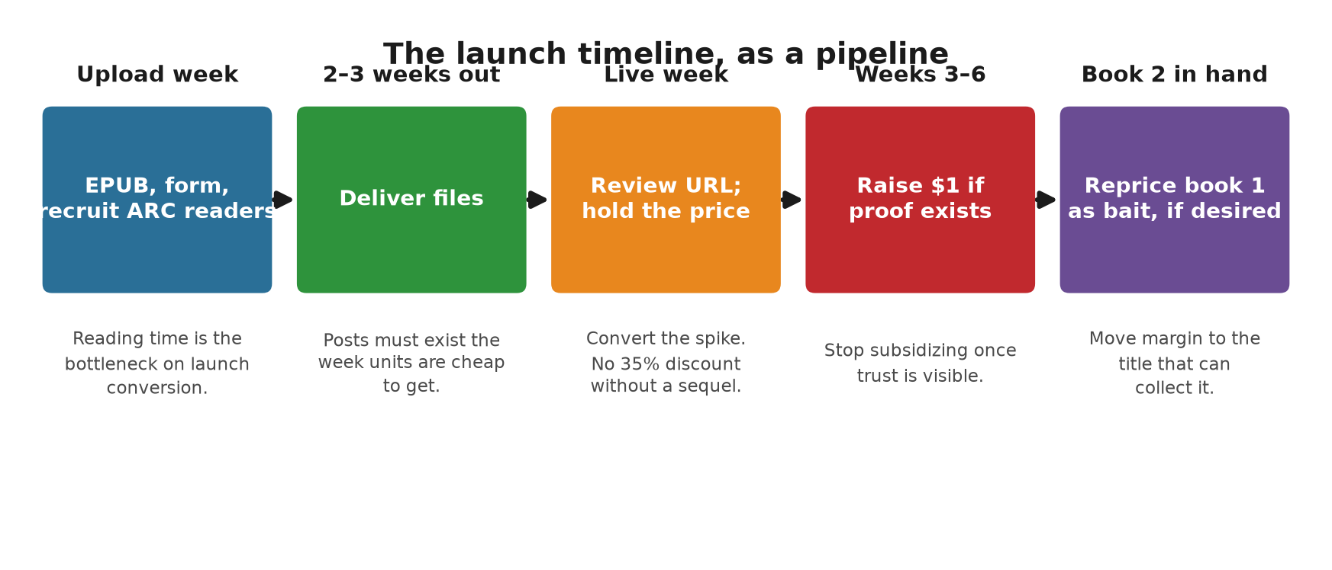
1. Lock the manuscript, convert it to an EPUB, and price the ebook inside the 70 percent band unless you already have a sequel that justifies pricing this one as bait.
2. Recruit advance readers now, and send them files two to three weeks before the product page actually exists.
3. Go live, send out the review URL, and don’t spend any serious ad money until a few honest reviews actually exist.
4. If the roster turns out thin, run one capped matching-service campaign to fill the gap.
5. Once you have proof the book sells: raise the price by a dollar if units hold steady, or keep the current floor and get to work on book two.
6. Once book two exists, decide deliberately whether book one should become bait for it, and put the actual margin on whichever titles are positioned to collect it.
7. Only after all of that, spend on free promotional windows, newsletters, or ads — treating the page as an actual product rather than a plea for attention.
The letters for each step — invitation, confirmation, delivery, live page, and the one follow-up — are in Chapter 13, ready to copy. The live-page letter can link straight to Amazon’s review form, with your own ASIN in place of the placeholder:
https://www.amazon.com/review/create-review?asin=YOURASIN

Field reports — what published accounts actually show
Certainty, labeled. Blogs and author interviews are not laboratories. They are still better than folklore, provided you notice who already had a list before the launch you are reading about. The pattern that repeats is not magic — it is proof on the page, a price that can move, and something to sell after book one.

This book’s approach, in the wild

An established science-fiction author’s series launch (BookBub Partners case study, 2016)
The author was not a first-timer, and that fact is part of the lesson here. Two weeks before launch, he sent digital advance copies to forty readers through BookFunnel, and about half of them posted a review on launch day. He also placed short quotes in the editorial-review field on the product page, which is a separate thing from the customer-review module itself. He launched at $0.99 and raised the price to $2.99 within a week. Over the first seven weeks, the book sold more than 20,000 copies plus a substantial amount of Kindle Unlimited reading, and the author has said explicitly that his mailing list did more for the launch than any single other tactic.
What’s worth copying here: the two-week advance-copy window, using BookFunnel as delivery plumbing, and a planned price raise after launch. What’s not worth copying blindly: opening at $0.99 with no list and no sequel of your own — this author was effectively buying rank with a crowd he already owned.

A debut novelist’s launch (BookBub Partners interview, 2024)
This is a debut closer to what most first-time authors actually face. The author built her advance-reader roster using a Google Form, social media posts, BookFunnel delivery, and BookSirens — the latter producing nine readers and seven reviews, some of them usefully detailed. Goodreads filled up first, reaching around 120 ratings before Amazon’s review count caught up. She priced the ebook at $3.99 and didn’t discount it immediately, and a week after launch reported more than 200 copies sold. The features that actually moved units were a BookBub New Releases for Less placement and an advance-access email blast — not the ARC team on its own.
What’s worth copying: pairing a sign-up form with a capped matching service, holding at $3.99 when you don’t yet have a sequel to recover the cost of a $0.99 week, and treating a service like BookSirens as a quality supplement rather than your main pipeline. Treat any extra physical gifts as entirely off-limits if they’re tied to an Amazon review in any way — Amazon’s rule remains that the free copy of the book is the only allowed concession.

The 20Booksto50K philosophy (an indie publisher, multiple interviews, 2017–2024)
This one isn’t a single launch, and isn’t quite this chapter’s usual kind of case study — it’s a publishing philosophy, documented on the record across many interviews rather than as one countable event. The publisher behind it, through LMBPN Publishing, built a catalog of several hundred titles around a stated unit target: roughly $7.50 in royalty per book per day as the bar a title needs to clear to remain worth active promotion, a figure he has repeated consistently across interviews rather than asserted just once. The name “20Booksto50K” describes the broader movement that the press’s founders helped start through their talks — prioritizing volume and catalog depth over any single book’s individual performance, with book one deliberately priced to move readers into the later books that actually carry the margin.
What’s worth copying: setting a stated per-unit bar instead of relying on a vague sense that a book is “selling okay,” and deliberately treating book one as an acquisition cost at full catalog scale. What’s not worth copying blindly: this model assumes a catalog large enough that the bar can be measured across dozens of titles at once — as discussed across multiple interviews — rather than a debut author’s single book, which has no fleet-wide average to fall back on.

A composite pattern, illustrative only (not a single checkable source)
Unlike the sourced cases above, this one doesn’t actually clear this book’s own bar for a real case study — it comes secondhand, from a formatter describing unnamed KDP exports rather than from a named author on the record. It’s included only because the shape it describes recurs often enough to be worth naming, clearly marked here as the exception it is. In this account, a four-book series sat at a flat $4.99 for six months, with book-one-to-book-two read-through running at about 11 percent. Book one was then cut to $0.99 for thirty days with the rest of the series already live, and read-through to book two rose to about 19 percent during that window. Treat the shape of that result, not its specific numbers, as the real takeaway: don’t discount book one to nothing until a paid book two actually exists to receive the traffic.

Kboards thread on full price versus 99 cents (2017)
In this thread, working authors compared notes publicly. One launched at $2.99 and raised the price to $4.99 after three or four weeks — unit rank worsened, but overall revenue improved. Another launched a sequel at $0.99 while book one ran a free-day promotion simultaneously. The store itself has changed considerably since 2017, but the underlying tradeoff hasn’t: $0.99 buys motion, while $2.99–$4.99 buys margin. Decide which of those two problems you actually have before choosing.

Alternatives that are not the same book

List first, book second
The established author’s result above is, in part, a result of the list he’d already built. Some authors deliberately refuse to launch at all until a few hundred email addresses exist, on the reasoning that the first-review problem shrinks considerably once launch week is no longer cold. The real cost of this approach is time: if the manuscript is already finished, waiting a full year just to start the ARC clock is usually the wrong trade, since a finished manuscript ages more like milk than wine. The better approach is building the list in parallel with finishing the book, not before it.

Full-price launch, no 99-cent week
The debut novelist’s decision to hold at $3.99 is this alternative in practice, as is the Kboards author who raised to $4.99 and ended up taking home more money on fewer copies. This approach fits a standalone book, a slower-writing author, or anyone who genuinely won’t have a sequel out this year.

Promo stacking after proof
Freebooksy, Bargain Booksy, Fussy Librarian, and stacked partners are how many midlist fiction authors create a second spike. The commonly reported practice is stacking several lists on one planned price cut rather than lighting a silent free day. Those sites often want a review floor. That is the hinge: ARCs first, stack later.

Wide and slow
Published first-year accounts from authors building across several stores at once treat success as steady doubling rather than an Amazon spike. Libraries and Apple promotions via Draft2Digital become part of the engine. Reviews still matter on every storefront. Select free days and permafree book one cannot share a title. Different calendar, real business.

What the blogs get wrong
Some street-team advice tells authors to make their advance readers buy the already-live book so the resulting review carries a Verified Purchase badge. Amazon does not require this, and pressuring readers into it effectively reconstructs the exact kind of condition Amazon’s rules forbid. Some relaunch write-ups describe spending thousands of dollars on ads against a page that still can’t convert, then blaming the ads for the result rather than the page. And some promise a hundred reviews within forty-eight hours — that is not a method this book will endorse or describe as usable.
The accounts that actually hold together, across every example above, share three things in common: someone genuinely read the book before the wider crowd arrived, the price either sat inside the 70 percent band or was a deliberate, temporary discount paid to move readers into a sequel, and there was a next title, an email list, or both waiting behind it. Missing all three of these is exactly how a book ends up selling only to cousins, and then stops selling at all.

Claims that do not survive a spreadsheet
- That a debut should open at $0.99 to get reviews. Reviews come from people who agreed to read, not from a royalty you set on fire.
- That $1.99 is a friendly compromise. It is often a 35 percent trap that earns less than $2.99.
- That you should keep a first novel at $0.99 forever. Forever bait with no sequel is charity.
- That raising the price after reviews is a betrayal. Early price rented attention. Later price collects it.
- That one hundred reviews are required before anyone pays. The costly gap is zero testimony.
- That free days print reviews. They print files.
- That family reviews, properly disclosed, are a business plan. They are a policy problem.
One last limit worth stating plainly: this book cannot choose your tropes for you or make a weak cover convert on its own, and it cannot freeze KDP’s price band or a vendor’s fees in place — look both up again in the actual month you publish. What this chapter can do is refuse to indulge the hobbyist story in which a few courtesy sales from friends count as a real launch. Strangers pay once they see that other strangers actually finished the book, at a price the royalty table doesn’t punish, feeding into a catalog that has somewhere else to send them next. That’s the entire commercial problem this chapter has been describing. Everything else from here is simply execution.
Sources: KDP Help: Customer Reviews (G202101910); ebook list price and 70 percent option; Free Book Promotions; Select terms. Amazon Community Guidelines. Vendor pricing pages, because they move.
Not legal advice. Not an Amazon publication.

Part VIII — Using AI Well

Chapter 32: Using AI Without Losing the Business
Chapter 19 already covered the core rule for AI in your manuscript: it can speed up the unglamorous parts of writing, disclosure to KDP is mandatory, and a human stays the last editorial judgment. Chapter 28 covered the volume version of misusing it — flooding categories with thin, minimally reviewed AI output. This chapter is the rest of it: where AI genuinely helps everywhere else in the business, the disclosure rule stated in full, who owns what an AI writes, and the one line that separates “AI helped me write my book” from “I laundered someone else’s” — because that line gets crossed by processes that sound perfectly professional right up until the step that gives them away.

Where it earns its place beyond the manuscript
The same tools that help with a first draft are useful at almost every later stage of this pipeline, used the same way: as a fast first pass a person then judges, not as the final decision.
- Cover concepts (Chapter 21): generating rough visual directions or thumbnail-test variants to react to, before a human designer executes the one that actually works. An AI-generated final cover image carries its own disclosure obligation — see below — separate from the manuscript text.
- Ad copy and product-page description drafts (Chapters 22 and 25): fast variants of a headline, a bullet list of benefits, or an ad’s body text, for you to pick from and edit — the same “several alternatives, human picks and rewrites” pattern Chapter 19 already described for manuscript prose.
- Keyword and category brainstorming (Chapter 22): surfacing phrases and angles you might not have thought of, which you then verify the way this whole book insists on — checking they’re real search terms and an honest fit, not just plausible-sounding.
- Research synthesis in your own words: using AI to summarize a pile of your own notes or a topic you’re already researching, then writing the actual explanation yourself. This is meaningfully different from the trap in the next section, and the difference is exactly what that section is about.

Building background knowledge on a topic, the legitimate way
Writing competently about a topic you don’t already know cold takes real background research, and there’s nothing improper about drawing on more than one kind of source to get there — the question is always what you do with what you gather, not how many places you looked. A straightforward, legitimate process runs through three steps:
1. General search first. A search engine orients you fast: current terminology, what’s actually being asked and argued about the topic right now, recent developments a book written five years ago wouldn’t know about. Treat this as a map of the territory, not a source to write from directly — you’re finding out what’s out there and which questions matter, not collecting text to reuse.
2. AI for explanation and gap-filling. Ask an AI tool to explain a concept, walk through an argument, or suggest an analogy the way you’d ask a knowledgeable colleague — not “condense these three specific books,” but “explain X” or “what’s the standard way to think about Y.” Use the answer to test and sharpen your own understanding, then write the explanation yourself, in your own words and your own structure. This is the same research synthesis named above, and it’s exactly why the distinction matters: you’re the one producing the explanation that ends up on the page.
3. Read what’s already published in the space — condensing and merging is fine here, as background. Reading other books on your topic is normal, expected preparation, and for a topic two or three existing books already cover, condensing each one’s key content into your own notes and merging those notes into one synthesized picture of what the field already says is exactly what a literature review or a research binder is — a legitimate way to get oriented fast instead of slowly. The rule that keeps this a research technique rather than the trap in the next section: those merged notes exist to build your own understanding, and nothing else. Close them before you draft, and write the actual manuscript from what you now know, in your own words, your own structure, your own examples — not by editing the merged notes themselves into publishable prose.
None of this is the trap the next section names, as long as the condensing and merging stays on the input side, feeding your own understanding, and never becomes the output you edit into your book. The difference was never about how many sources you touch, or even whether you condense them — it’s whether the condensed material stays private research or quietly turns into the draft. If the thing you’re polishing into a finished chapter is the condensation itself, you’ve crossed into the next section’s trap, no matter how good your notes were.

The disclosure rule, stated precisely
KDP’s publishing questionnaire requires you to disclose AI involvement, and the platform draws a specific line worth stating exactly rather than approximately:
Key takeaway: AI-generated content — text, images, or translations an AI tool produced, even if you edited the result afterward — must be disclosed. AI-assisted content — where you wrote or created it yourself and a tool only edited, refined, error-checked, or helped you brainstorm — does not need to be disclosed. The distinction is Amazon’s to draw, not yours to interpret generously: get it wrong and the risk is the listing coming down, not a warning email. Disclosure happens privately at upload and never appears on the product page. See KDP Help: Content Guidelines (G200672390) before you check either box — for the manuscript, the cover, or both.
That same distinction is why “I used AI to help me write” and “AI wrote it and I edited it” are not the same sentence, even when the finished pages look similar. Which side of the line a given book falls on is a fact about how it was made, not a matter of how confident you feel about your edits.

Who owns what the AI wrote?
Disclosure answers what Amazon needs to know. Ownership is a separate question, and the answer surprises most people: in the United States, text an AI produced on its own belongs to nobody.
The rule is the human-authorship requirement. The U.S. Copyright Office will not register material whose expressive content was generated by a machine, and the courts have backed it. In Thaler v. Perlmutter, the U.S. Court of Appeals for the D.C. Circuit held in March 2025 that the Copyright Act requires a human author. On March 2, 2026, the Supreme Court declined to hear the appeal, which leaves that ruling standing. Declining a case is not a Supreme Court ruling on the merits, but the practical position today is clear: a work with no human author has no copyright.
That does not leave AI-assisted books unprotected. The same appeals ruling says the requirement does not bar works made with the help of AI; what counts is the human contribution. Your own sentences are yours. So are your creative selection and arrangement of material and your creative changes to it. What stays unprotected is the machine-written expression itself. In its January 2025 report on copyrightability, the Copyright Office concluded that prompts alone, however detailed or often revised, do not make you the author of what comes back. How much human shaping turns AI material into your work is still being argued in court, so don't plan a business around the generous end of that line. Other countries draw it differently (the United Kingdom, for one, has a separate rule for computer-generated works), so check the law where you sell if a book depends on it.
Here is where the usual mix-up happens. An AI service's terms typically say the output is yours to use. That is permission, not ownership. The company is promising not to claim the text against you; it cannot hand you a copyright the law says does not exist. You may publish the output, but you cannot stop anyone else from copying the parts no human wrote.
Take the most tempting case: you had a long, sharp conversation with a chatbot, say about whether time is real, and you want to turn it into a book.
- You may. Check that service's terms first; most allow it.
- Disclose it. Every answer the AI wrote is AI-generated content under the KDP rule above, however much you trimmed it.
- Know what you own. Your questions, your commentary, your creative edits, and your choice and ordering of excerpts can be protected. The AI's paragraphs, copied as they came, cannot, and a competitor could lift them.
- Make it yours. The more of the finished book is your own explanation, argument, and structure, the more of it you own and the more there is for a reader to buy. A transcript with a cover is the weakest version of the idea. A book that uses the conversation as raw material is the strongest.
- Save the transcript and every draft. A chat service may not keep the conversation, and the AI will not remember it in a new session. Dated prompts, outputs, and revisions are also your evidence of what the human contributed if ownership is ever questioned.
Key takeaway: "The terms say the output is mine" means you may use it. It does not mean you own it. In the U.S., only the human-authored parts of an AI-assisted book carry copyright, so the more of the book you actually wrote, the more of it is yours.

The trap that looks like a process
A specific pattern is worth naming directly, because it’s packaged persuasively enough that it can look like professional workflow rather than what it actually is: take a small number of existing books on the same topic, have AI condense and merge them, then run a “similarity audit” whose job is to find and eliminate close parallels with those specific sources — in wording, in examples, in the particular way a concept is explained — until the draft no longer looks traceably derived.
The tell is the audit step itself. Legitimate research doesn’t need to check a finished manuscript against a short list of specific source books to scrub out whatever still resembles them — that step only exists because the process expects resemblance and is designed to launder it. Facts and concepts in a textbook aren’t protected by copyright; the specific way an author explains them, their chosen analogies, and their pedagogical structure are exactly what copyright protects. A workflow whose last move is erasing detectable similarity to particular copyrighted works isn’t producing independent material — it’s producing a derivative one dressed to pass inspection.
This isn’t only a copyright problem you’d face from the original authors. It’s also a direct hit on the account-level trust this entire book keeps coming back to (Chapter 28): a catalog built this way is one infringement claim away from every title on the account, not just the one book, and “an AI tool did the condensing” is not a defense KDP or a court is likely to find persuasive. If you want to write a textbook or a popular-science book on a subject other authors have already covered, the legitimate version of that project starts with researching the actual subject matter — not condensing their books — and produces your own explanations, your own examples, and your own structure, informed by the field rather than assembled from a few competitors’ pages.

Claims that do not survive contact with a copyright claim
- That rewriting a summary in different words makes it original. Originality lives in structure, explanation, and example — not just vocabulary — and a similarity audit built to catch exactly that isn’t evidence of originality, it’s evidence the process expected to need one.
- That AI involvement dilutes responsibility for what gets published. KDP’s disclosure requirement and ordinary copyright law both attach to the publishing account, not to whichever tool typed the words.
- That a book has to look AI-flooded (thin, generic, unedited) to be a policy problem. A polished, heavily-edited book built by laundering specific existing sources is a different, more serious problem than the volume-flooding trap in Chapter 28 — better production values don’t fix a derivative-work claim.

What copyright actually protects — and a legitimate way to adapt someone else’s work
Copyright protects the specific way an idea gets expressed — wording, chosen analogies, structure — not the underlying facts or ideas themselves (U.S. Copyright Act §102(b)). That is exactly why “I kept the facts and just rewrote the wording” is weaker than it sounds for nonfiction: the analogies, the structure, and the explanatory choices are the expression, not decoration around it.
None of the following, on its own, makes a derivative work legal — each gets repeated constantly, and none of them holds up:
- “I changed a set percentage of it.”
- “AI wrote the new wording.”
- “I credited the original author.”
- “It’s transformative” — transformative purpose is one factor in a four-factor U.S. test, not a standalone pass (see the Fair Use Index).
- “It’s for an educational market.”
- “Only the structure or approach is the same, not the exact words.”
- “I didn’t charge money for it.” Commercial gain is one factor courts weigh, not a threshold — plenty of noncommercial uses still infringe.
- “It’s a parody.” Parody, satire, and pastiche are specific, narrow legal categories with their own requirements; calling something a parody doesn’t make it one, and a work that doesn’t actually comment on or mock its source through the borrowing itself won’t qualify just because the author labels it that way.
If the goal is genuinely to build on someone else’s existing work rather than your own research, there are exactly two legitimate paths: get a license from the rights holder, or adapt something actually in the public domain — not just old, not just freely downloadable somewhere, but verified public domain in every territory you’ll sell in. Duration rules are jurisdiction-specific and don’t track intuition: a modern translation of a public-domain original can still be separately protected, and an “old” edition can carry its own separately-copyrighted introduction, annotations, or cover art (Circular 15A: Duration of Copyright). Verify the exact edition and every layer of it before you build anything on it — not after.
Key takeaway: “I checked, and this exact text and translation are public domain everywhere I’m selling” is a real starting point. “It felt old enough” is not, and has ended author careers that started from exactly that assumption.
Sources: KDP Help: Content Guidelines (G200672390); Thaler v. Perlmutter, 130 F.4th 1039 (D.C. Cir. 2025), cert. denied (U.S. Mar. 2, 2026); U.S. Copyright Office, Copyright and Artificial Intelligence, Part 2: Copyrightability (January 2025); U.S. Copyright Act §102(b); U.S. Copyright Office Fair Use Index; U.S. Copyright Office Circular 15A (Duration of Copyright). General principles only, not legal advice — get a lawyer for a specific manuscript, not a book chapter.
Not legal advice. Not an Amazon publication.

A Closing Word
Nothing in this book is complicated on its own. Royalty math is arithmetic. Keyword slots are a form field. A launch is a calendar with the same events moved closer together. What makes self-publishing hard isn’t any individual step — it’s that all thirty-two chapters’ worth of steps land on one person, and it’s tempting to skip the unglamorous ones (a real editing pass, an honest category choice, the tax interview) in favor of the exciting one (hitting publish).
The authors who make good money at this aren’t the ones who found a secret Amazon doesn’t want you to know. They’re the ones who did the plain, checkable, occasionally tedious work in every chapter of this book, on purpose, in order, and then did it again for the next book — because by the second time, most of it was already fixed cost, paid off. That’s the whole secret, and it was never actually a secret.
If you remember one thing from both halves of this book, make it the keep test from Part I: before you spend money or a week, write what one sale leaves you, who the book is for and who it is not for, and the one change you will make and the day you will look. Every chapter after that is the same three lines, worked out in more detail. The checklist, the royalty reference, and the official sources follow, for the day you sit down to publish. Go write something worth finding.

Appendix A — The One-Page Launch Checklist
☐ Manuscript
☐ Developmental, line, copy, and proofread passes complete (Chapter 19)
☐ At least one pass done by someone other than you
☐ Every number and cross-reference checked
☐ Format
☐ Ebook: real Heading 1/2 styles used throughout; no page-numbered TOC; no index (Chapter 20)
☐ Print: page numbers, running headers, correct trim size and margins; spine width from KDP’s calculator, not hand-calculated (Chapter 20)
☐ Checked in KDP’s online previewer on more than one device size
☐ Physical proof ordered and read, for any print edition
☐ Cover
☐ Passes the thumbnail test at actual small size (Chapter 21)
☐ Matches genre/category conventions on purpose, not by accident
☐ Title readable, one clear focal point
☐ Metadata
☐ All seven backend keyword slots used, as full phrases, none repeating title/subtitle words (Chapter 22)
☐ Most specific honest category chosen in all three slots — chosen with care (Chapter 22)
☐ Price set deliberately inside (or intentionally outside) the 70% band, not by default (Chapter 23)
☐ Compliance
☐ Tax interview (W-9 / W-8BEN / W-8BEN-E) completed and correct (Chapter 26)
☐ AI-content disclosure answered honestly, if applicable (Chapter 19; Chapter 32 has the full disclosure rule and the trap to avoid)
☐ KDP Select enrollment decided on purpose, not left on autopilot (Chapter 27)
☐ Launch
☐ ARC team recruited, copies out with enough lead time to finish reading
☐ Reviews and personal-network purchases coordinated to land at/near launch, not trickled (Chapter 24)
☐ Ad campaign (auto, small budget) ready to start on launch day, if using one (Chapter 25)

Appendix B — Royalty Quick Reference
☐ Ebook
☐ 70% royalty band: list price $2.99–$12.99 (US), with a delivery fee (~$0.15 per MB of file size) taken off the price before the 70% applies — the top of the band expanded from $9.99 in July 2026; existing titles priced $10–$12.99 must be switched to the new band by hand in Rights & Pricing
☐ 35% royalty: any price outside that band ($0.99–$200), no delivery fee subtracted
☐ Kindle Unlimited / KOLL: paid per KENPC page read, from a shared monthly fund; rate varies month to month (historically roughly $0.004–$0.005/page) — check your Reports dashboard for the actual current rate
☐ Print
☐ Paperback (Amazon channel): 60% of list price at $9.99 and up on Amazon.com (50% below), minus printing cost
☐ Paperback (expanded distribution): 40% of list price, minus printing cost
☐ Hardcover (Amazon channel): 60% of list price, minus printing cost
☐ Printing cost depends on page count, trim size, ink (B&W vs. color), and paper choice — always confirm with KDP’s own price calculator before setting a list price
☐ The one formula worth memorizing
☐ Break-even ACOS ≈ Royalty per copy ÷ Sale price × 100%

Appendix C — ISBNs, Wide Distribution, and Further Reading

ISBNs
KDP does not require you to buy an ISBN, for any format, ever. A Kindle ebook needs no ISBN at all — it’s identified by its Amazon-assigned ASIN instead. A paperback or hardcover does need an ISBN to exist, but KDP assigns one to you automatically, at no charge, the moment you publish, if you don’t supply your own. Anyone charging you a fee “so you can get an ISBN and publish” is billing you for something KDP already gives away free — the same trap Chapter 28 names directly.
The only reason to buy your own ISBN instead is control, not permission. A free KDP ISBN lists KDP as the book’s publisher of record and ties that specific ISBN to Amazon’s own print service. Buying your own — from Bowker, the official U.S. ISBN Agency, or your own country’s national ISBN agency elsewhere — costs money, but lists you as the publisher of record and lets you move the same edition to a different print provider later without changing its identifying number. For a book staying on KDP print indefinitely, the free ISBN is a perfectly reasonable choice; buy your own only if you specifically want to be recorded as your own imprint, or expect to need print-provider flexibility later.

Wide distribution tools
For authors choosing to go wide (Chapter 27) rather than enroll in KDP Select, common legitimate routes include distributing directly to individual retailers (Apple Books, Kobo, Barnes & Noble Press) or through an aggregator that handles multiple retailers and library platforms from a single upload — Draft2Digital and PublishDrive are widely used examples. For wider print distribution into bookstores and libraries beyond KDP’s own expanded distribution option, IngramSpark is the most commonly used print-on-demand and distribution service in the indie-publishing space.

Further reading and legitimate resources
KDP’s own Help pages and KDP University — the single best free, authoritative, continuously updated source for exact current policies, price bands, and thresholds. When any number in this book conflicts with what KDP’s own pages currently say, trust KDP’s pages — this book’s arithmetic will still be correct, but specific figures (delivery fee rates, payment thresholds, category lists) are exactly the kind of detail that changes over time.
Author communities built around self-publishing craft and business (genre-specific writing organizations, indie-author forums and groups) are a good source of current, lived experience — read them the same way Chapter 28 recommends reading anything: with an eye for whether a claim is documented policy or someone’s unverified theory about “the algorithm.”
A tax professional familiar with royalty or self-employment income, for the specific questions Chapter 26 deliberately declined to answer in general terms.

Glossary
One line each. The chapter that teaches the word is named.
Advance copy. A free book you send before publication. A review is optional. Chapter 6.
Backlist. The books you already published and left on sale. Idea 20 in chapter 8.
Countdown. A short, scheduled price cut, up to seven days, for books in KDP Select on Amazon.com and Amazon.co.uk. It keeps the 70 percent rate below $2.99 if the book is on that option. Idea 9 in chapter 8. [6]
Delivery. A per-megabyte charge taken off before the 70 percent cut. Not taken off in the 35 percent band. Chapter 3.
Expanded distribution. The wider paperback channel. Its rate is lower than a sale on Amazon’s own store. Idea 22 in chapter 8.
Keep. What one sale leaves you after the percentage and, when it applies, delivery. Chapter 3.
KDP Select. A 90-day enrollment. Page reads may pay you. The ebook stays exclusive to Kindle for the term. Idea 8 in chapter 8; chapter 27 in full. [5]
Seventy percent band. On Amazon.com, as checked on 1 October 2026, the usual ebook prices from $2.99 to $12.99 where a 70 percent royalty can apply. The top was $9.99 until 7 July 2026. Chapter 3. [3]
Thumbnail test. Whether the title can be read when the cover is tiny. Chapter 5.

Official sources
These links support the platform rules named above. The thirty-two ideas, the sample months, and the rounded keeps are teaching tools, not Amazon rules. Checked 1 October 2026. Look again before you publish.
[1] Amazon KDP Customer Reviews
https://kdp.amazon.com/en_US/help/topic/G202101910
[2] Amazon Community Guidelines
https://www.amazon.com/gp/help/customer/display.html?nodeId=GLHXEX85MENUE4XF
[3] Amazon KDP eBook List Price Requirements
https://kdp.amazon.com/en_US/help/topic/G200634560
[4] Amazon KDP Digital Book Pricing Page
https://kdp.amazon.com/en_US/help/topic/G200634500
[5] Amazon KDP Select
https://kdp.amazon.com/en_US/select
[6] Amazon KDP Kindle Countdown Deals
https://kdp.amazon.com/en_US/help/topic/G201293780
[7] Amazon KDP Paperback Royalty
https://kdp.amazon.com/en_US/help/topic/G201834330
[8] Amazon KDP Content Guidelines
https://kdp.amazon.com/en_US/help/topic/G200672390
[9] Amazon KDP Kindle Publishing Guidelines
https://kdp.amazon.com/en_US/help/topic/GU72M65VRFPH43L6
[10] KDP Select Global Fund and All Stars Bonus Update, July 2026
https://www.kdpcommunity.com/s/article/KDP-Select-Global-Fund-and-All-Stars-Bonus-Update---July-2026
[11] Amazon KDP Create a Book (title creation limit)
https://kdp.amazon.com/en_US/help/topic/G202172740
[12] Amazon KDP Digital Rights Management
https://kdp.amazon.com/en_US/help/topic/GDDXGH9VR22ACM8U
Independent guide. Not affiliated with or endorsed by Amazon. Check the live help pages before you act.

Also by Lothar J. Musiol
Physics, Actually
- Physics, Actually, Volume 1: Motion, Forces, Time, and Relativity
- Physics, Actually, Volume 2: Gravity, Cosmology, and the Limits of Spacetime
- Physics, Actually, Volume 3: The Standard Model, Chaos, and the Edge of Knowledge
- Life, Actually: From the First Cell to the Edited Genome and the Search for Life Elsewhere
Math, Actually
- Math, Actually, Volume 1: From Arithmetic to Calculus
- Math, Actually, Volume 2: From Multivariable Calculus to Set Theory & Logic
- Math, Actually, Volume 3: From Differential Equations to Abstract Algebra
- Math, Actually, Volume 4: From Category Theory to the Frontier
Quanta, Actually
- Quanta, Actually, Volume 1: The Quantum World
- Quanta, Actually, Volume 2: The Quantum Conversation
- Quanta, Actually, Volume 3: Complete Quantum Electrodynamics Course
Science Sparks
- Science Sparks: Physics, Life, and Mathematics — The Same Few Rules, Told in Highlights
Look First
- Look First, Volume 1: The Universe Has No Now
- Look First, Volume 2: A Trip Is Not a New Life
Electrical Engineering Series
- Foundations of Electronics (Book 1)
- Circuits, Components, and Control (Book 2)
- Semiconductor Physics and Devices (Book 3)
- RF, Microwave, and Transceivers (Book 4)
- Communications, Wireless, and SDR (Book 5)
- Power and Energy (Book 6)
- Packaging, Layout, EMC, and Test (Book 7)
History
- The Dolphins' View of History
Fiction
- The Murder That Hadn't Happened Yet (The Relativistic Investigation Bureau, Book 1)
- The Warning That Was Sent Too Late (The Relativistic Investigation Bureau, Book 2)
- Schrödinger’s Paperwork (Lolly Wren’s Curious Science Adventures, Book 1)
- The Permitted Options (Lolly Wren’s Curious Science Adventures, Book 2)
- Protocol Flamingo (The Invasion Storybooks, Book 1), as George Herbert Fontaine
How-To
- Your First Book That Sells
- Your First YouTube Channel That Rocks

